**Ejercicios SQL.**

**Felipe de Jesus Zacarias Oviedo Maltez**

**# Empleado: 774311.**

Ejercicio #43 **Using databases and tables -**

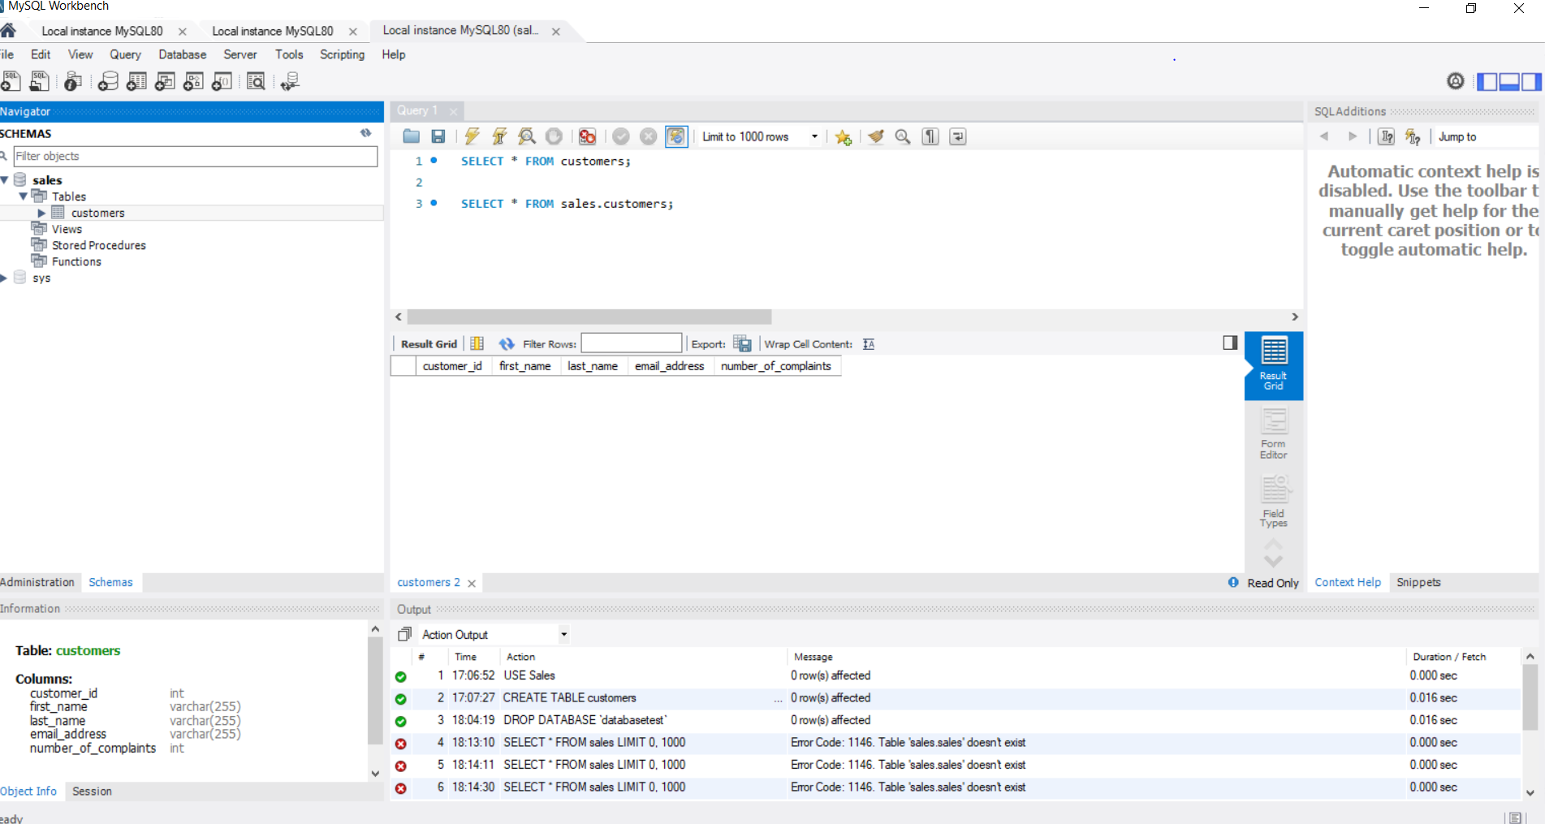

Ejercicio # 47 **PRIMARY KEY constraint - exercise**

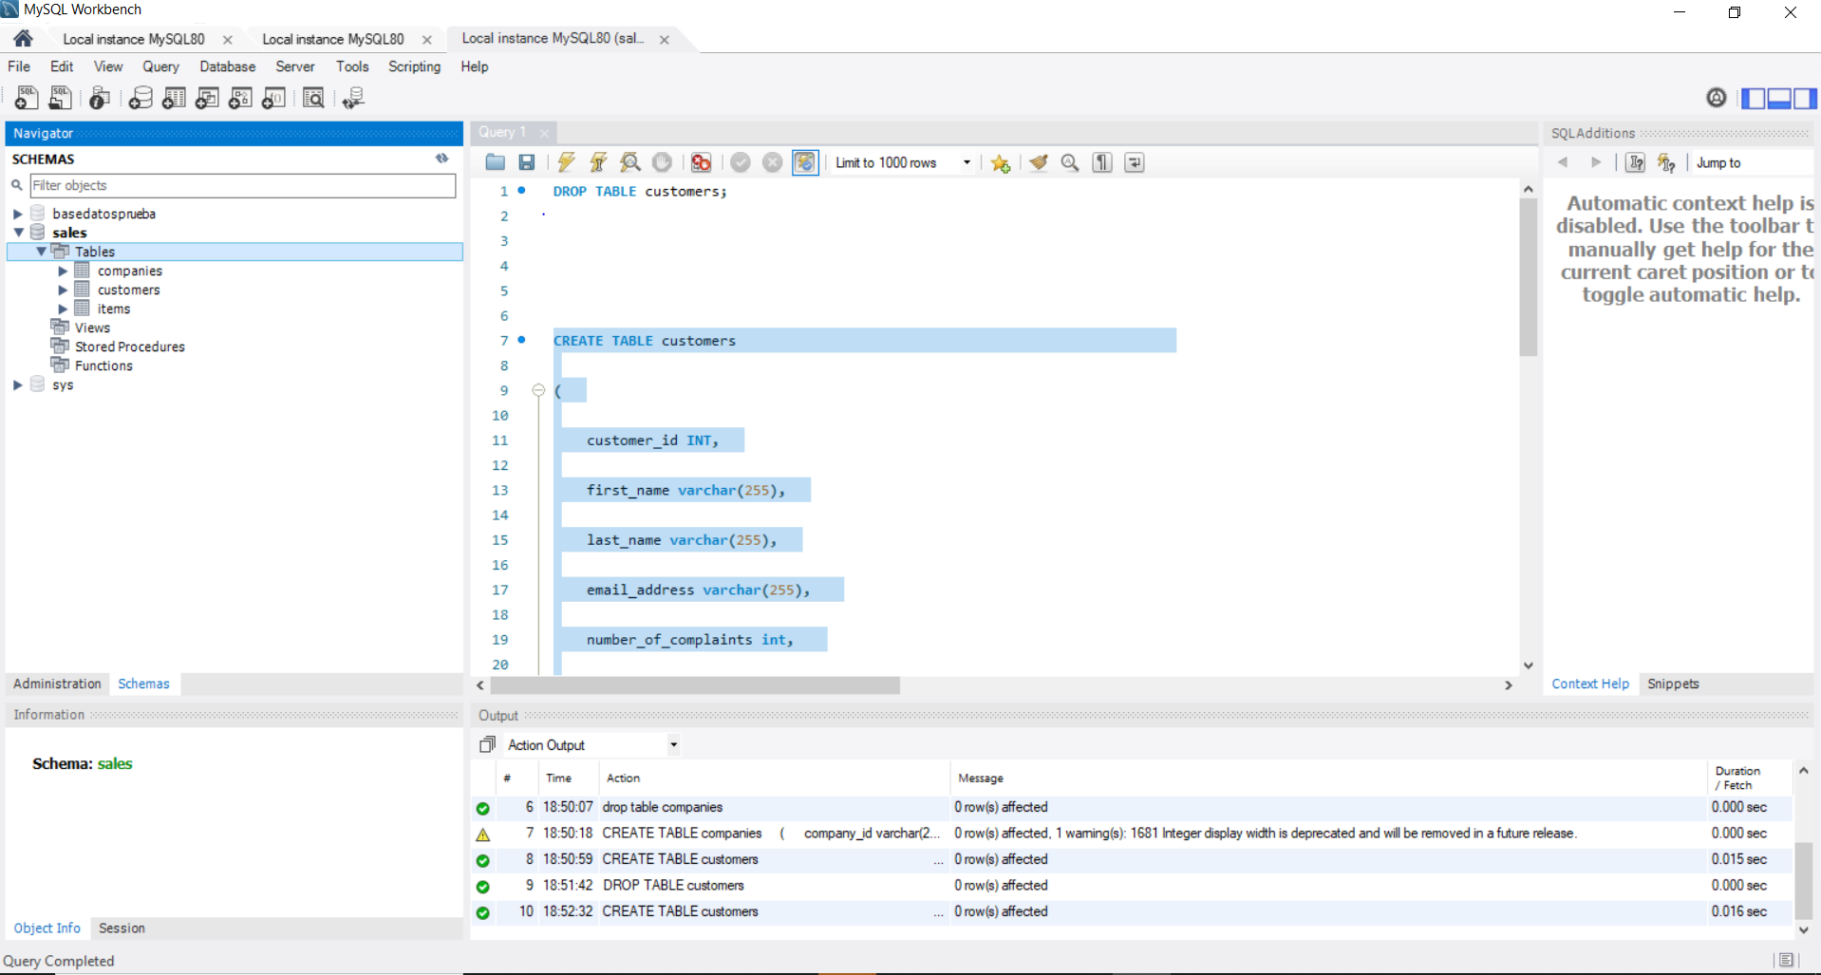

Ejercicio 51 , **FOREIGN KEY constraint - Part II –**

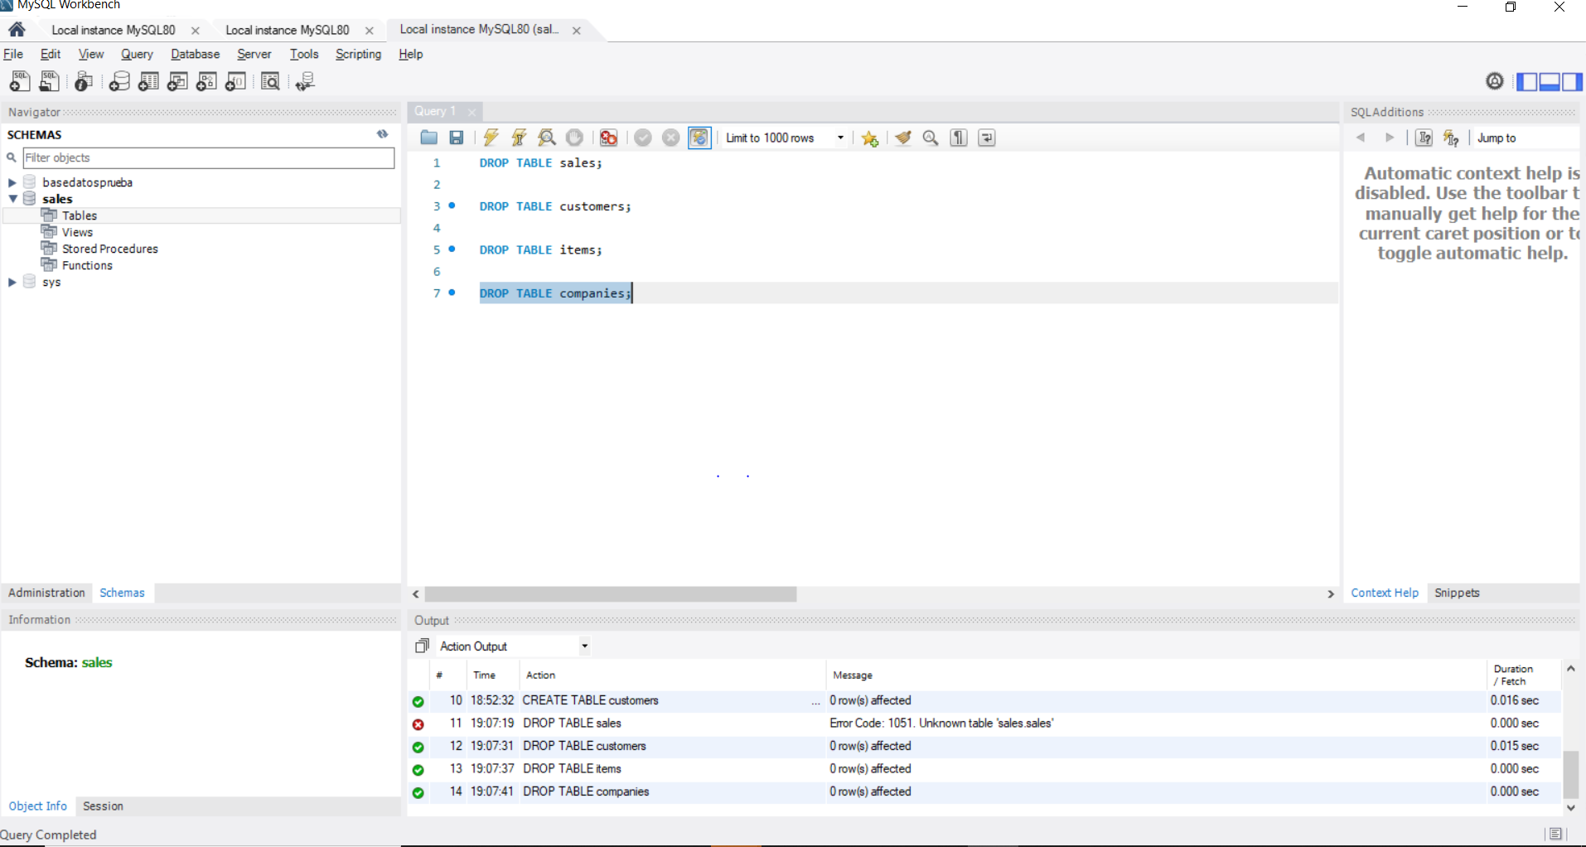

Ejercicio 57 **DEFAULT Constraint - solution** 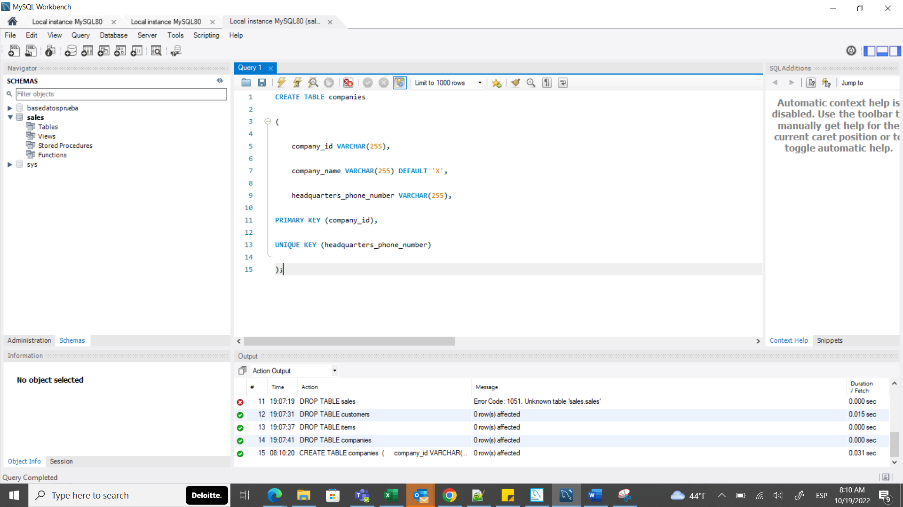

Ejercicio 60. **NOT NULL Constraint - Part I – solution**

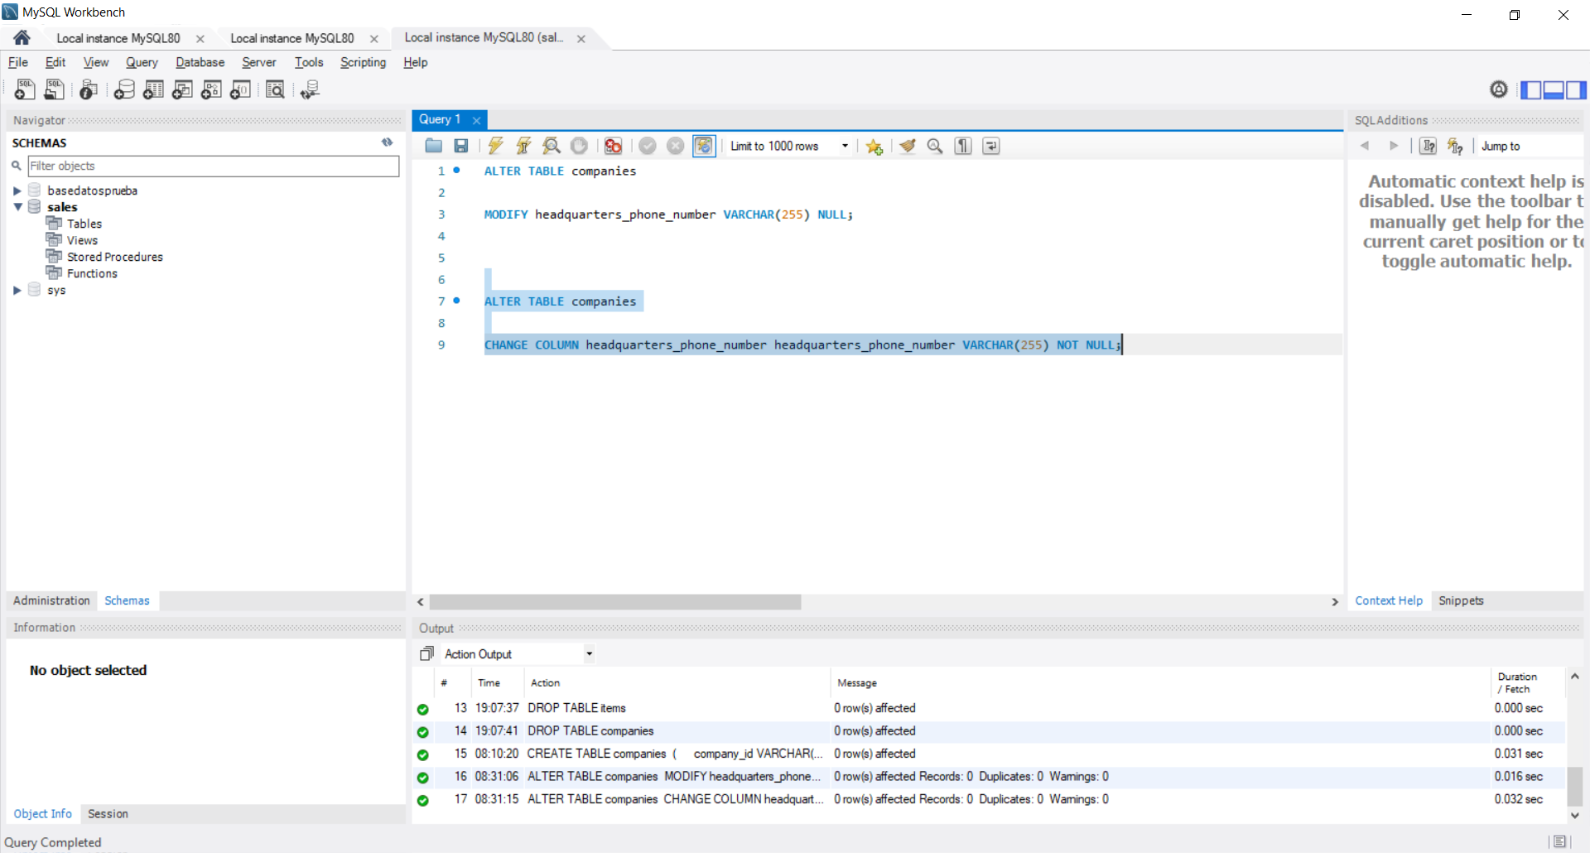

65 **Loading the 'employees' database**

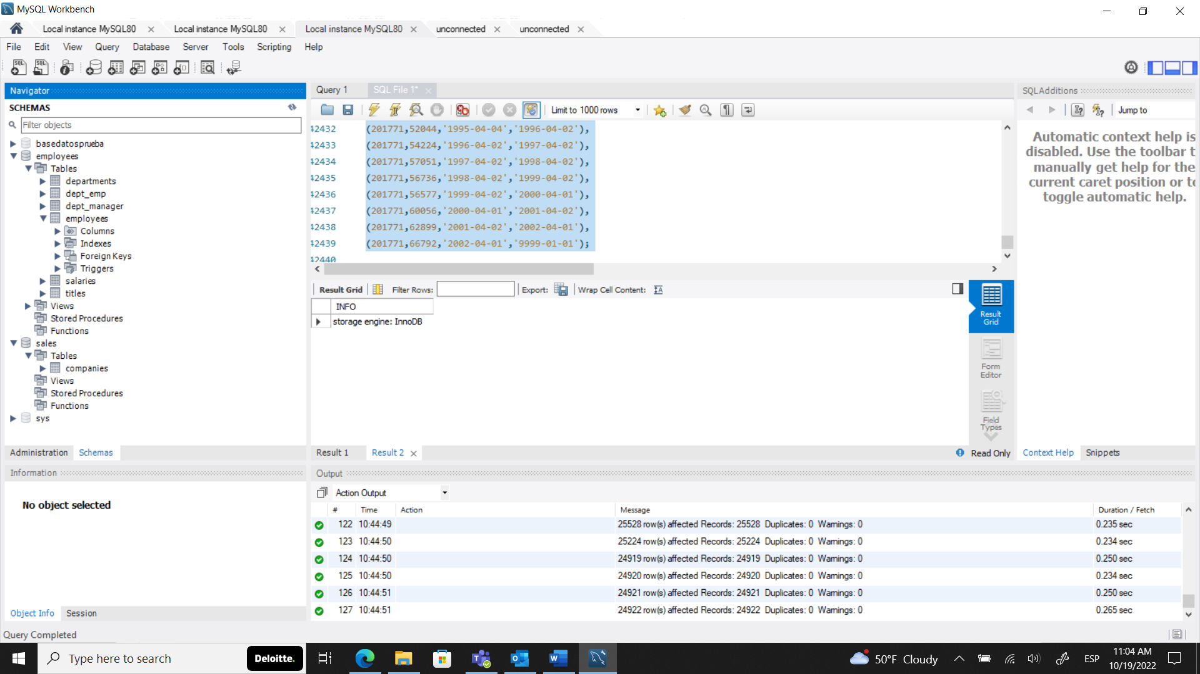

68 **SELECT - FROM – solution**

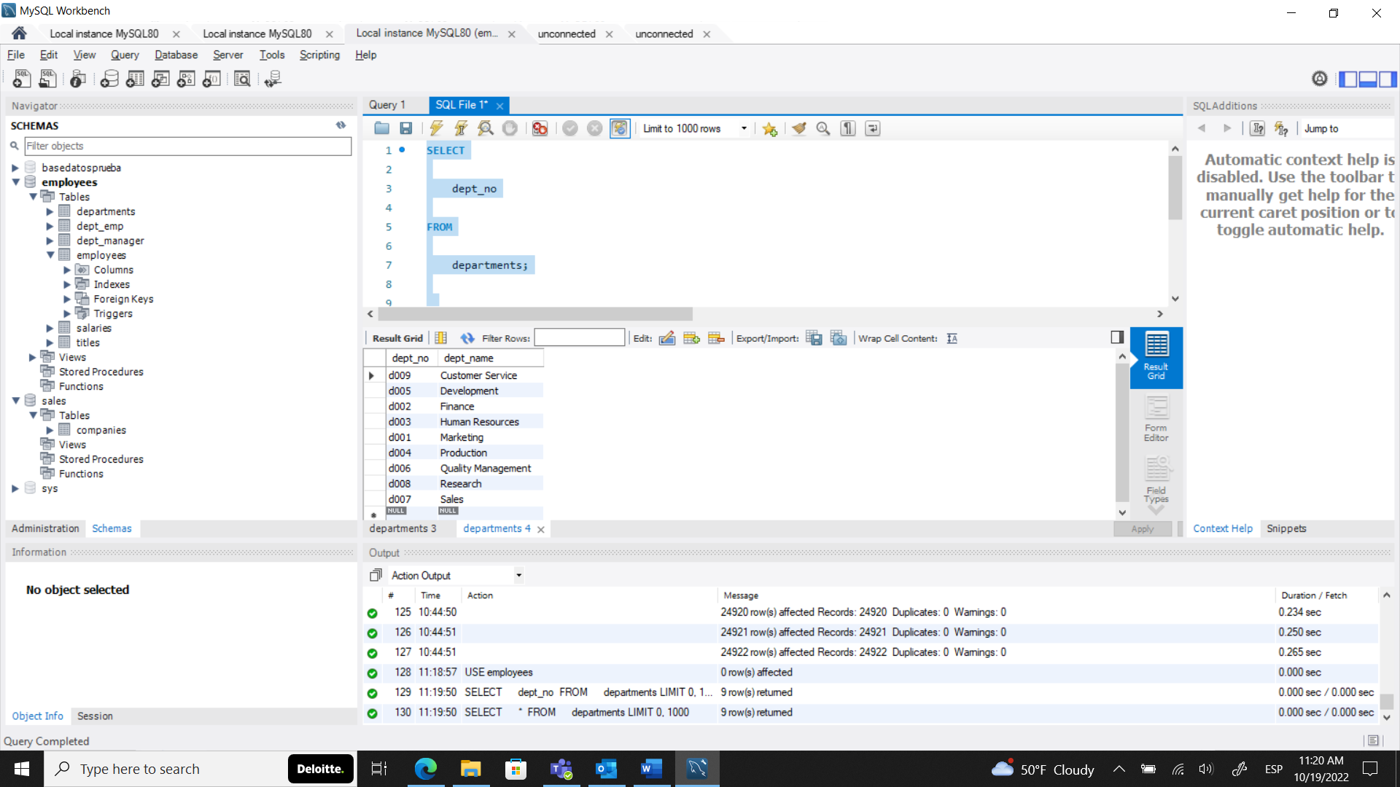

71. **WHERE – solution**

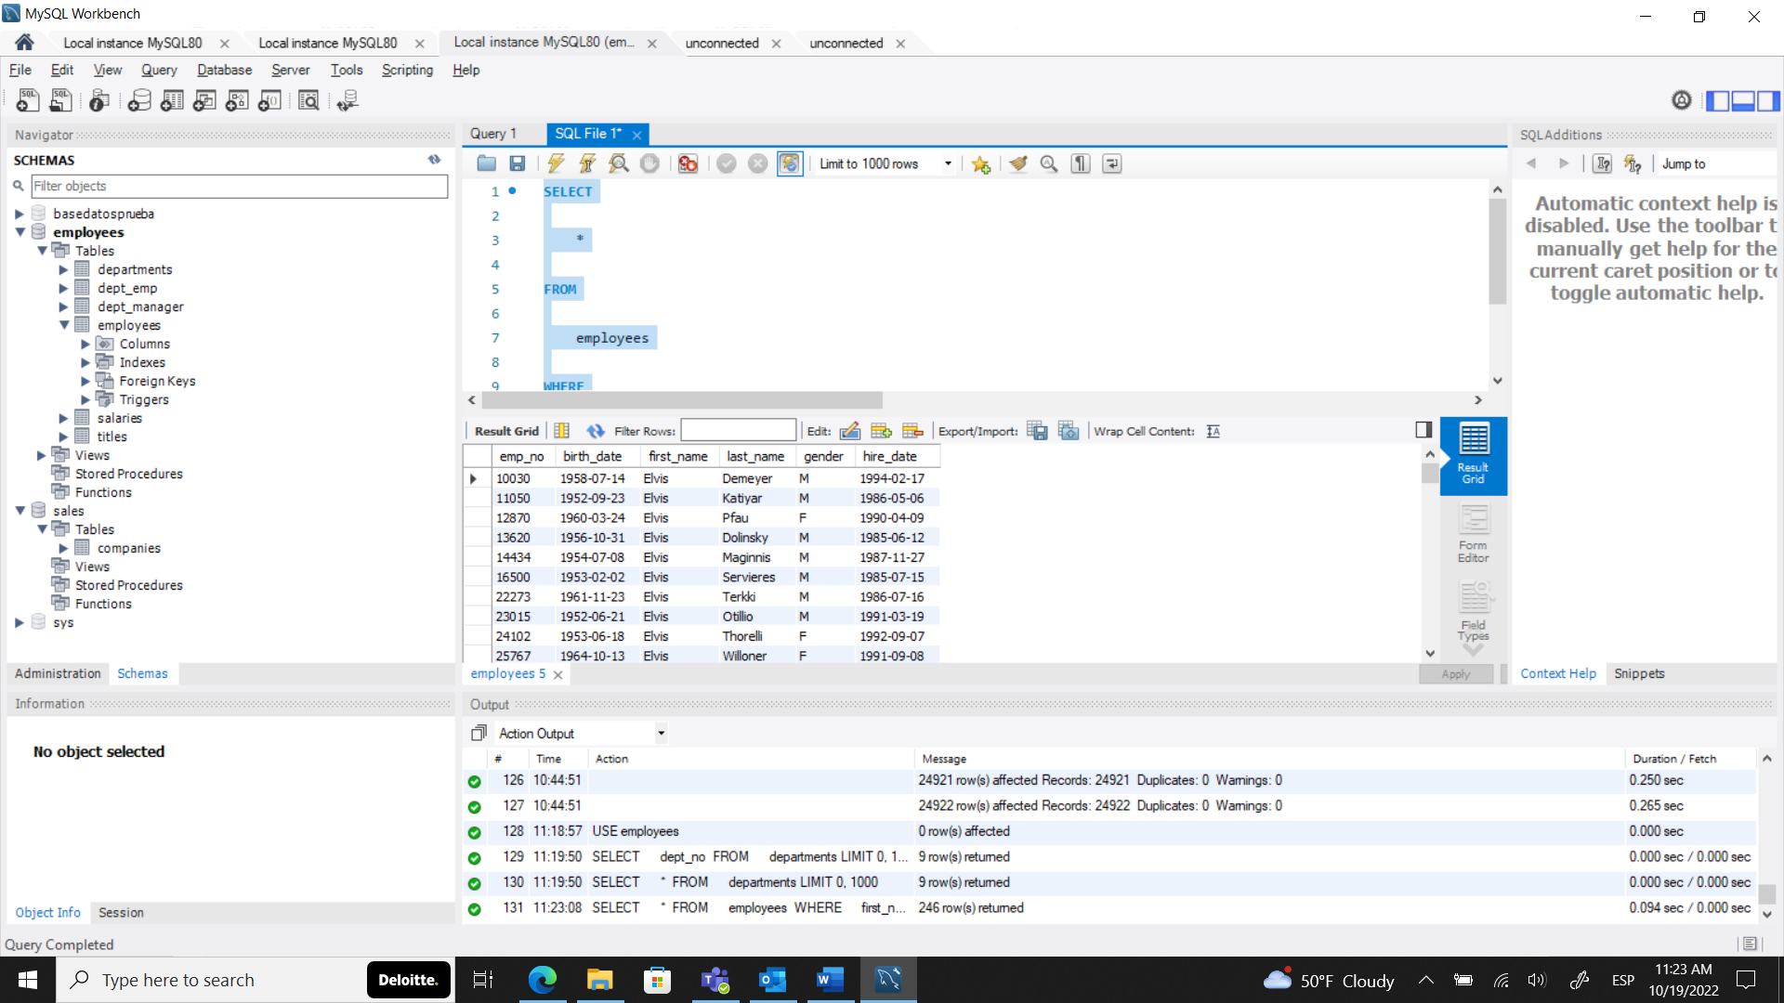

74. **AND – solution**

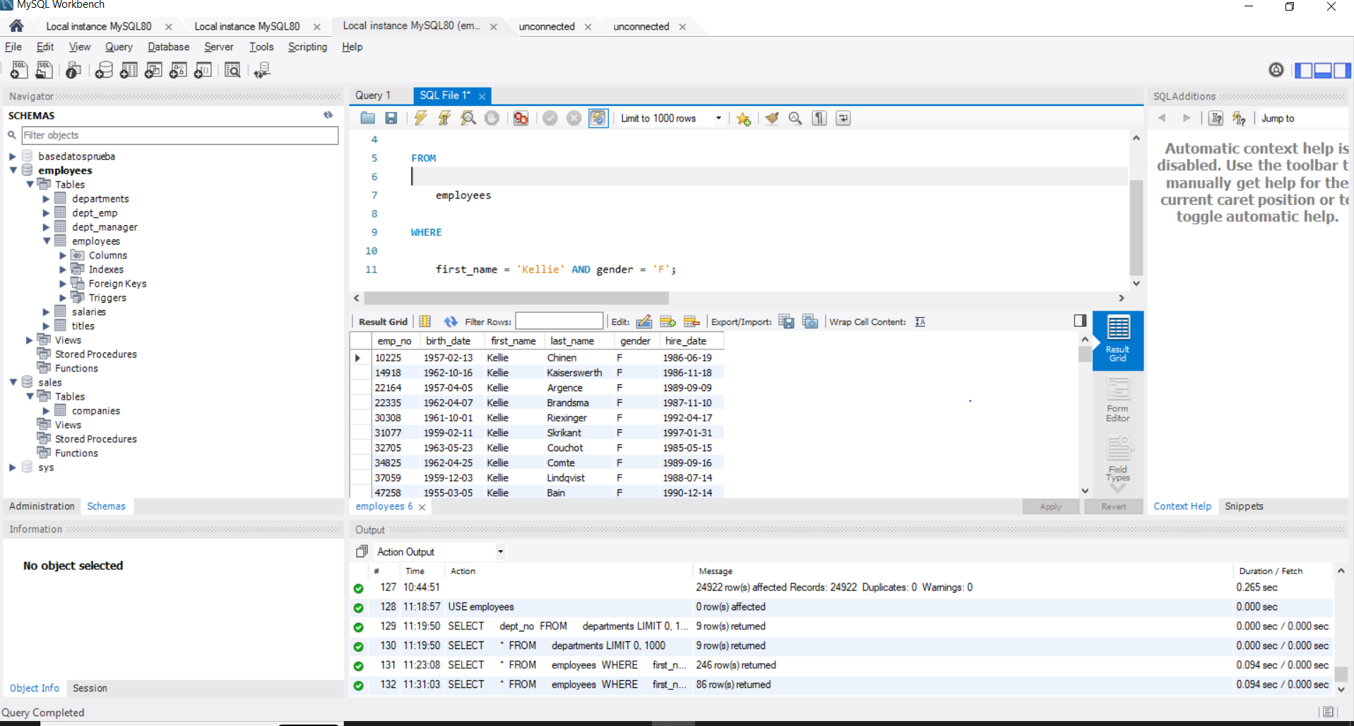

77 **OR – solution**

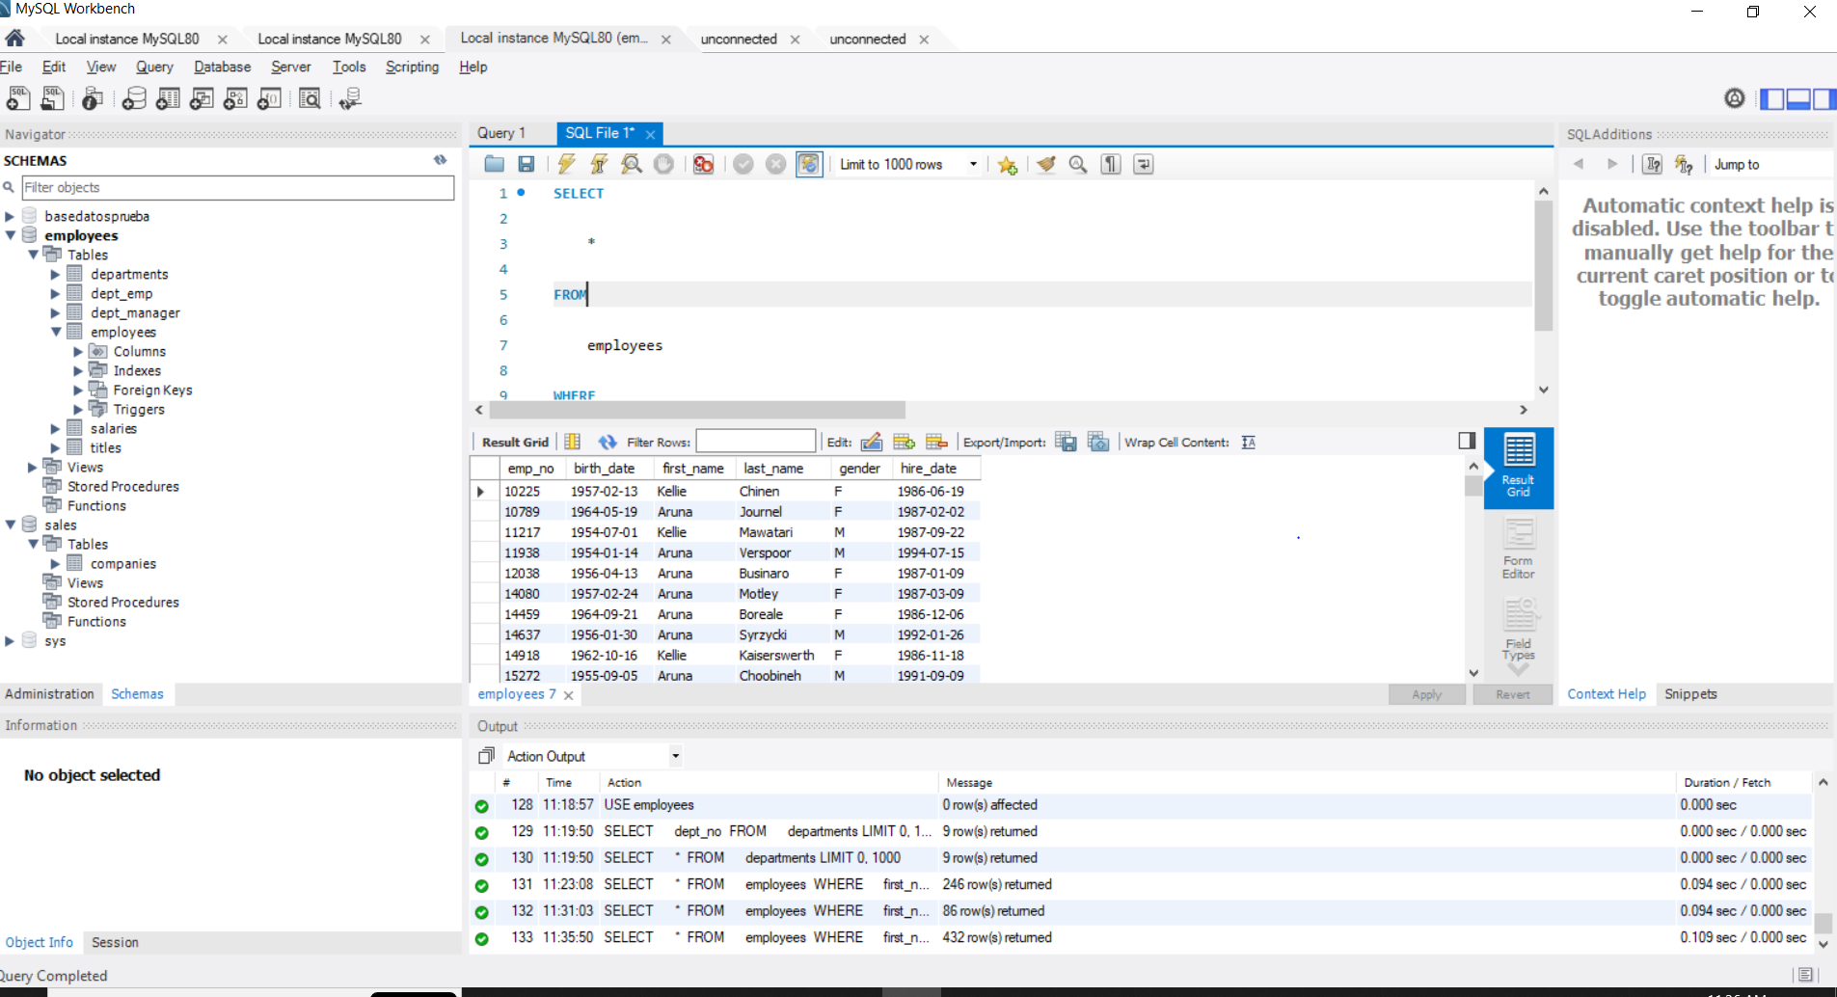

**80. Operator precedence – solution**

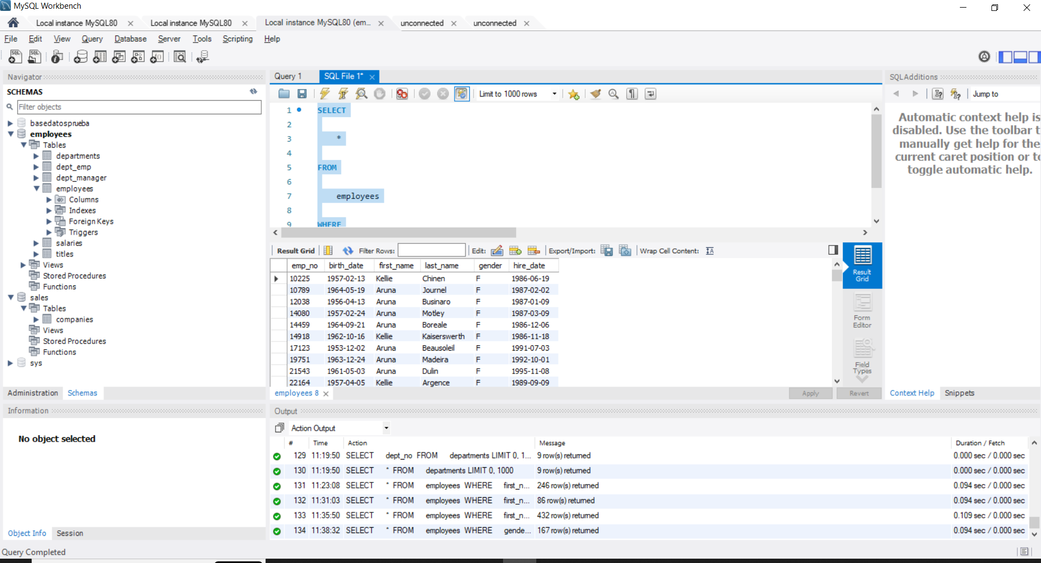

**83. IN - NOT IN - solution 1**

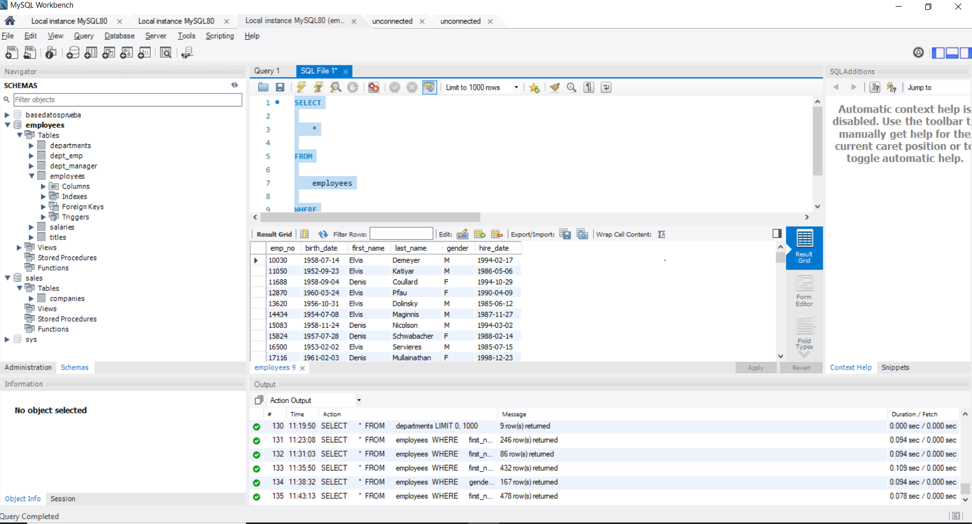

**85 IN - NOT IN - solution 2**

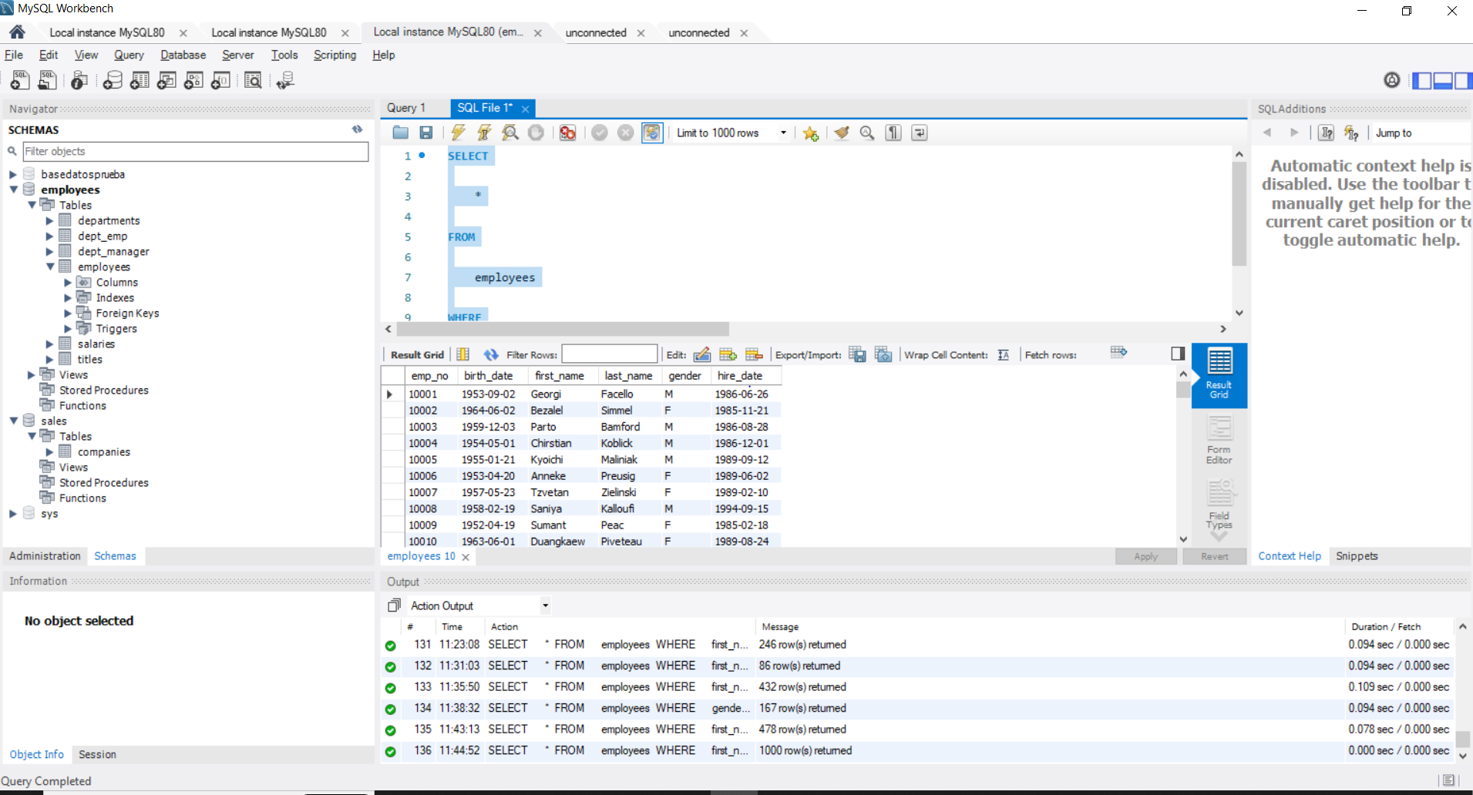

**88. LIKE - NOT LIKE – solution**

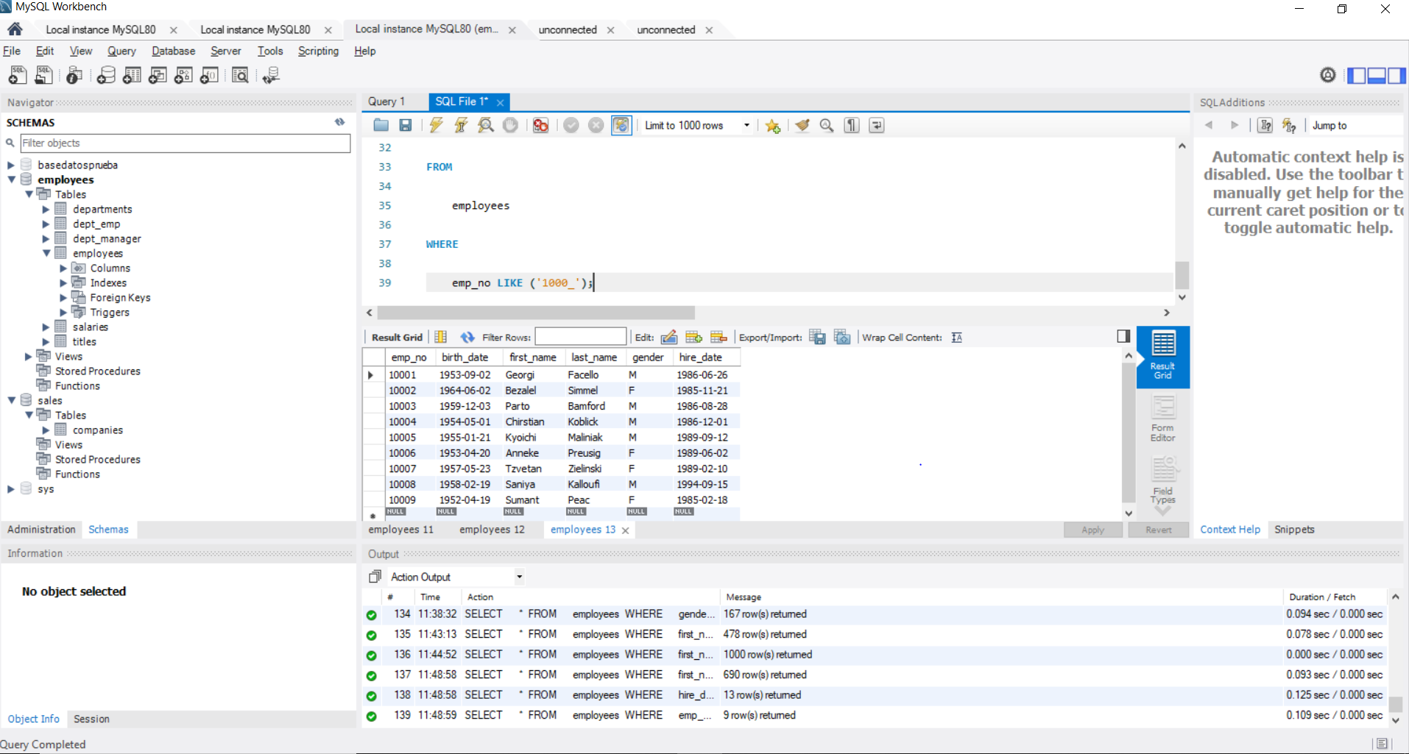

**91. Wildcard characters – solution**

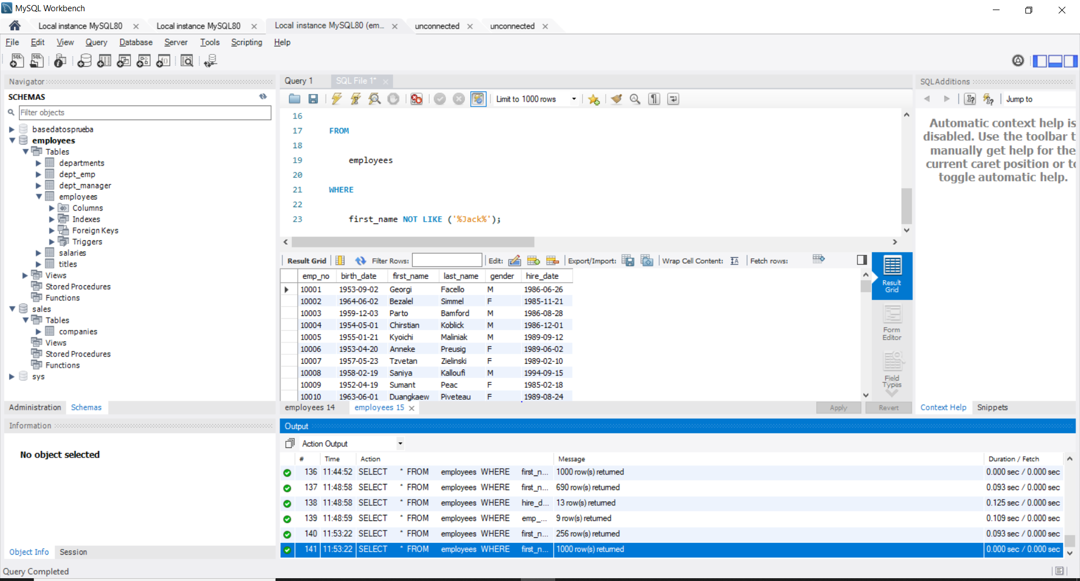

**94. BETWEEN - AND- solution**

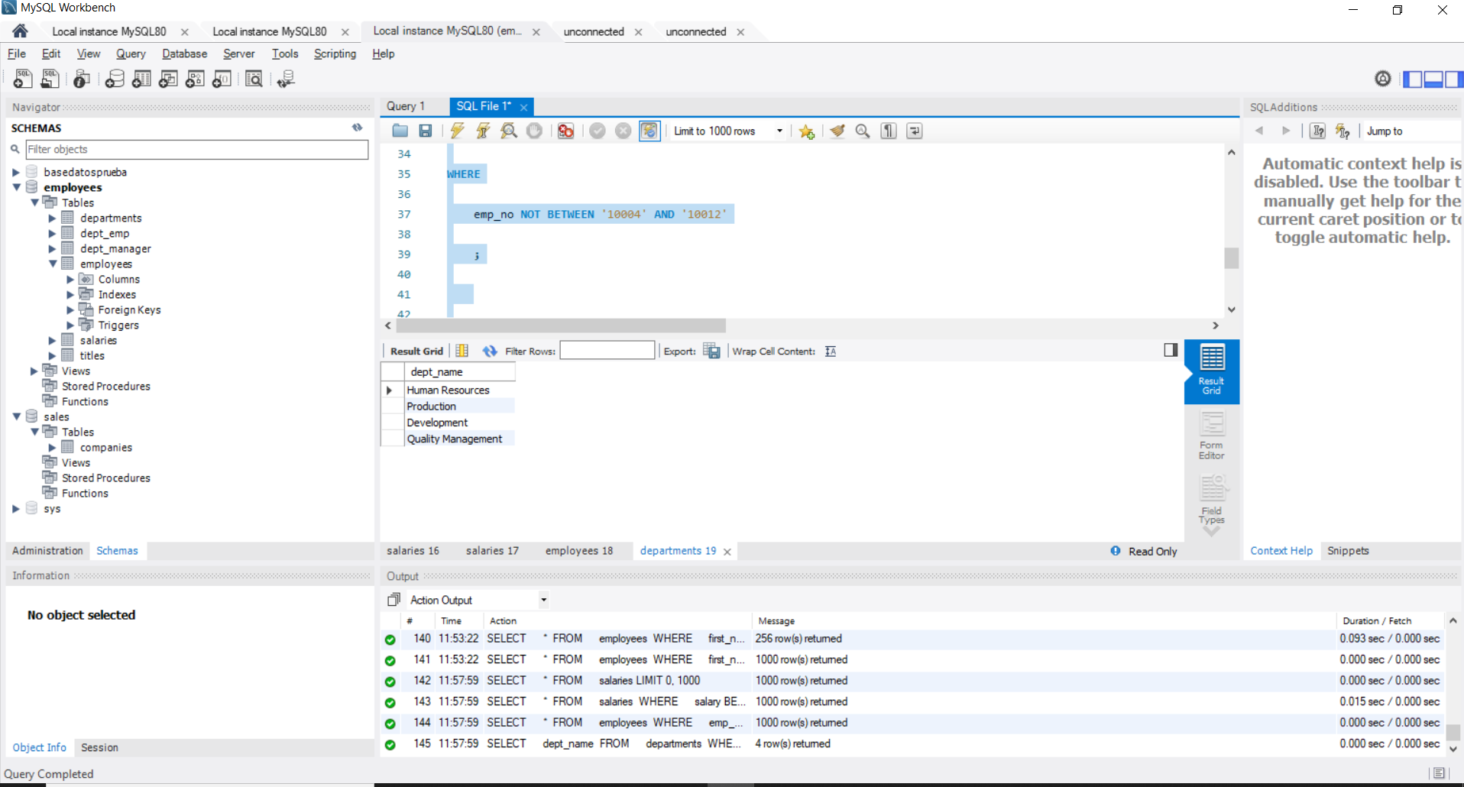

**97. IS NOT NULL - IS NULL – solution**

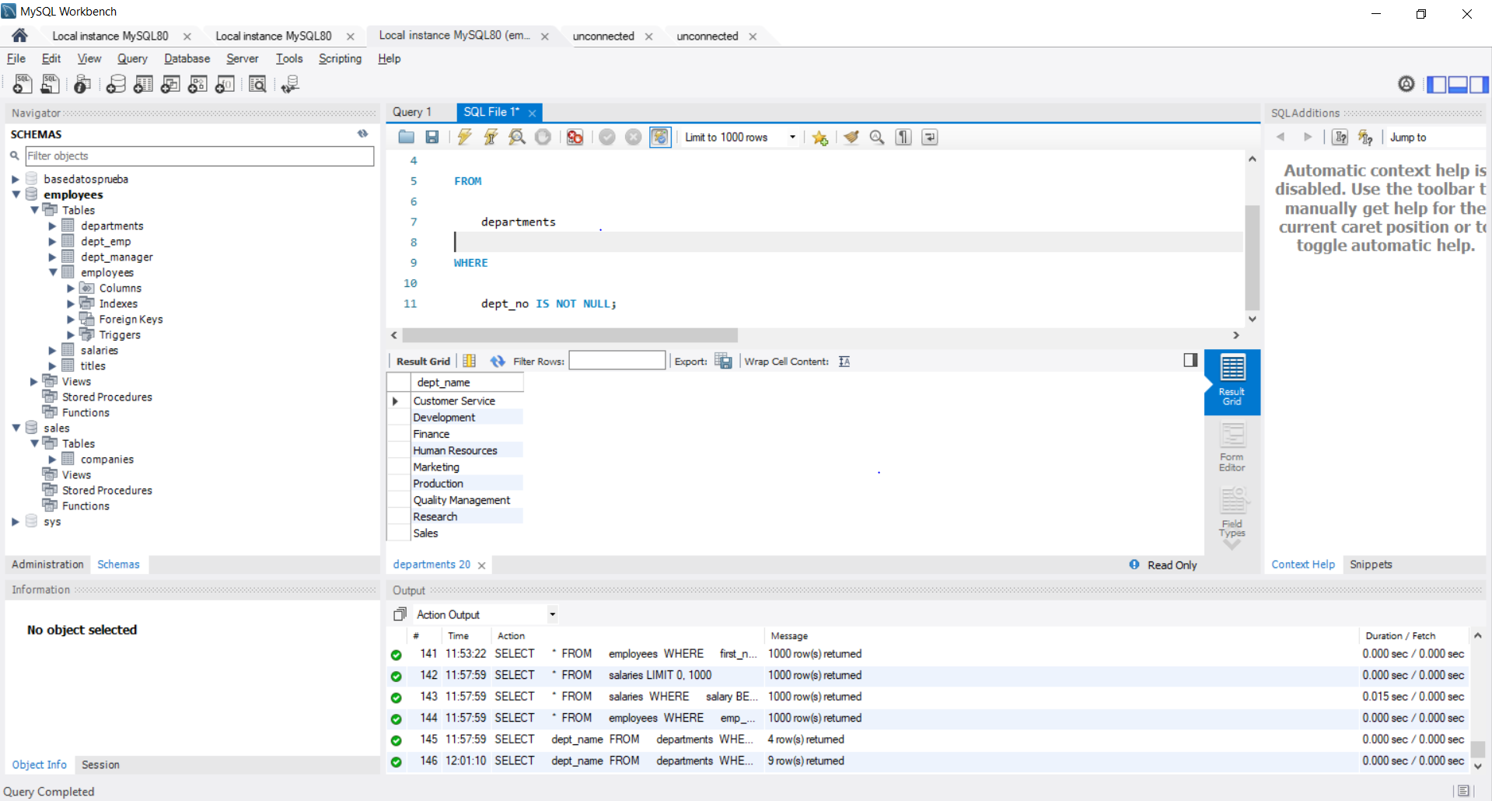

**100 Other comparison operators – solution**

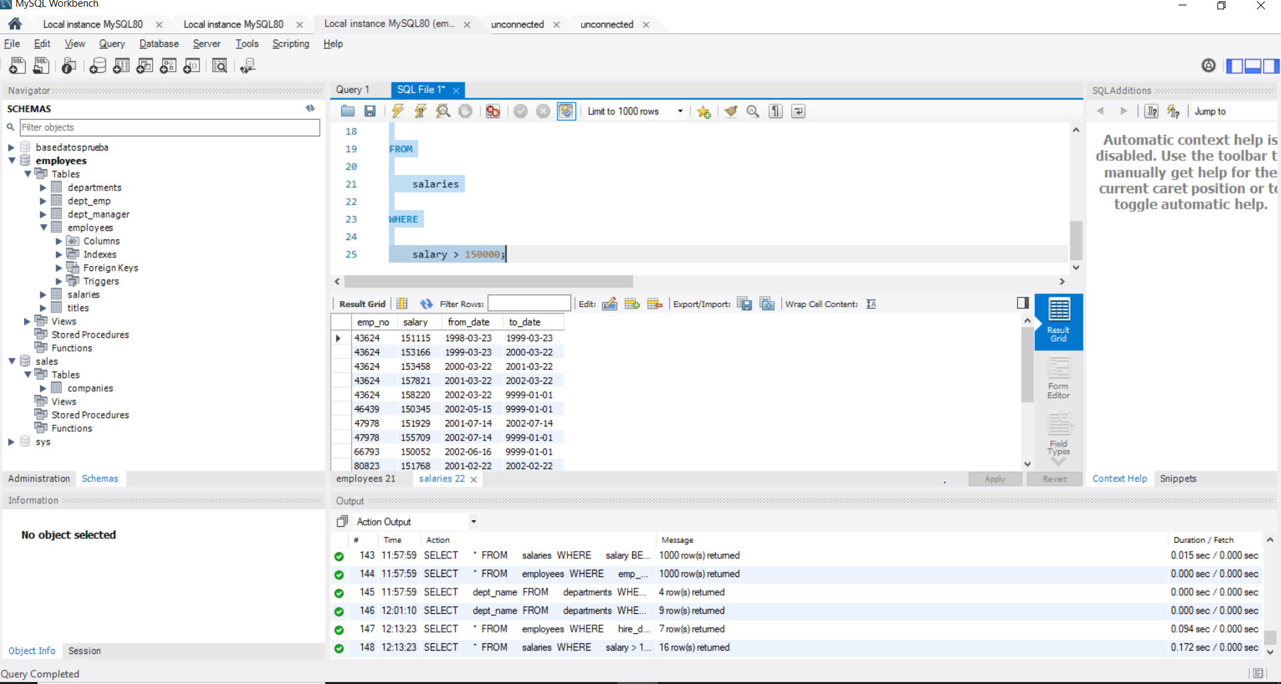

**103. SELECT DISTINCT – solution**

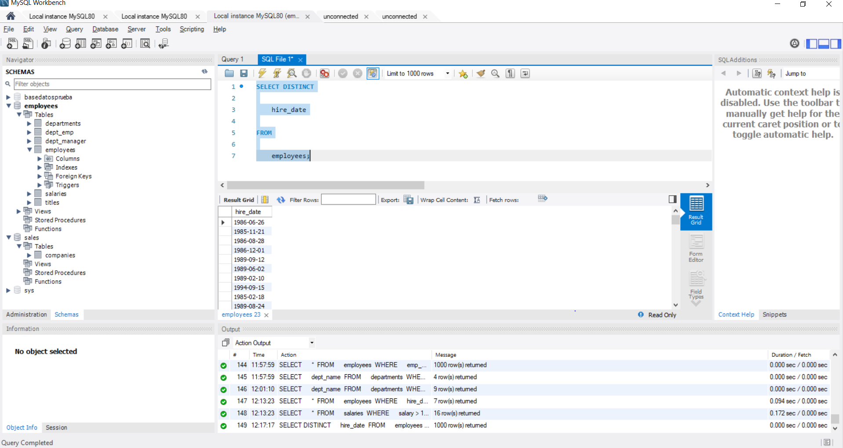

**106 Introduction to aggregate functions – solution**

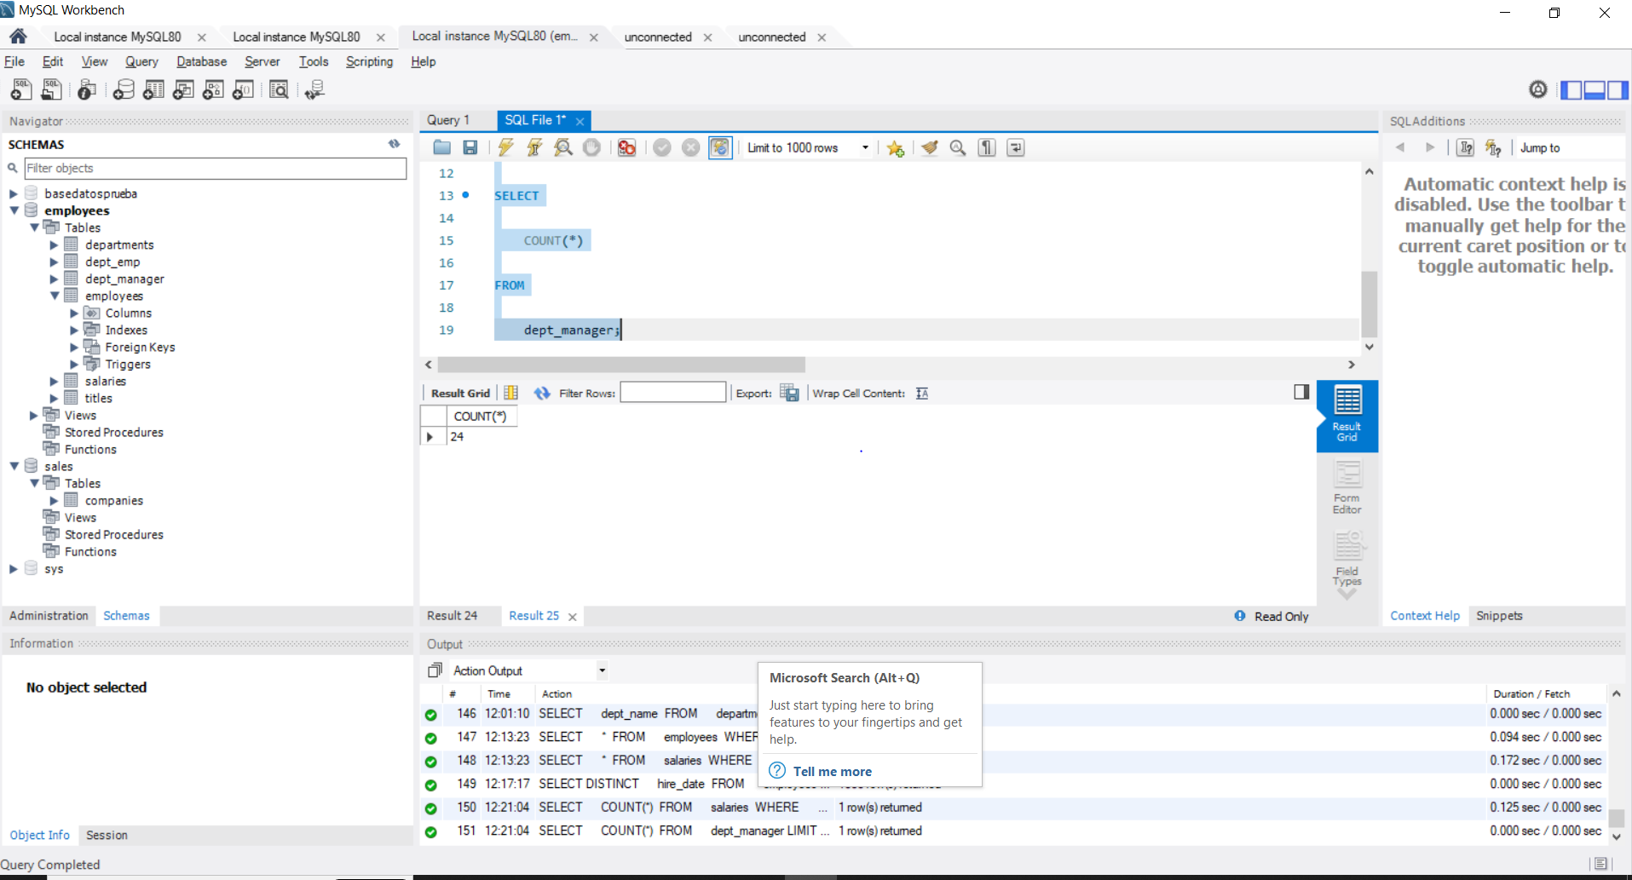

**109. ORDER BY – solution**

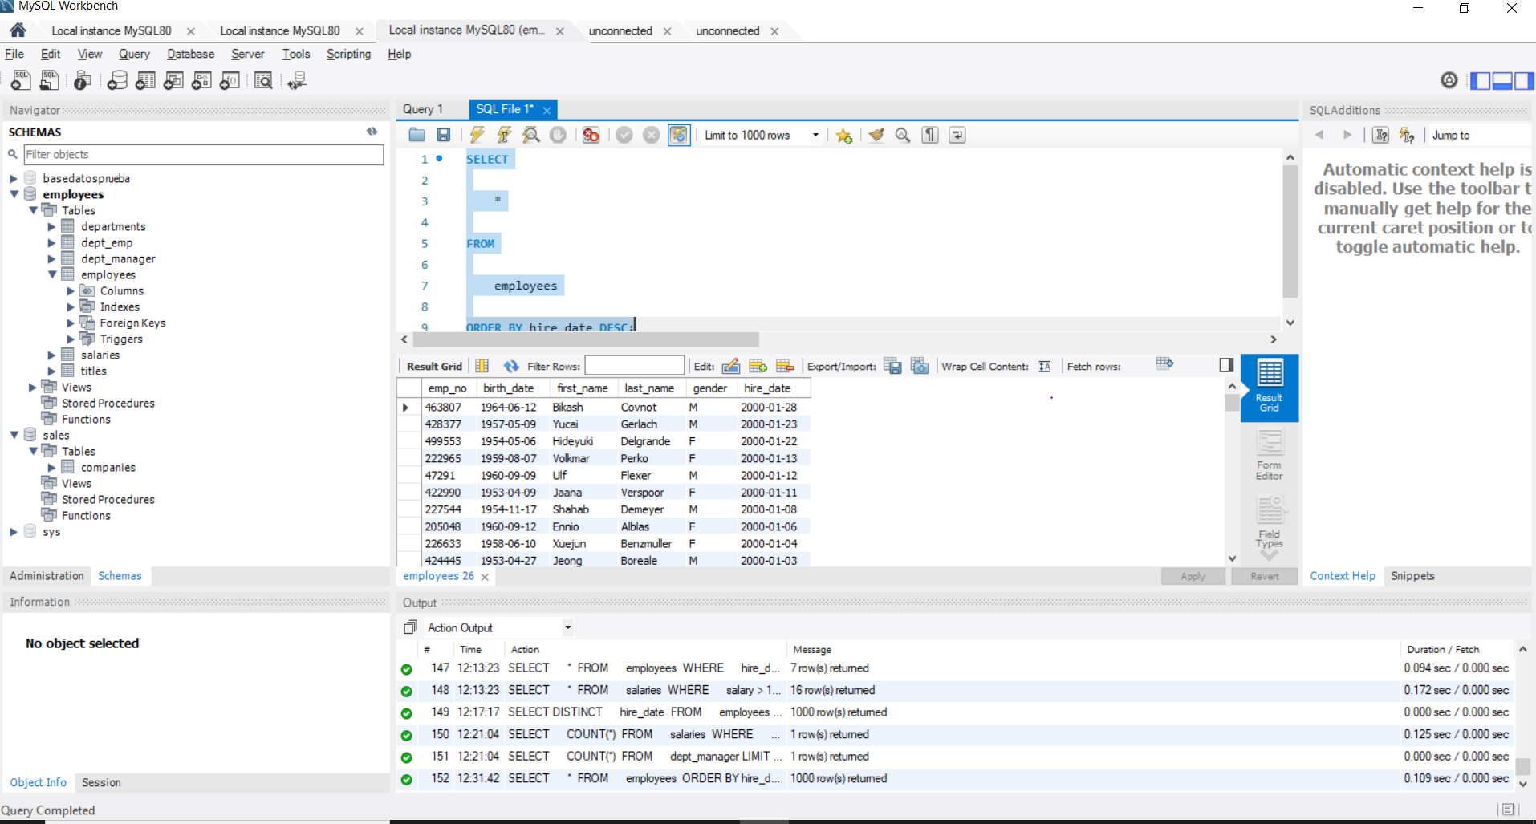

**113. Using Aliases (AS) – solution**

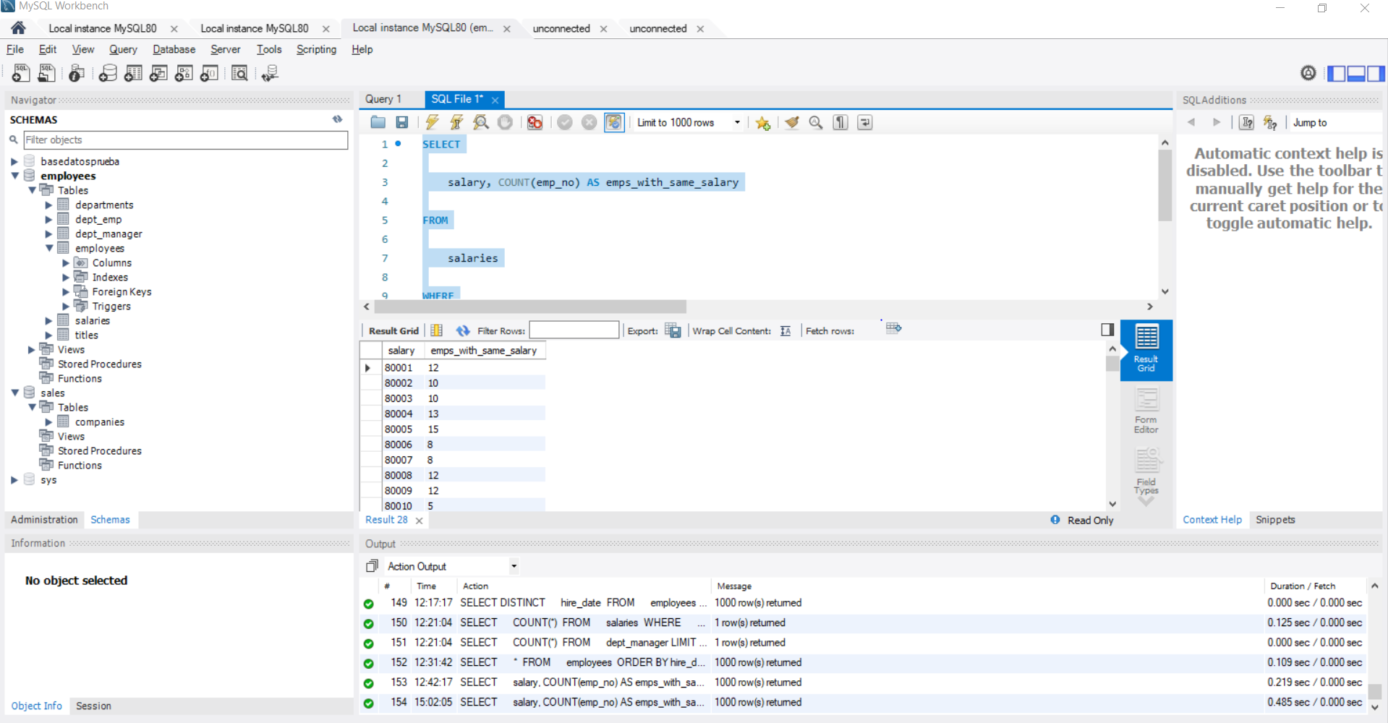

**116. HAVING – solution**

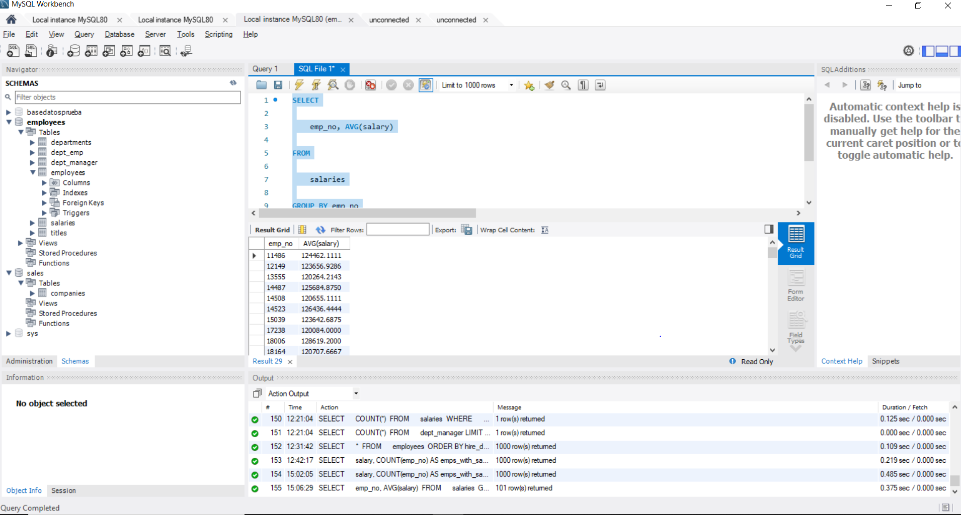

**120. WHERE vs HAVING - Part II – solution**

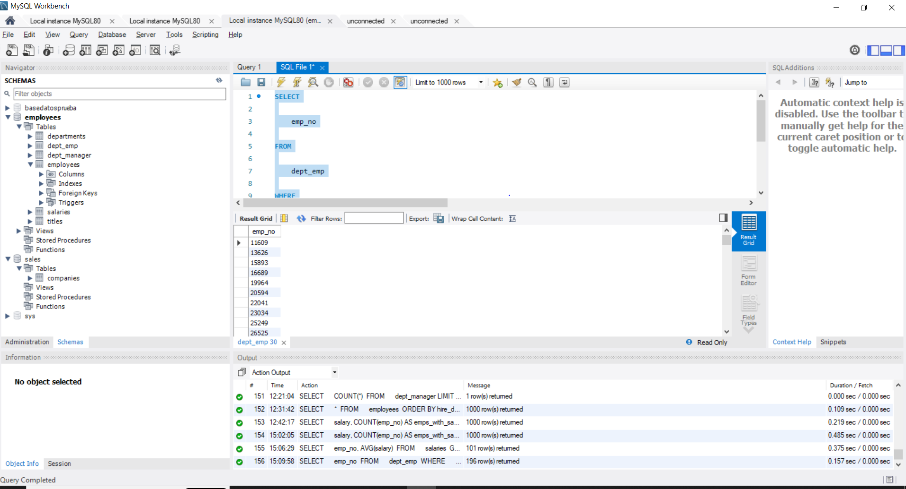

**123. LIMIT – solution**

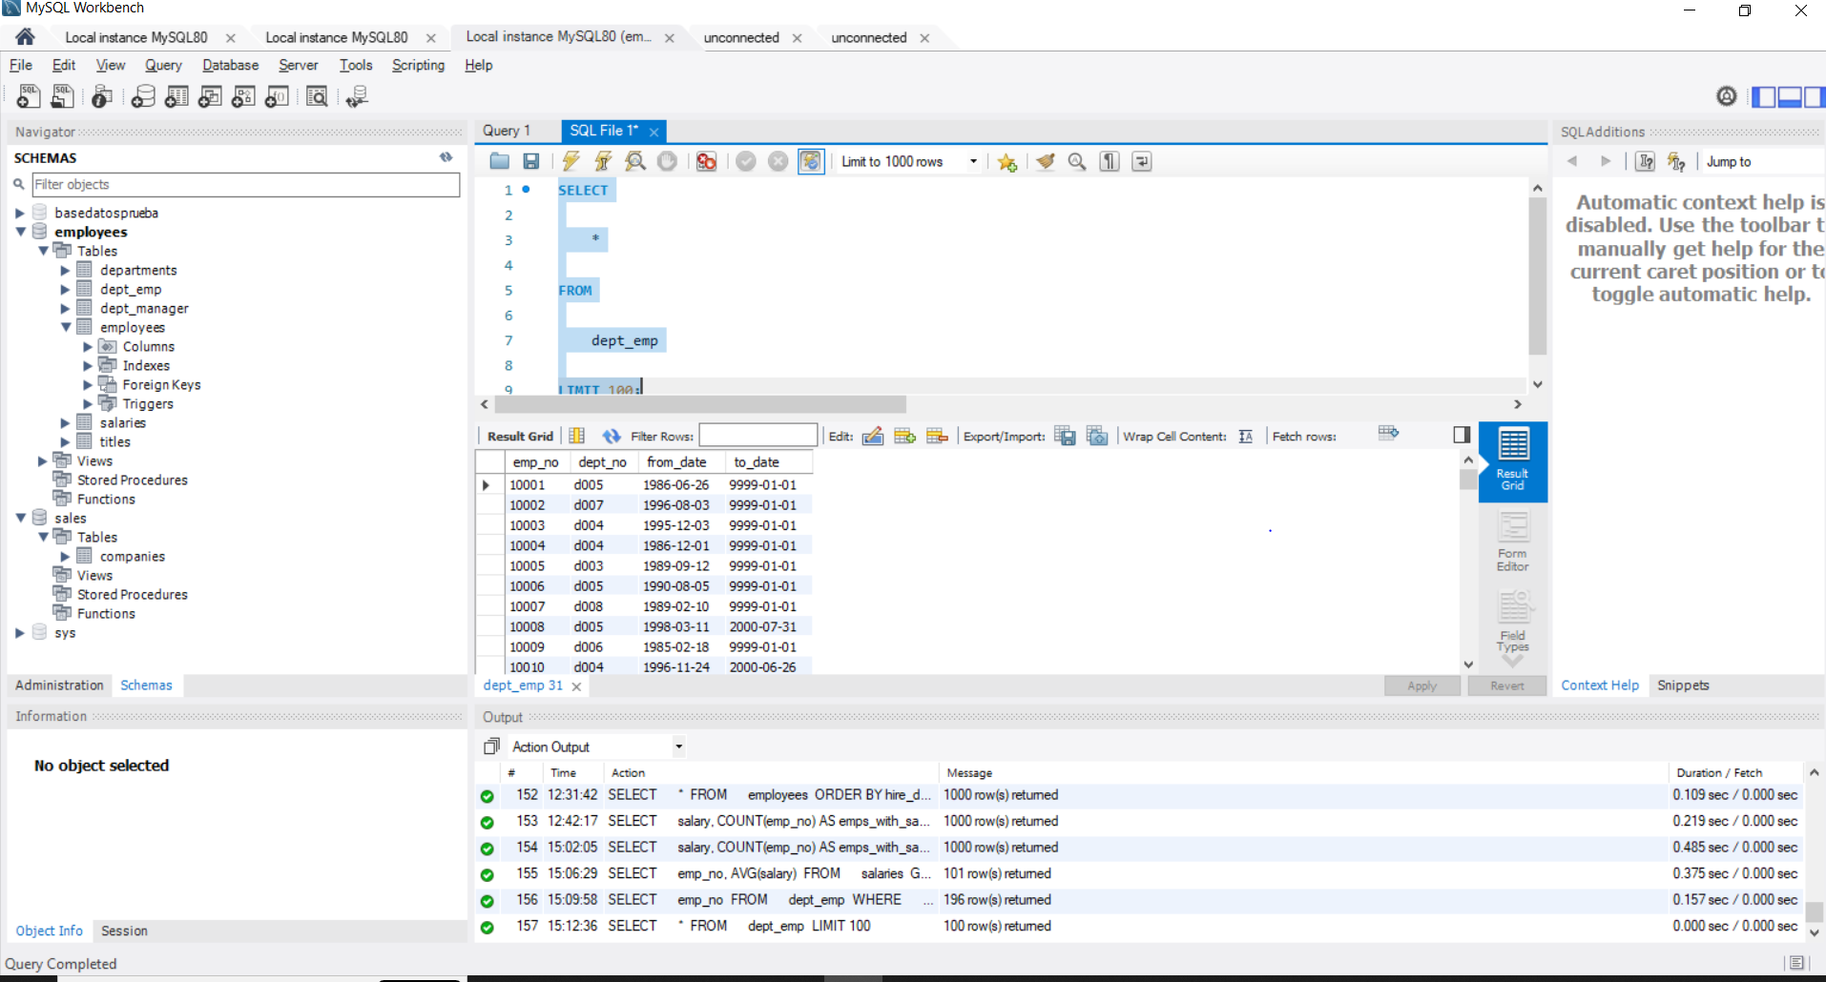

**127. The INSERT statement - solution 1**

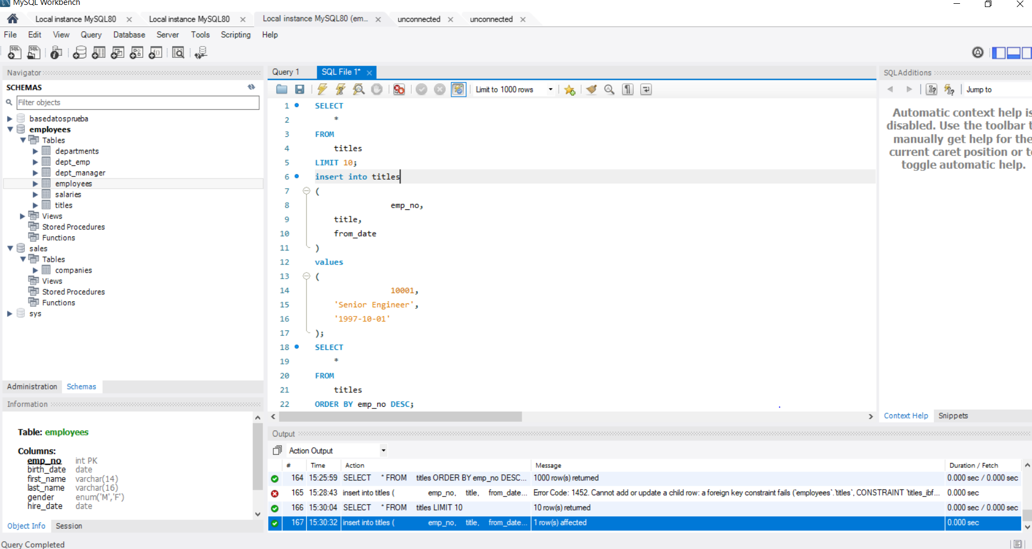

**129.The INSERT statement - solution 2**

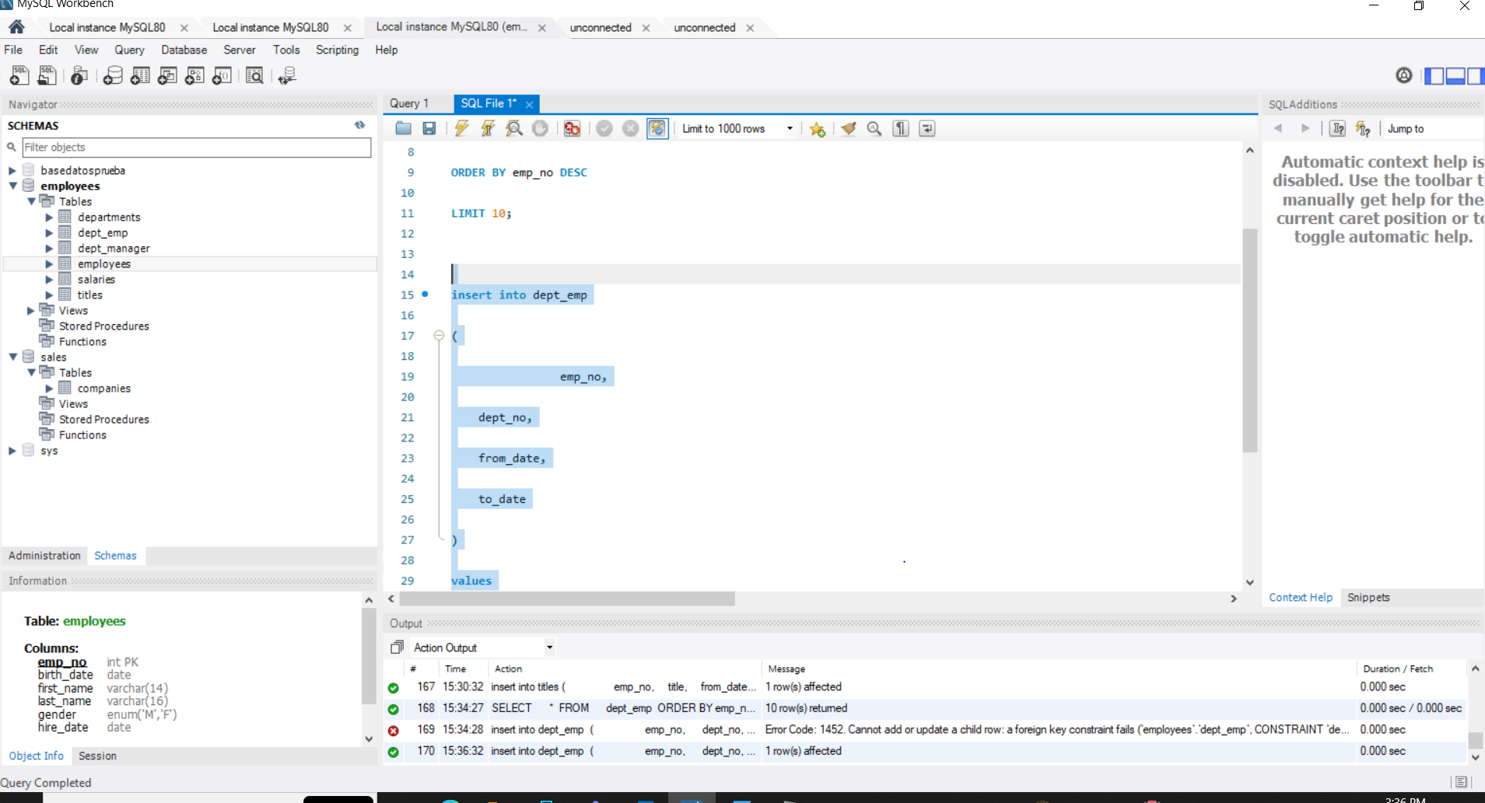

**132. Inserting Data INTO a New Table – solution**

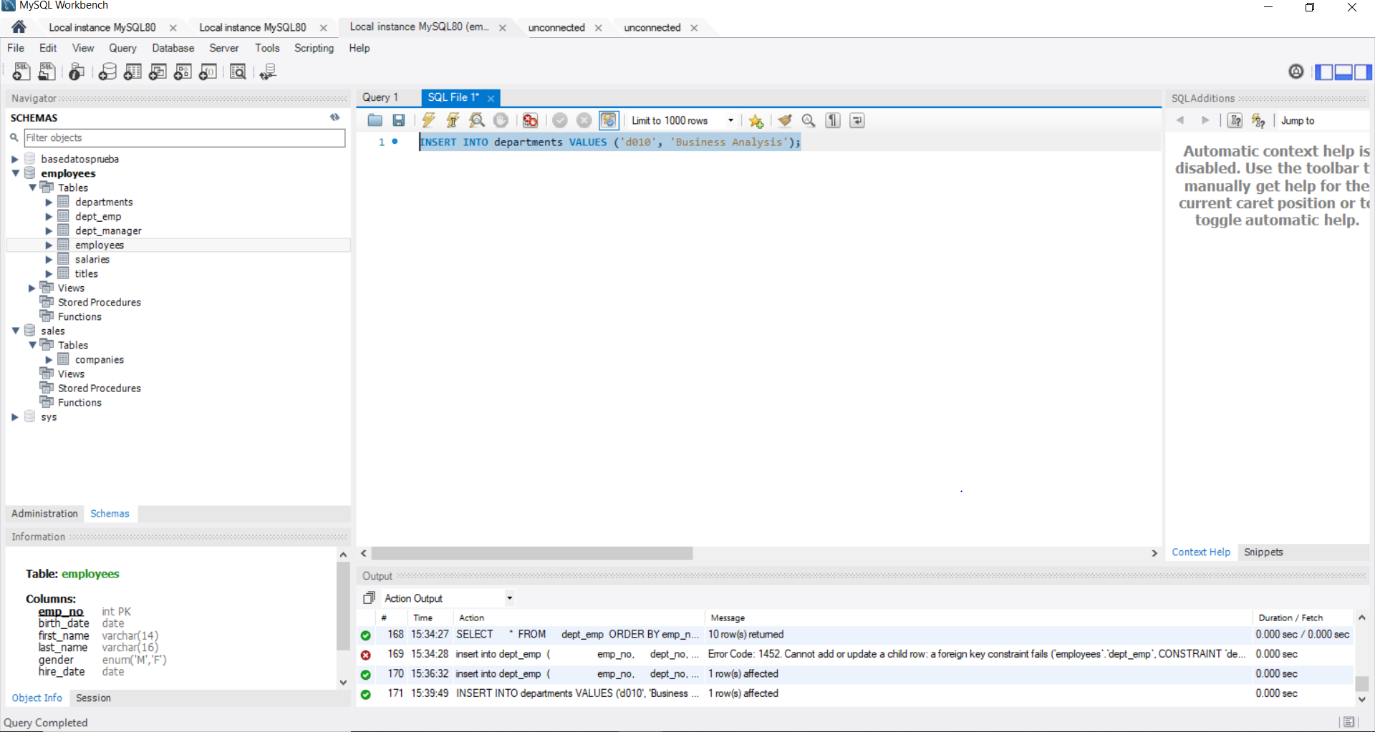

**138. The UPDATE Statement – Part II – solution**

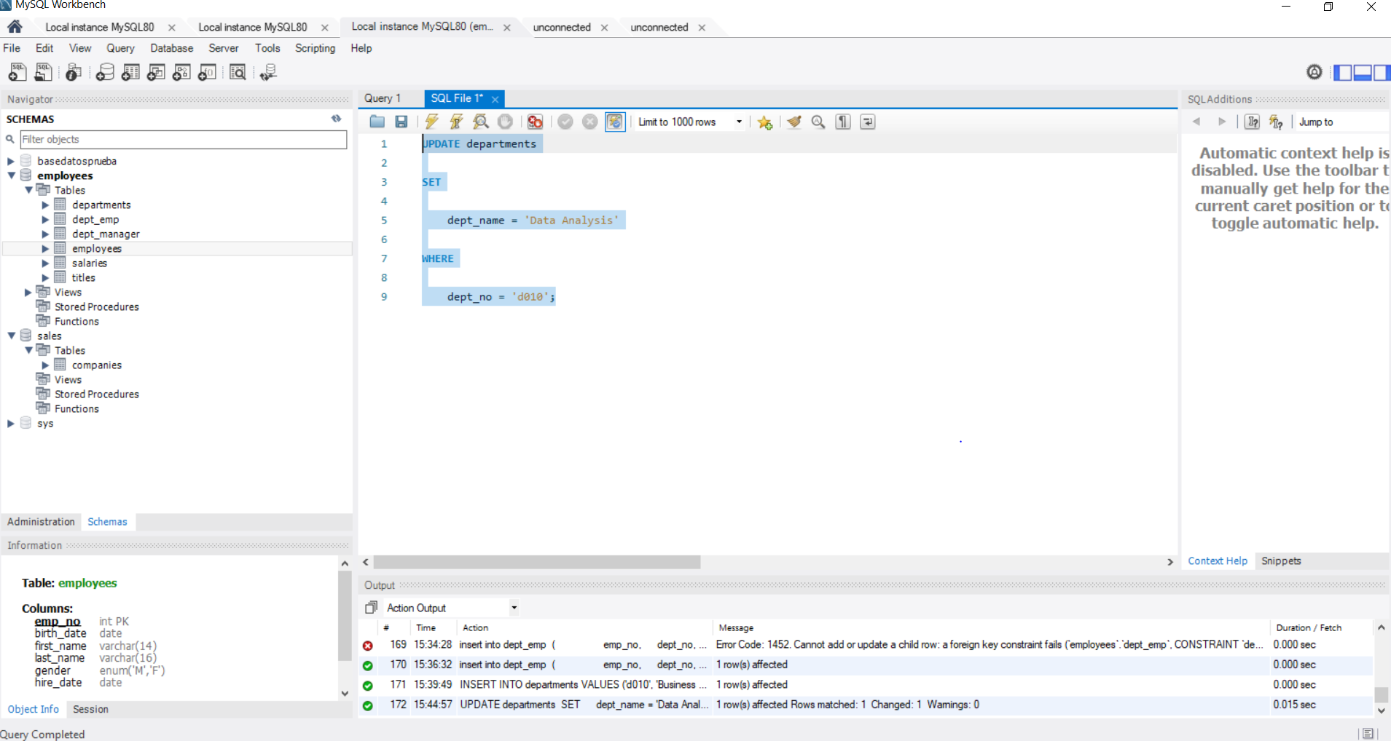

**142. The DELETE Statement – Part II – solution**

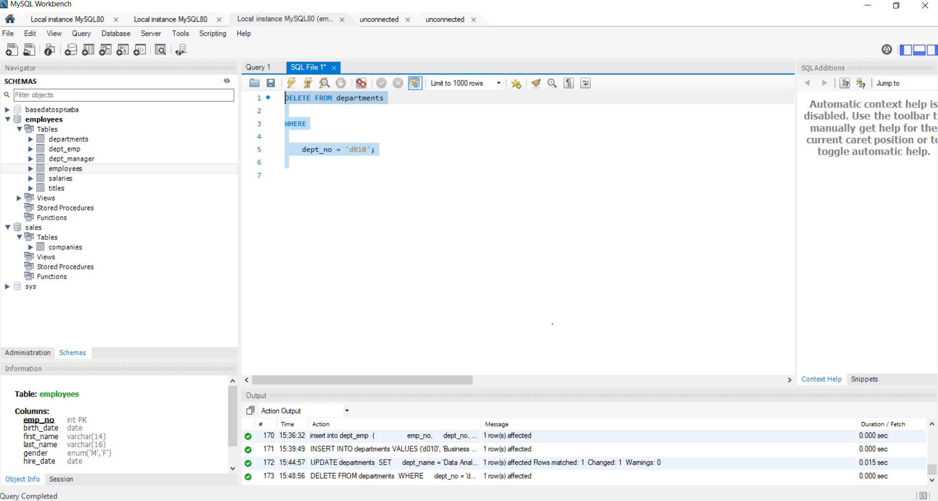

**146. COUNT() – solution**

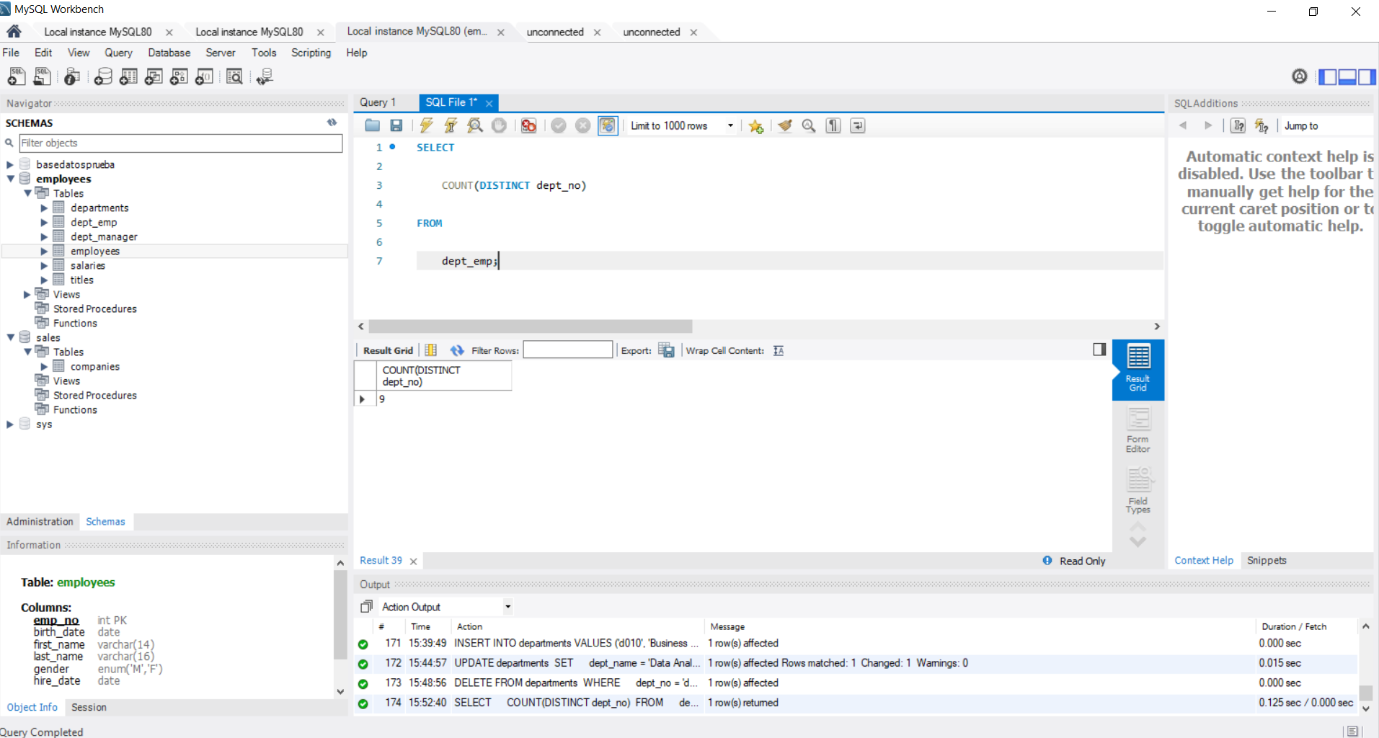

**149. SUM() – solution**

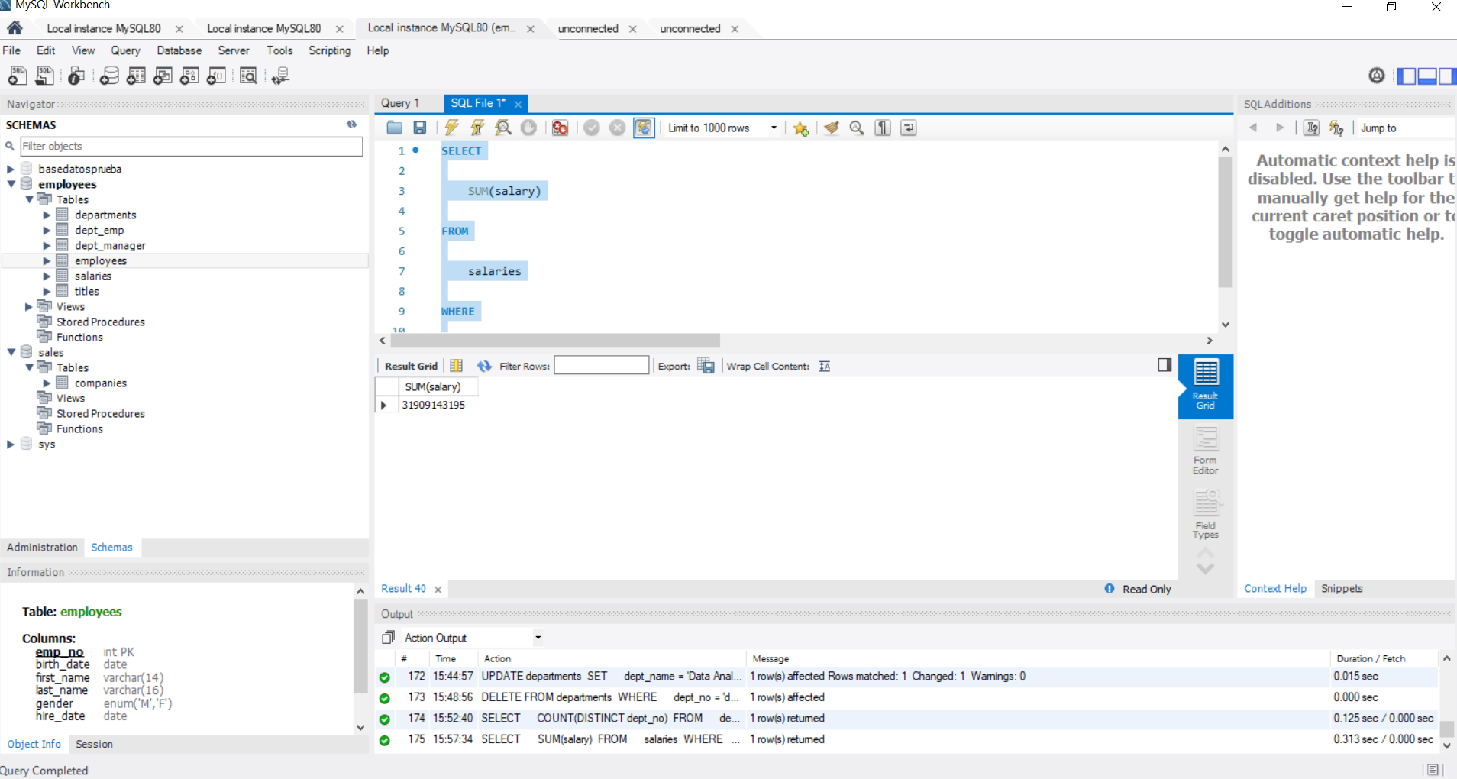

**152. MIN() and MAX() – solution**

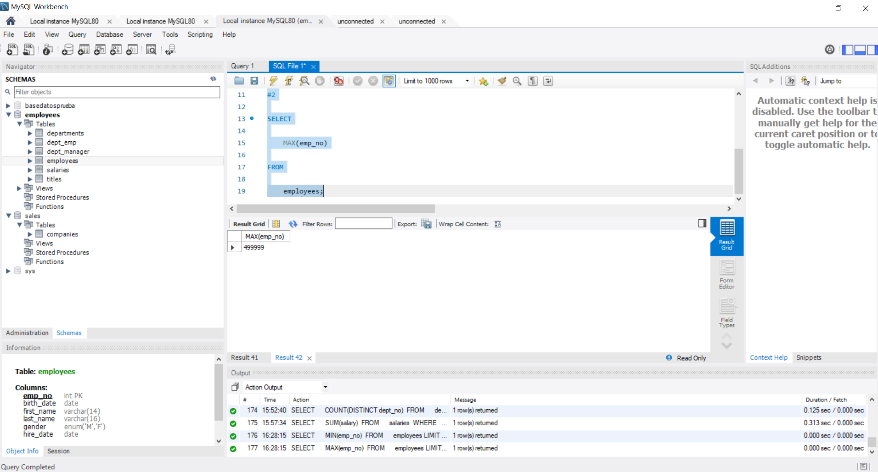

**155.** **AVG() - solution**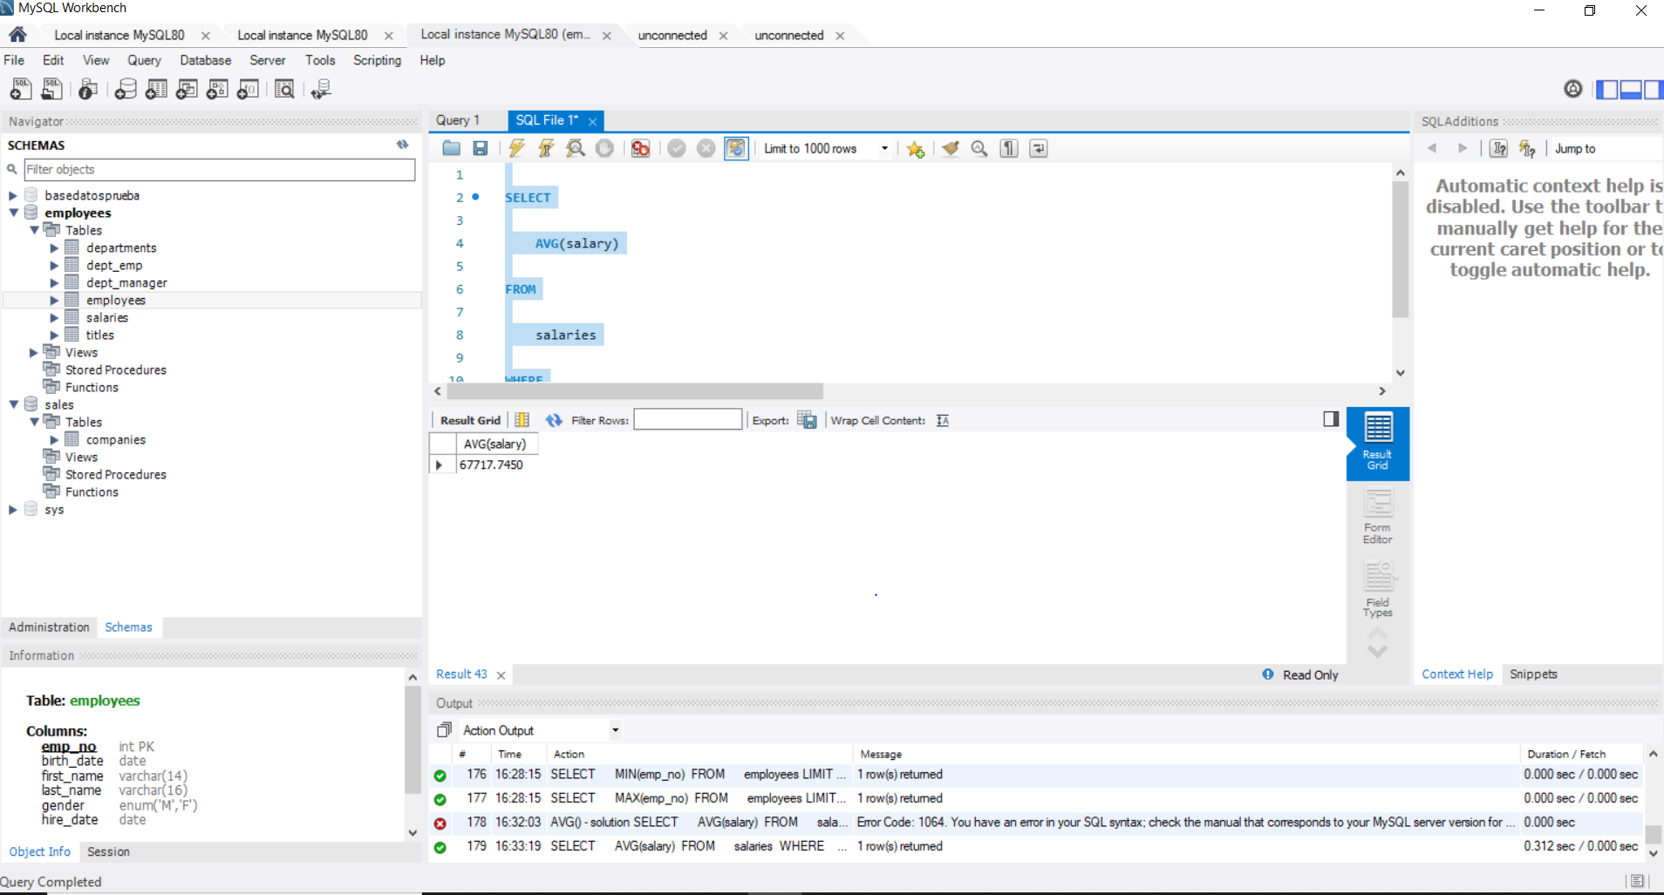

**158. ROUND() – solution**

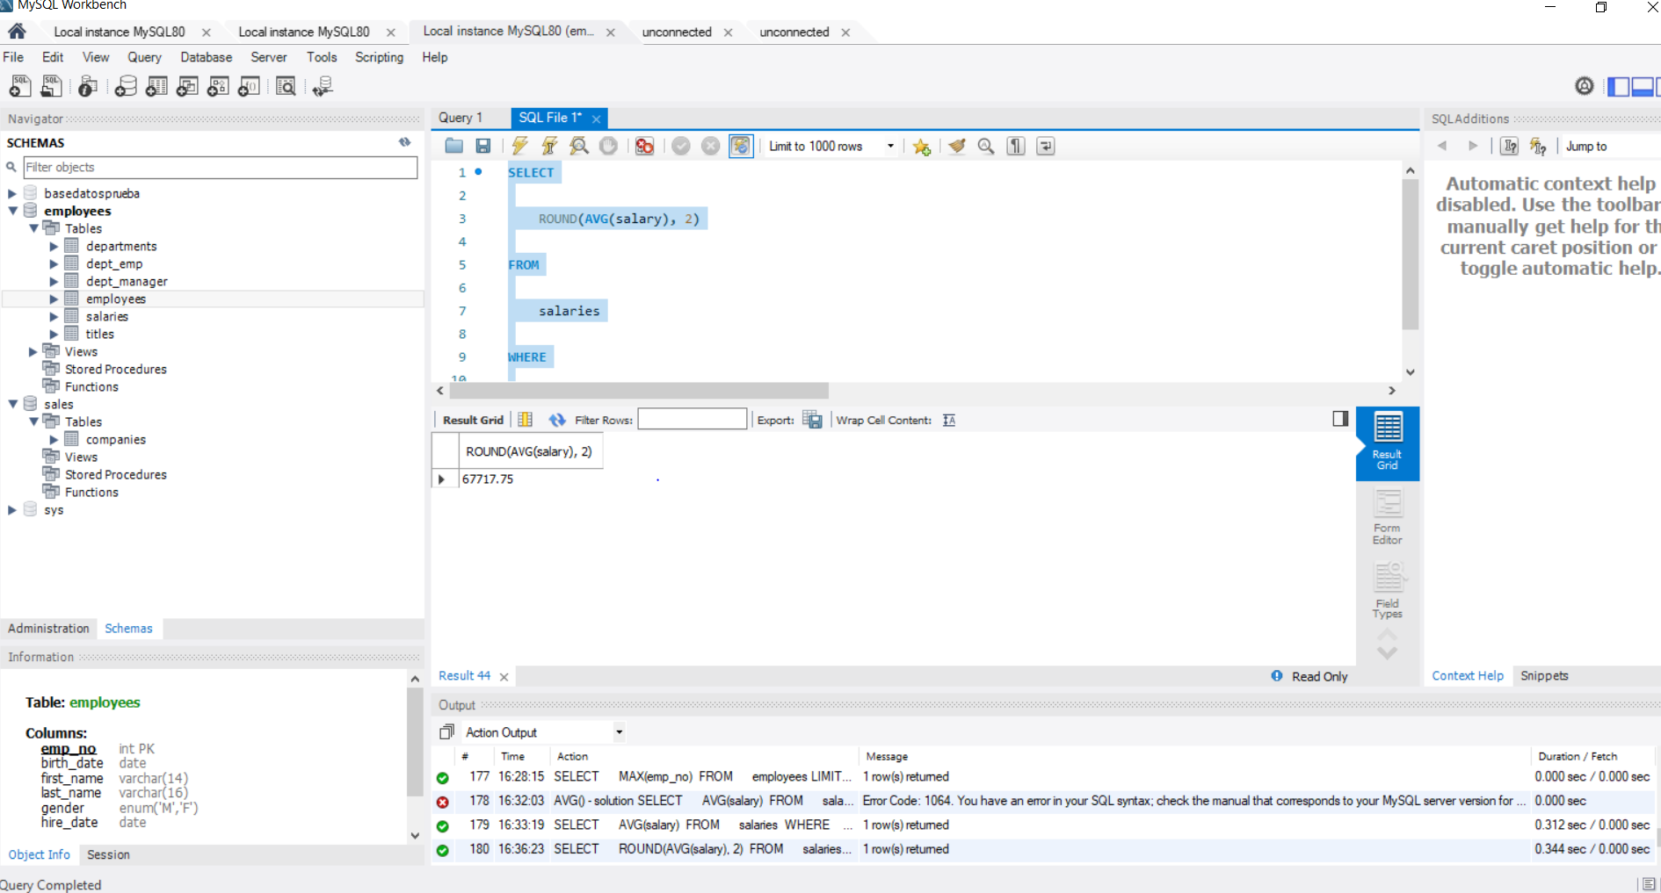

**163. Another example of using COALESCE() - solution 1**

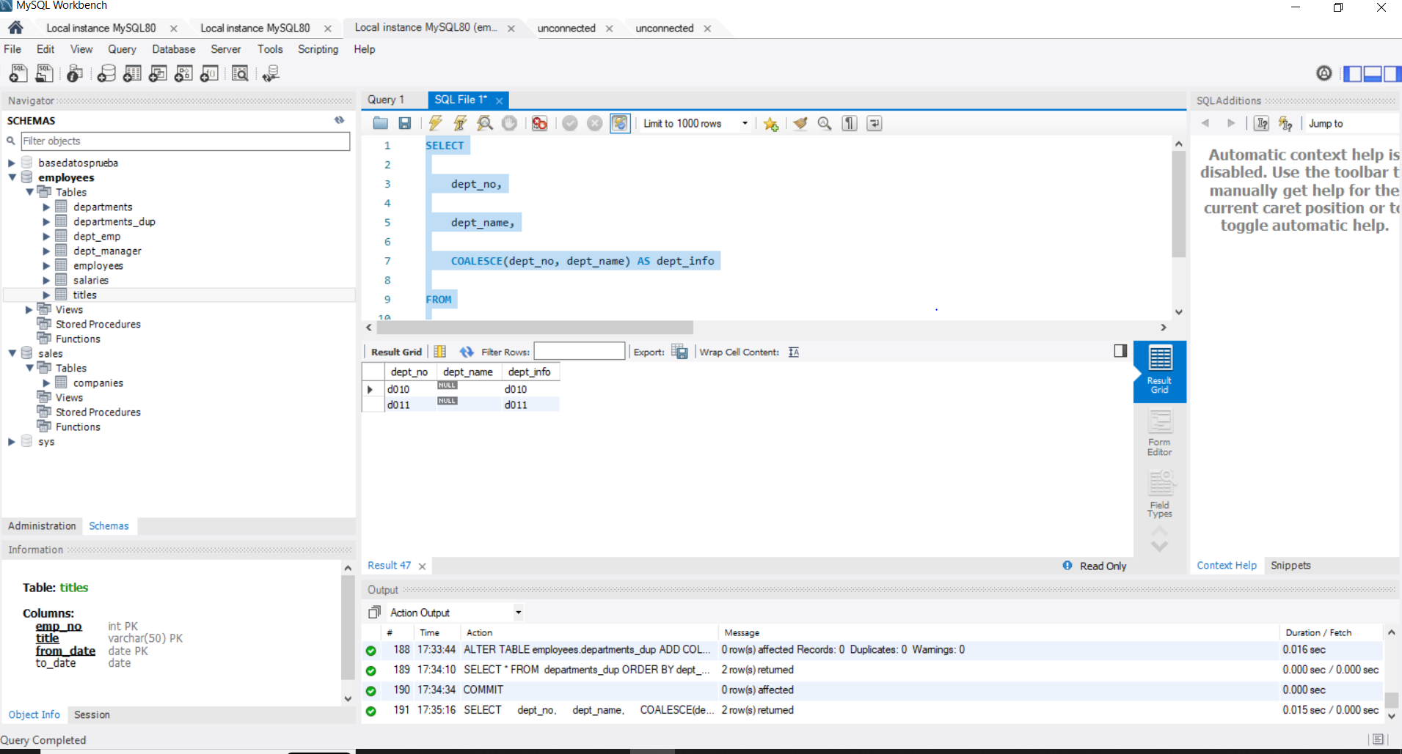

**165. Another example of using COALESCE() - solution 2**

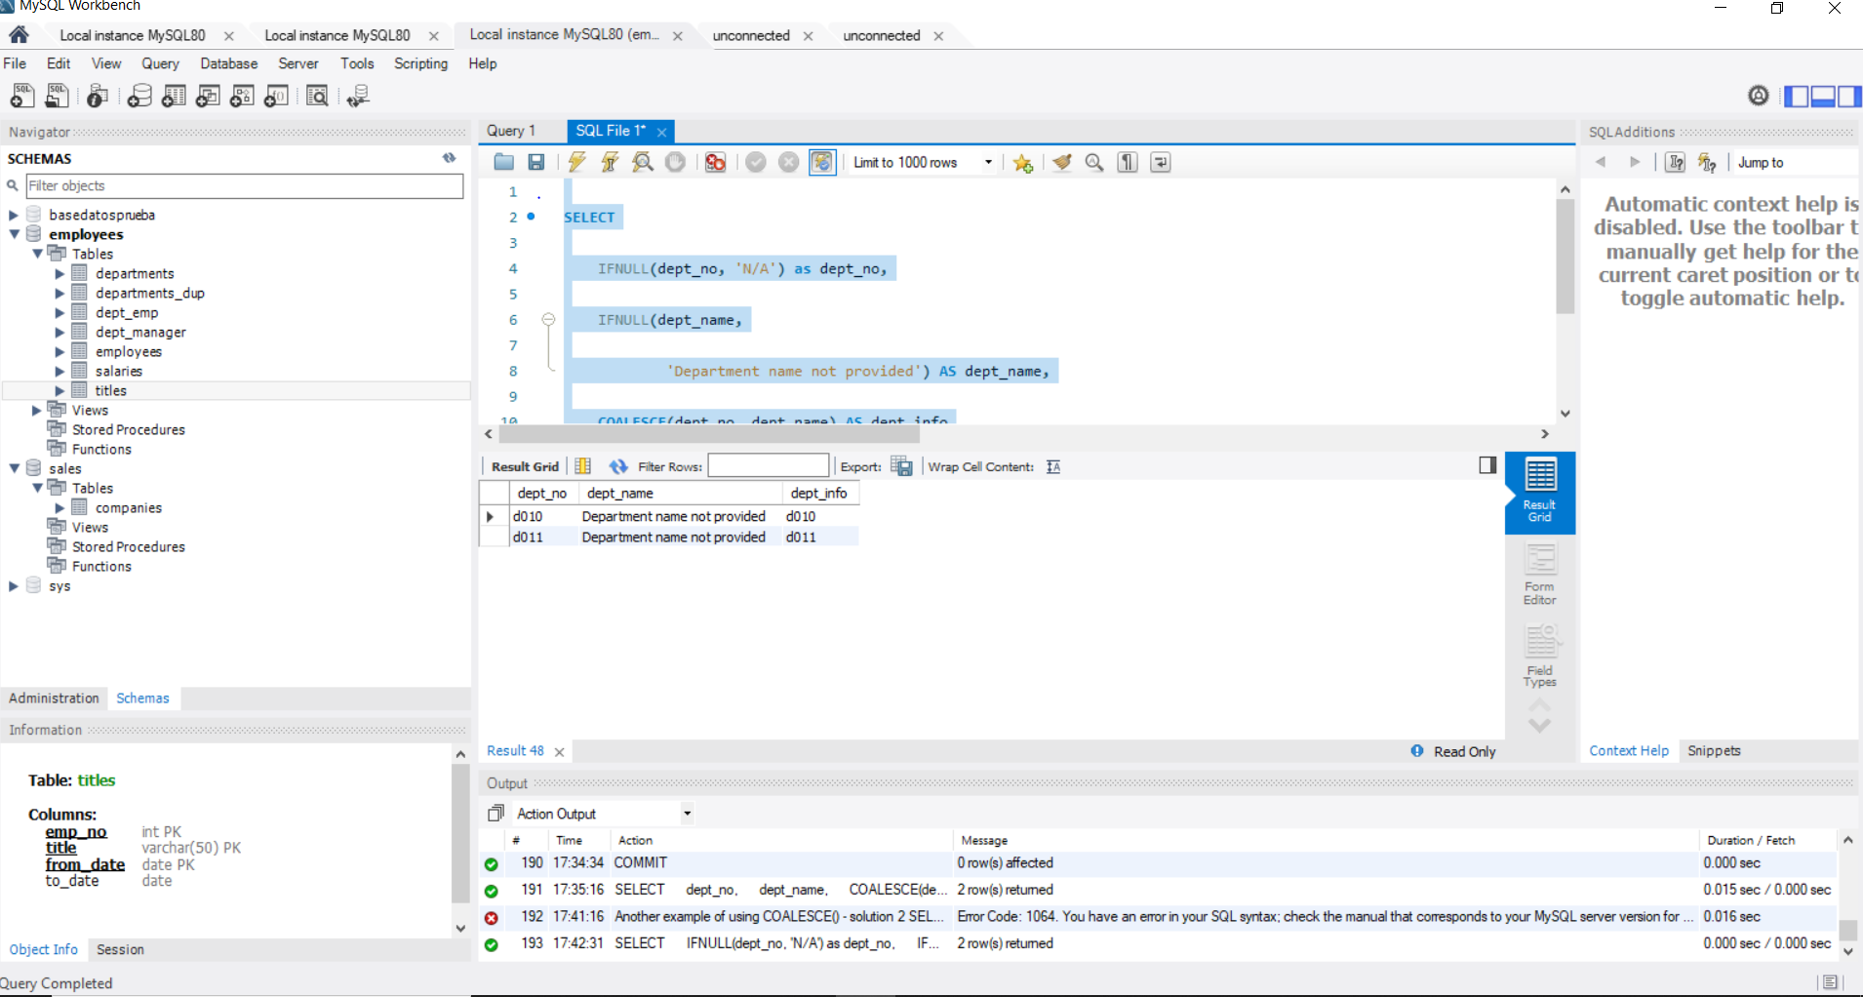

**173. INNER JOIN - Part II – solution**

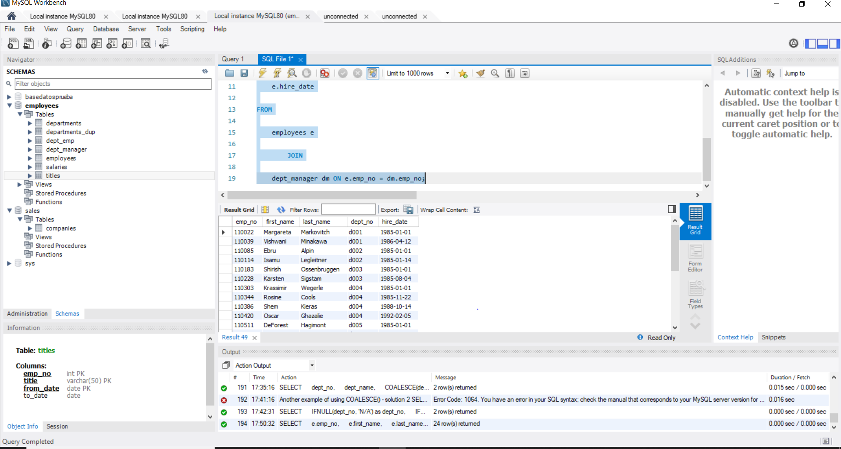

**179.LEFT JOIN - Part II – solution**

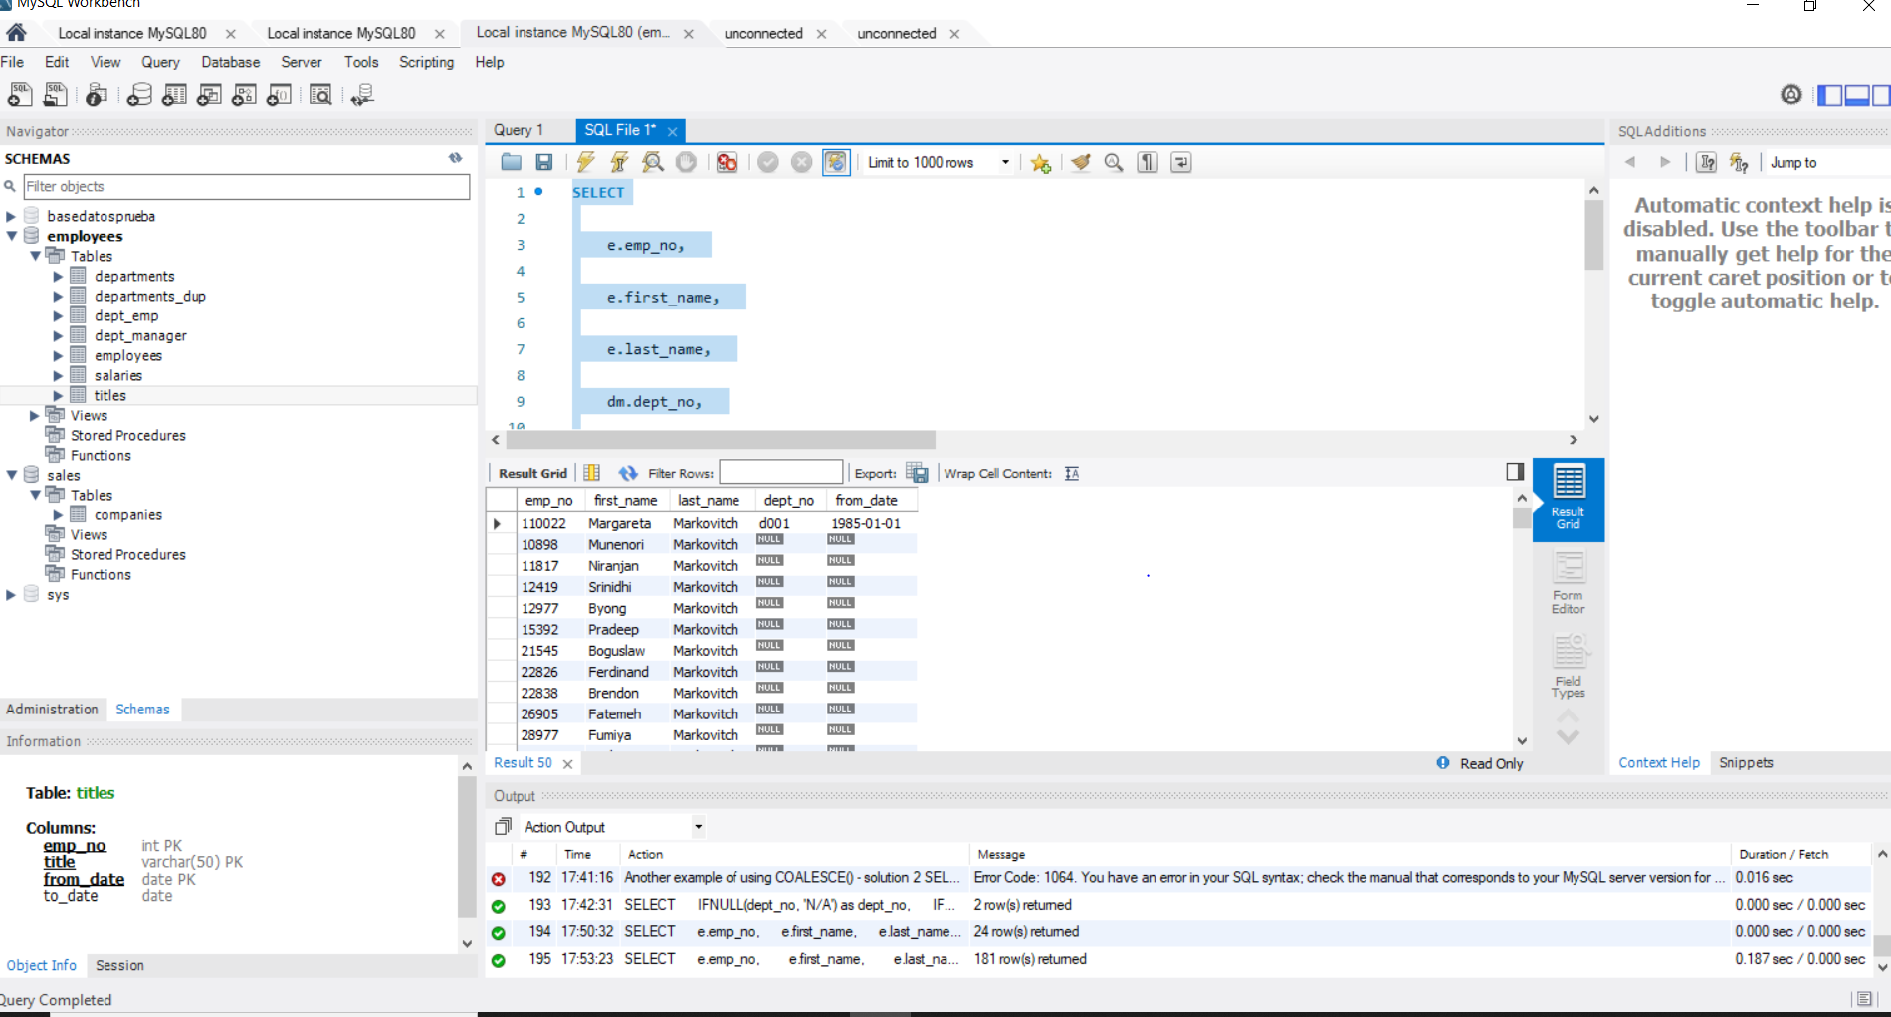

**183.The new and the old join syntax – solution**

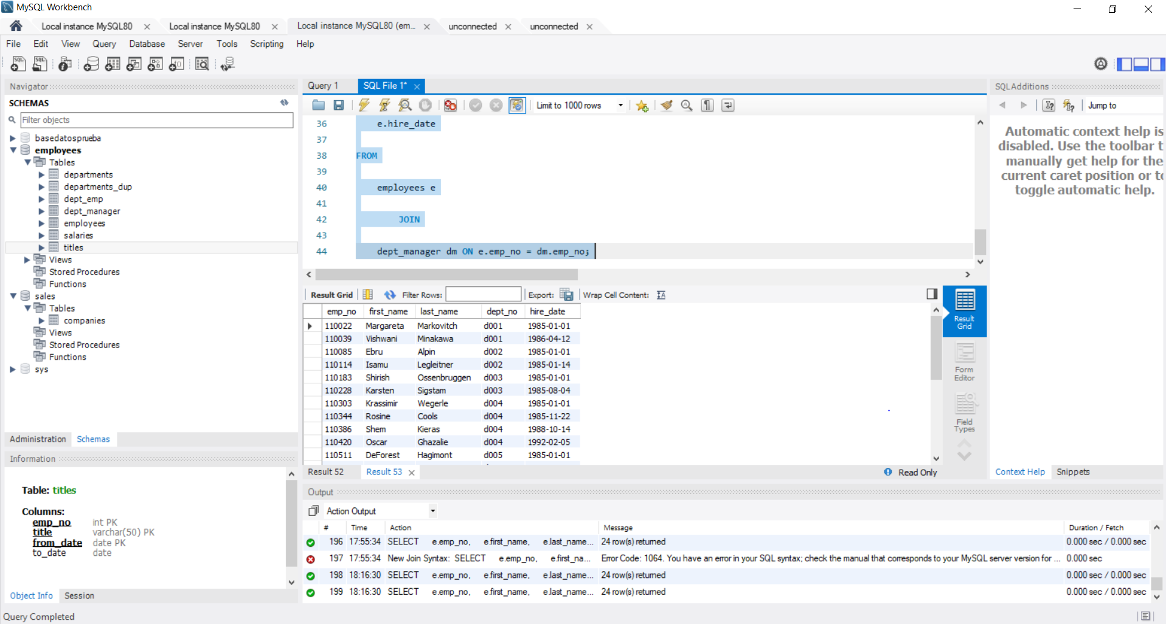

**187. JOIN and WHERE Used Together – solution**

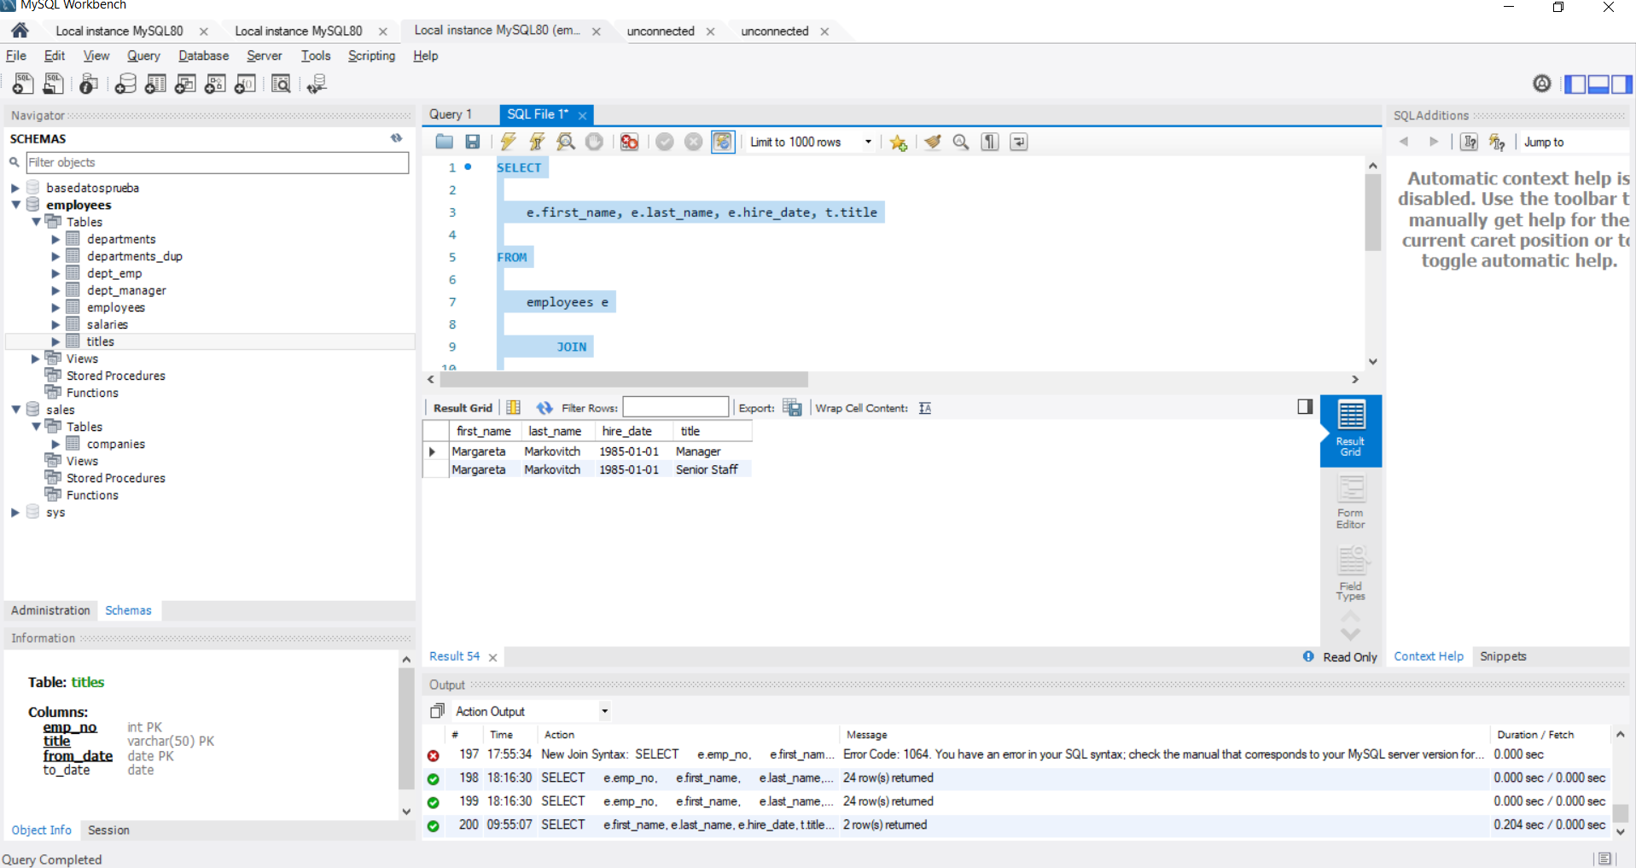

**190. CROSS JOIN - solution 1**

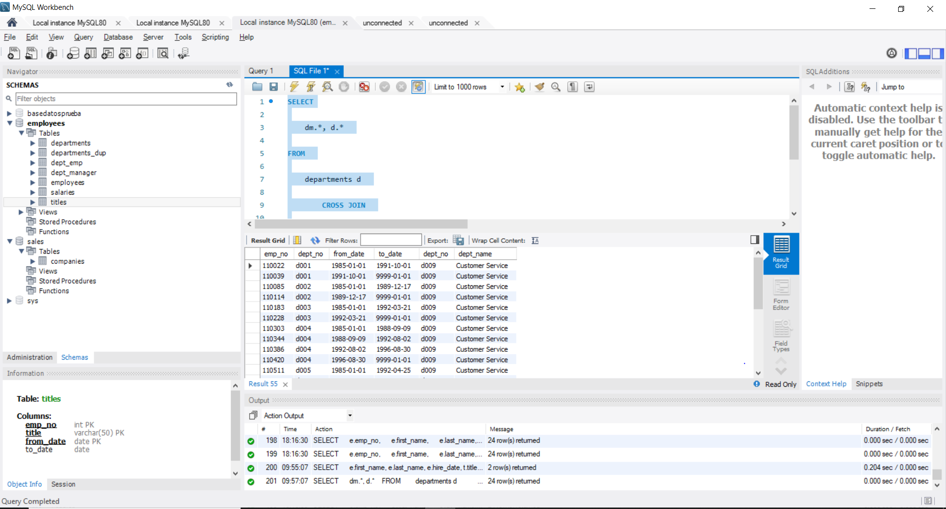

**192. CROSS JOIN - solution 2**

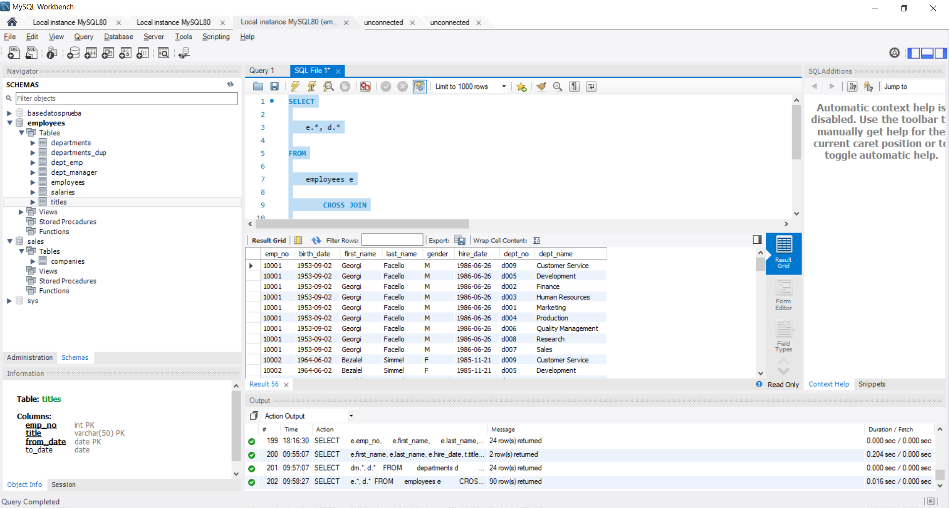

**196. Join more than two tables in SQL – solution**

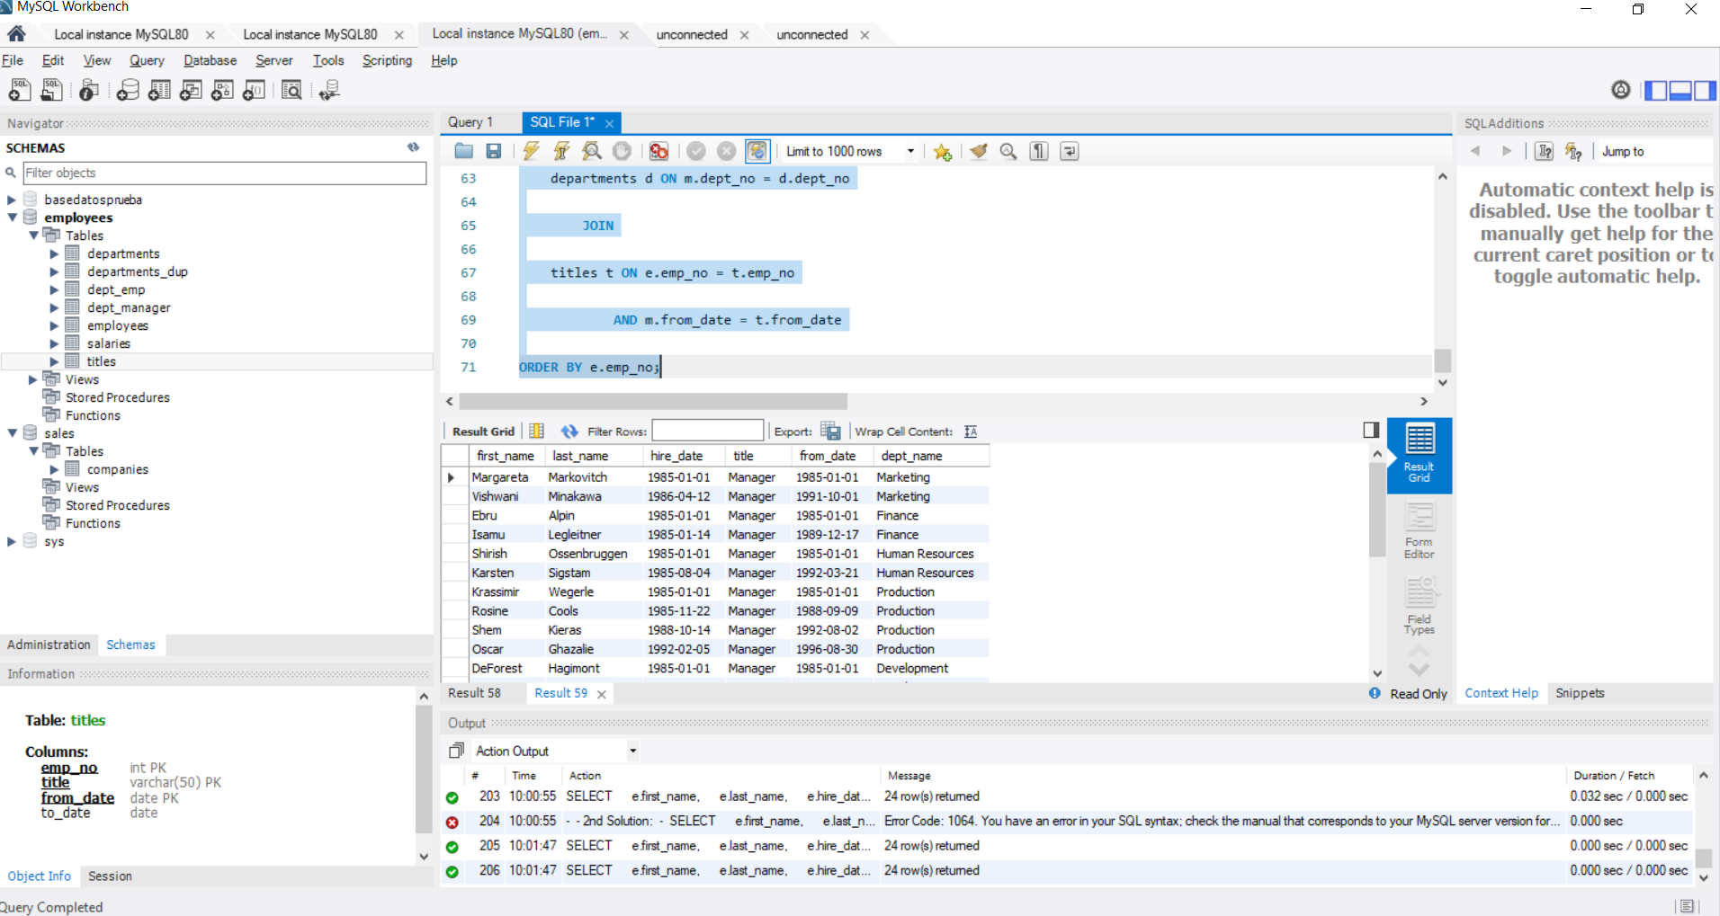

**199.Tips and tricks for joins – solution**

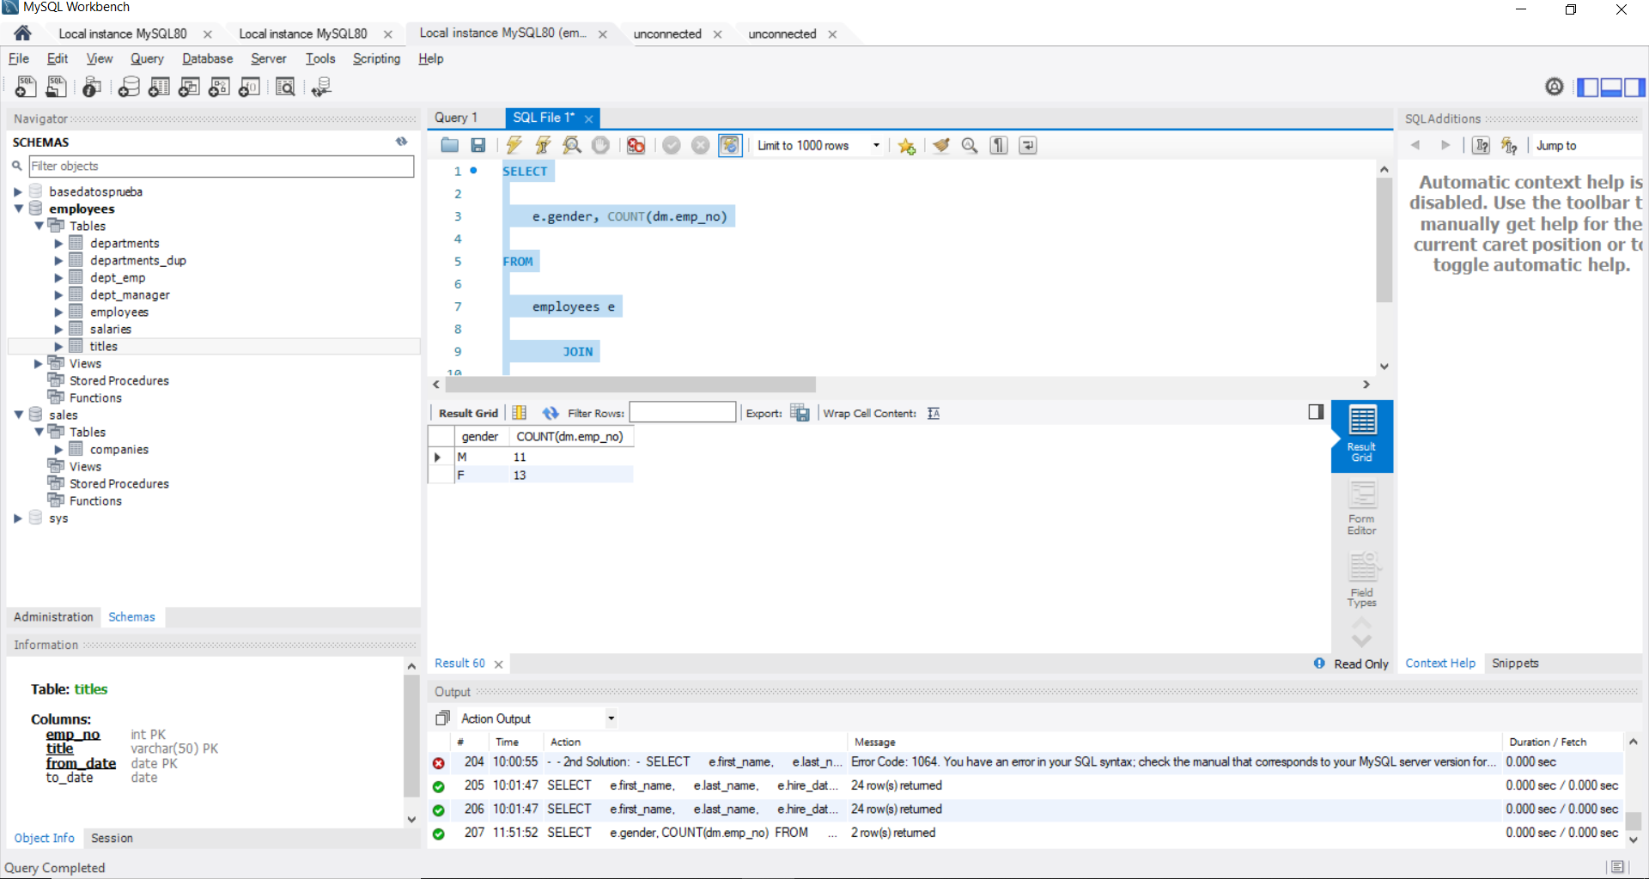

**202. UNION vs UNION ALL – solution**

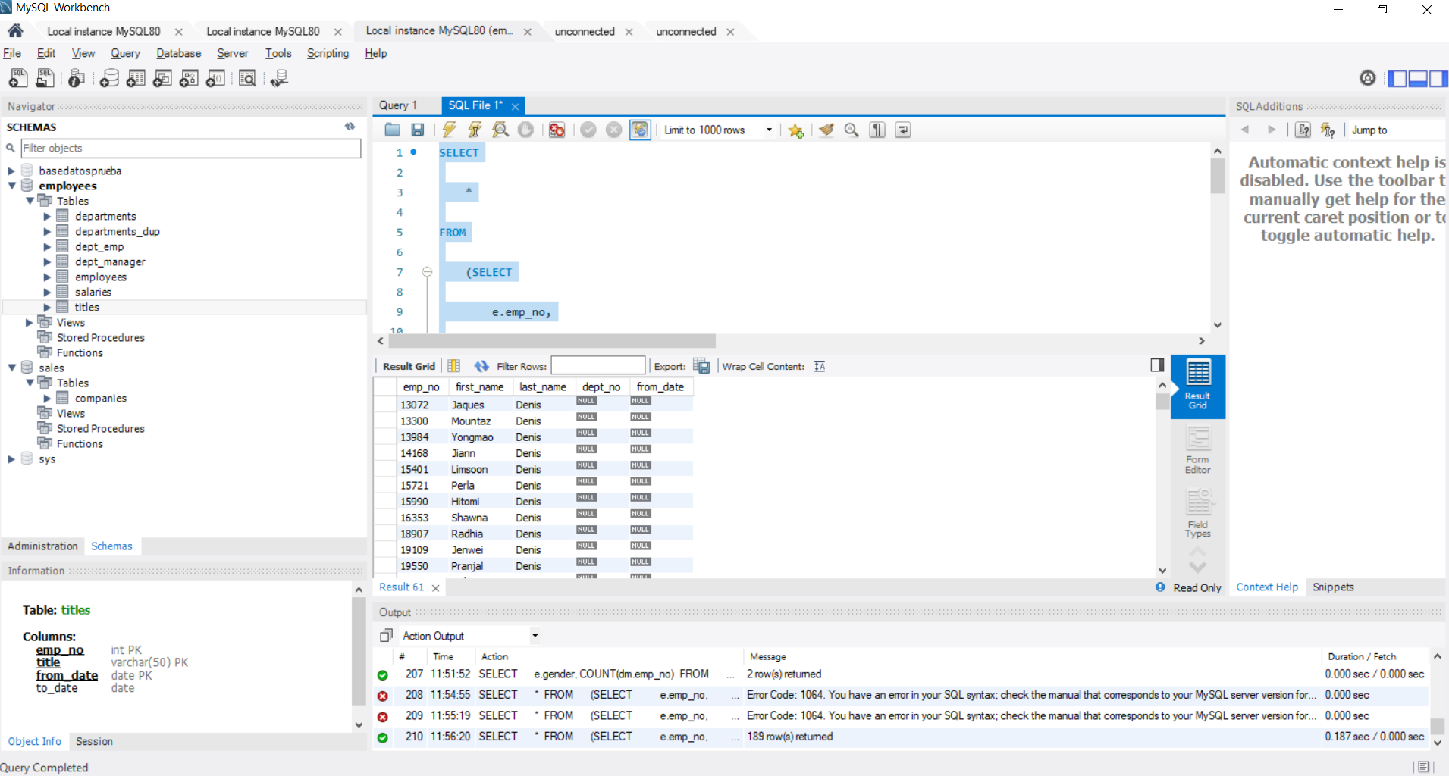

**205. SQL Subqueries with IN nested inside WHERE – solution**

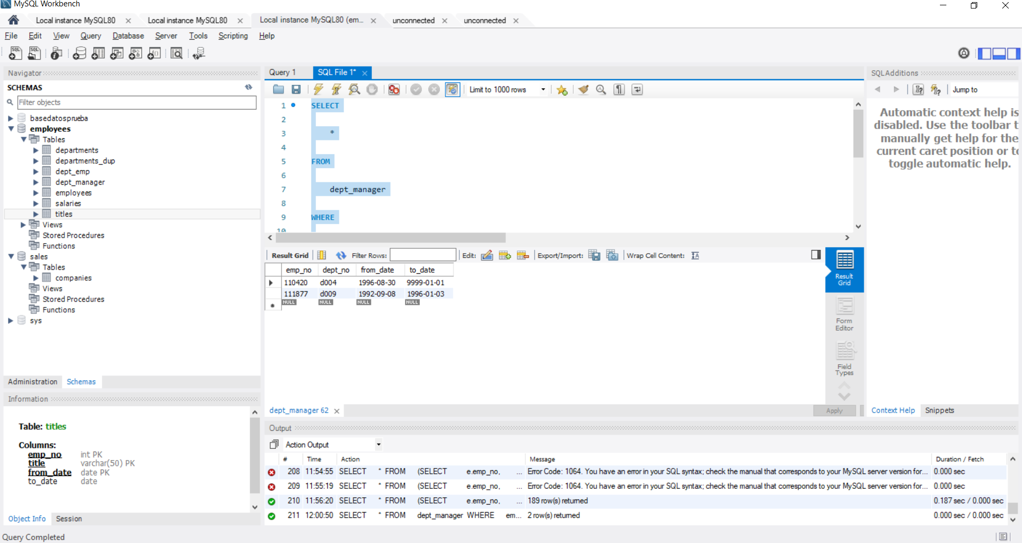

**208. SQL Subqueries with EXISTS-NOT EXISTS nested inside WHERE – solution**

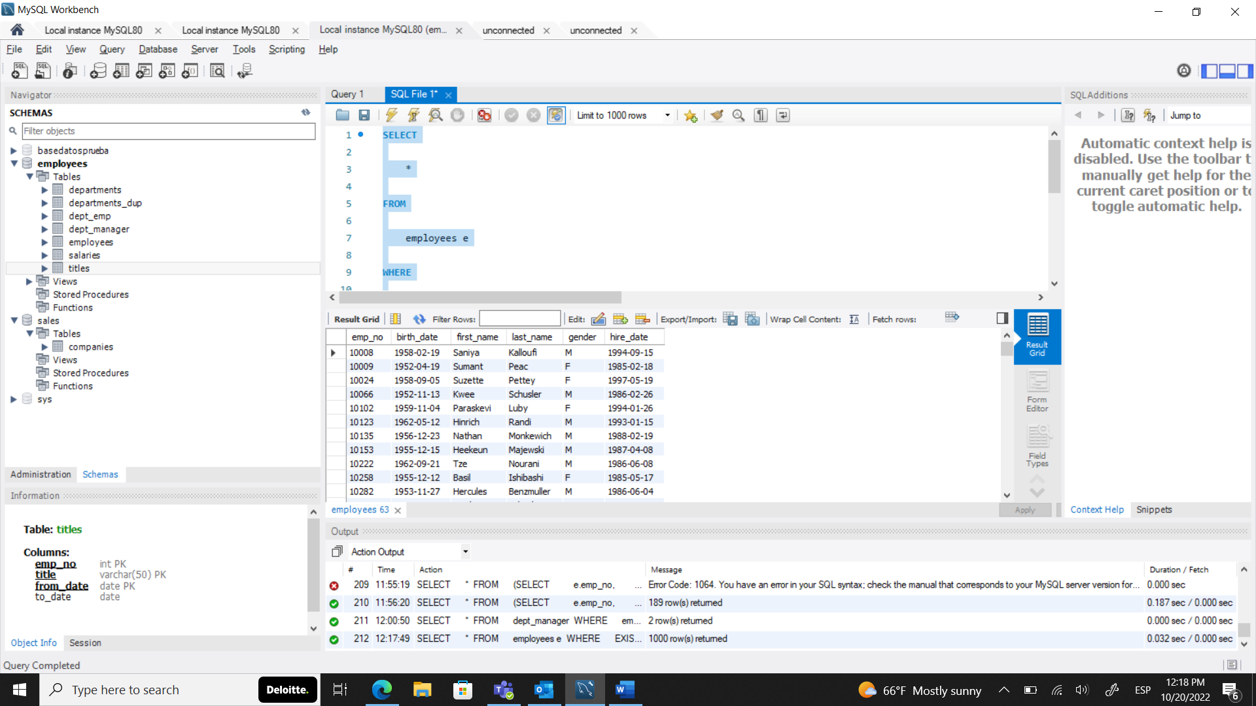

**211. SQL Subqueries nested in SELECT and FROM - solution 1**

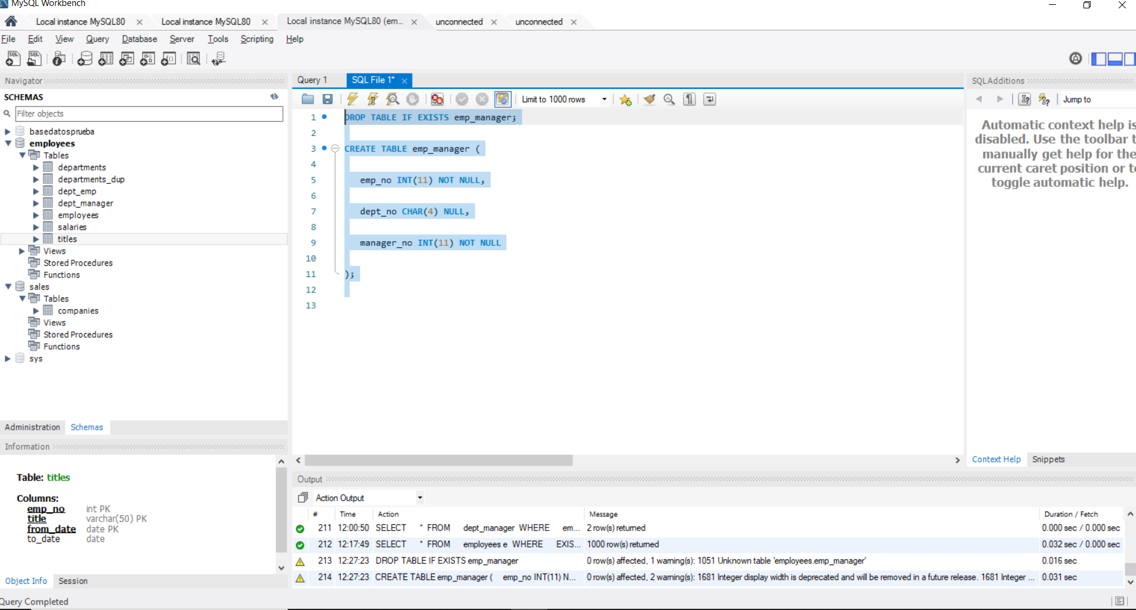

**217. Views – solution**

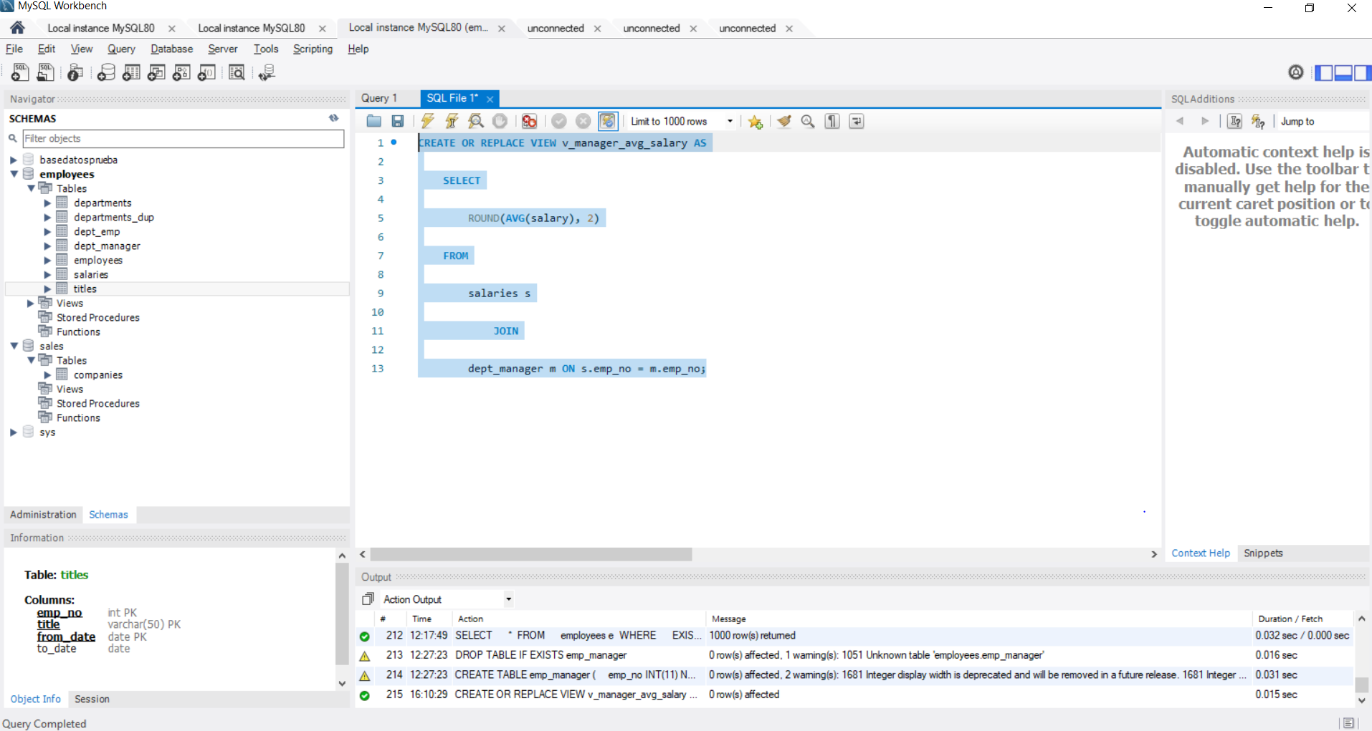

**223. Stored procedures - Example - Part II – solution**

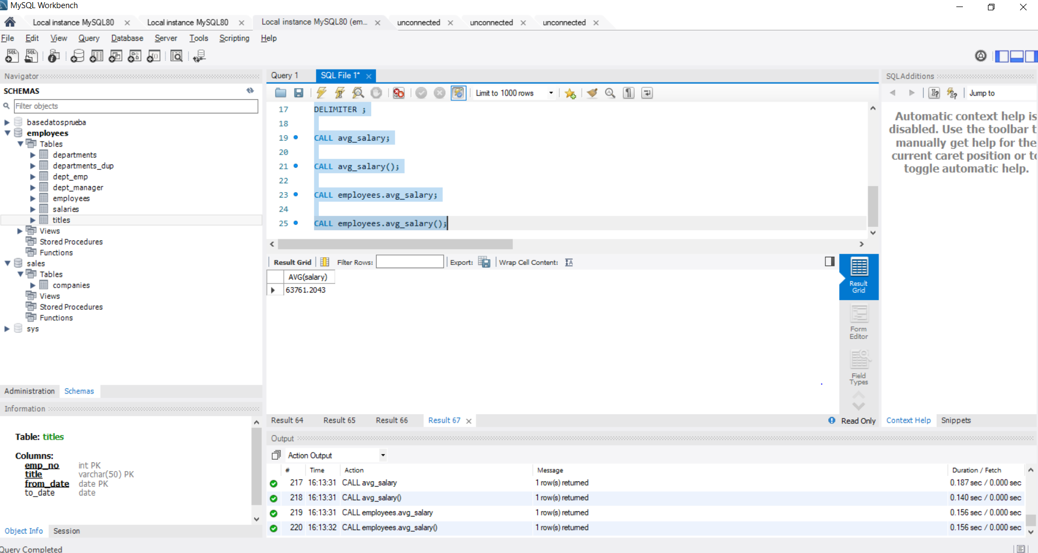

**228.Stored procedures with an output parameter – solution**

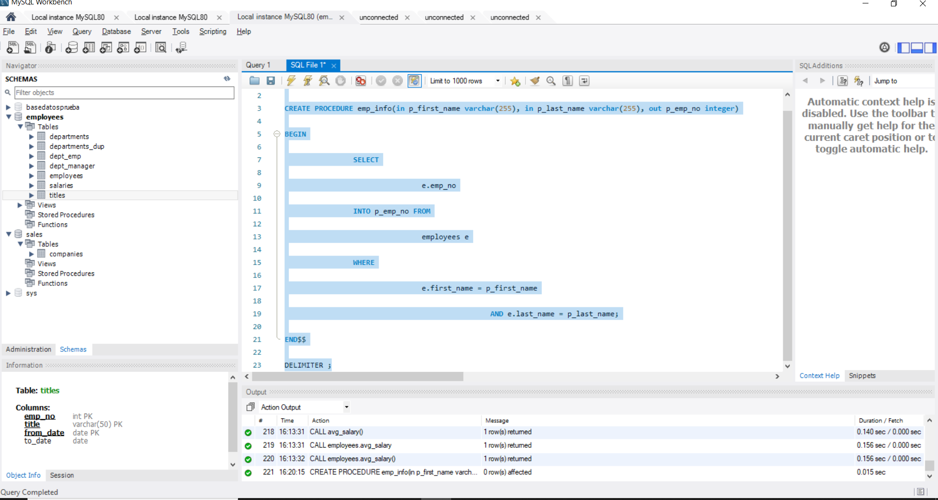

**231.Variables – solution**

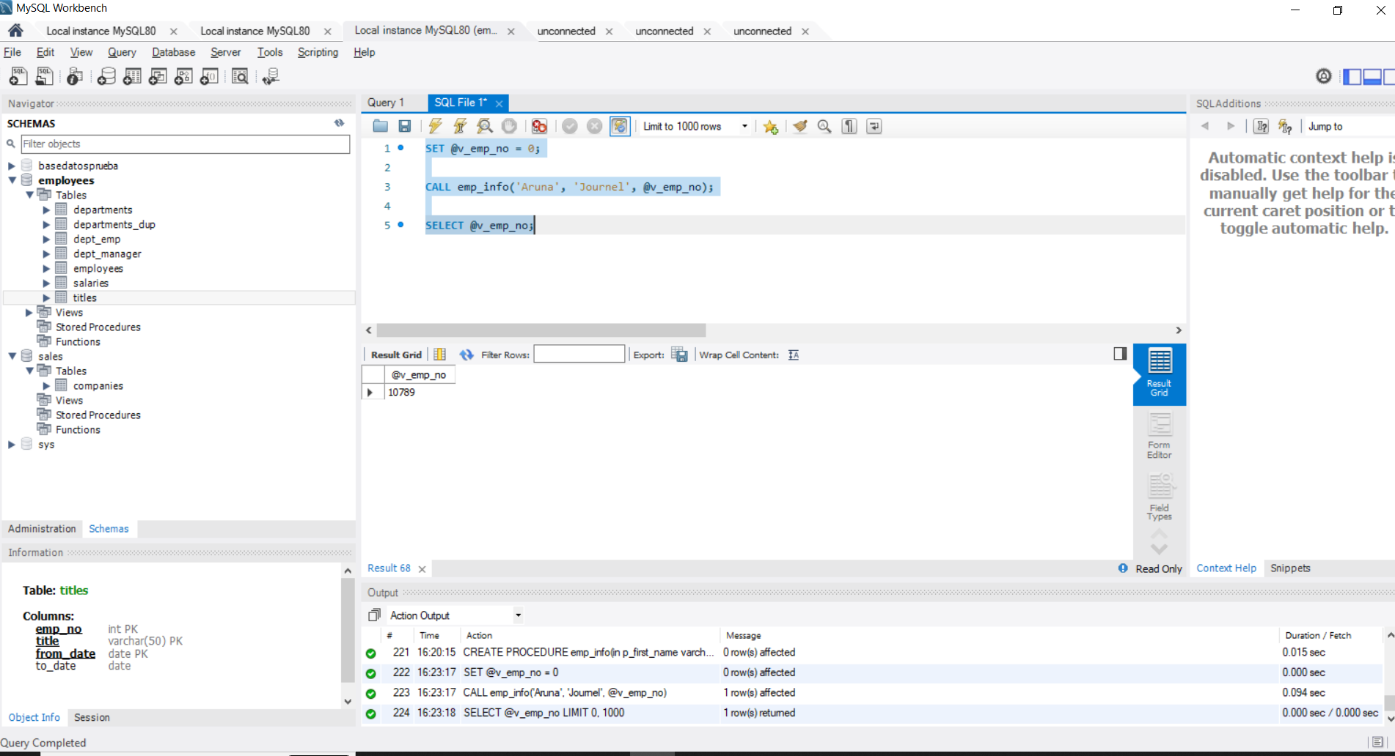

**235.User-defined functions in MySQL – solution**

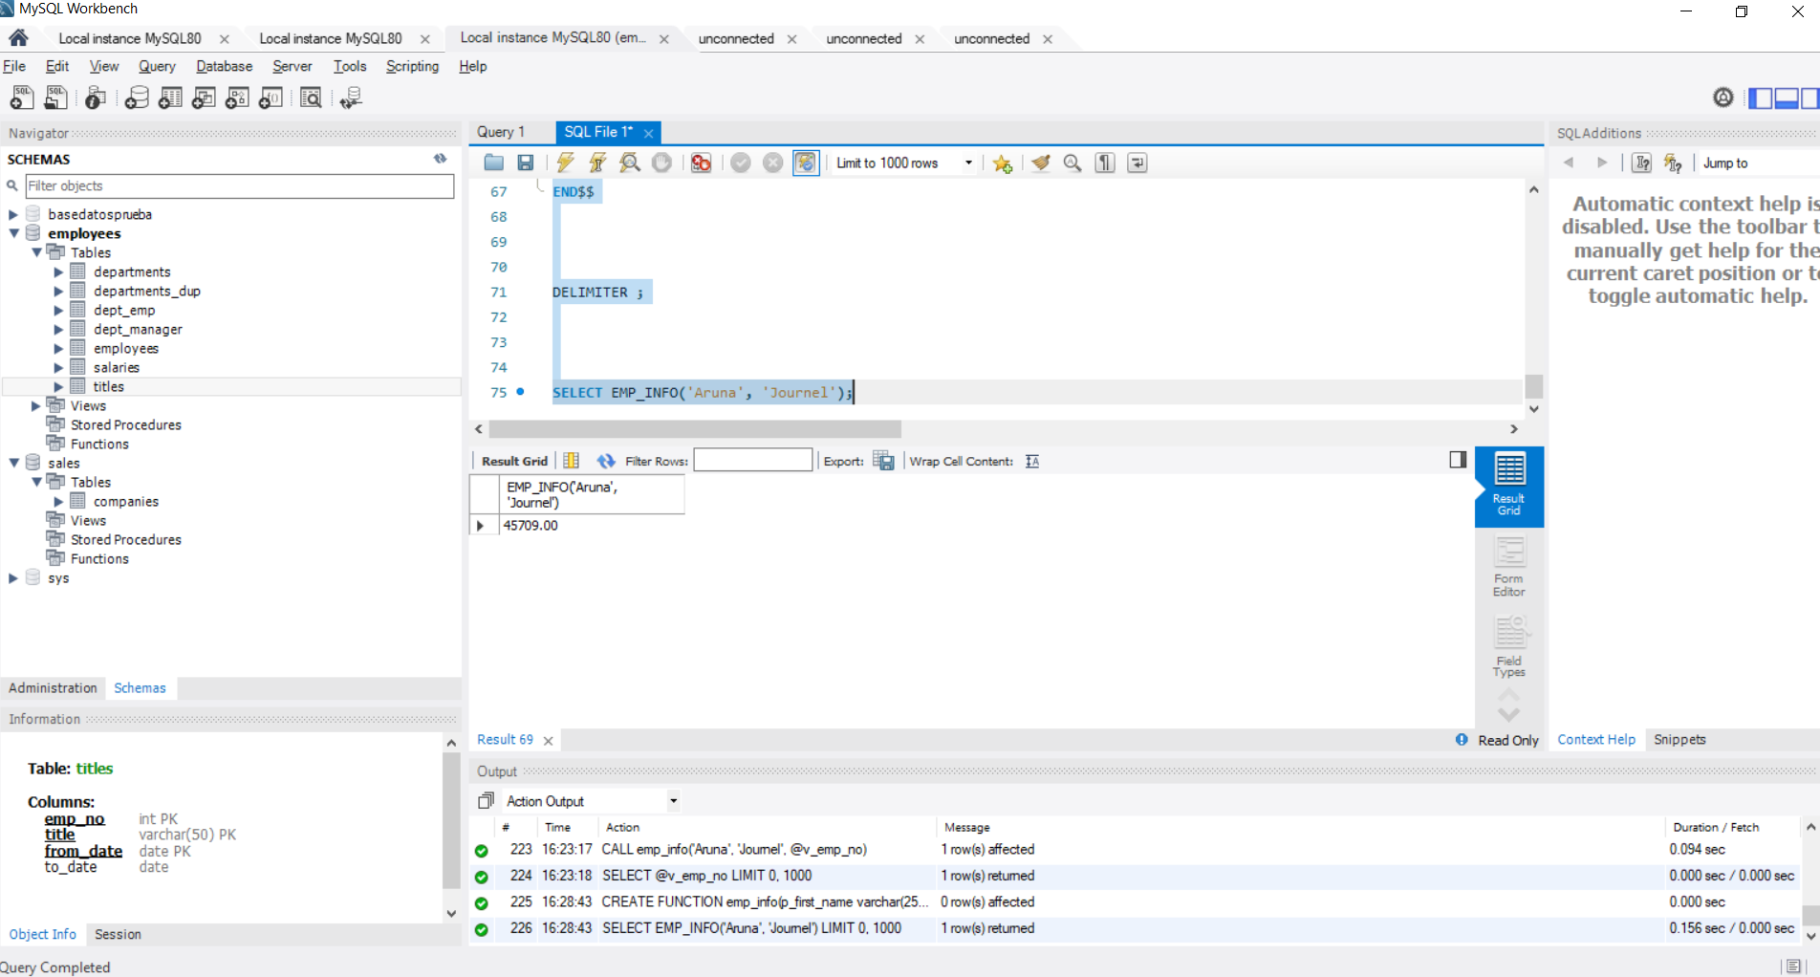

**244.MySQL Triggers – solution**

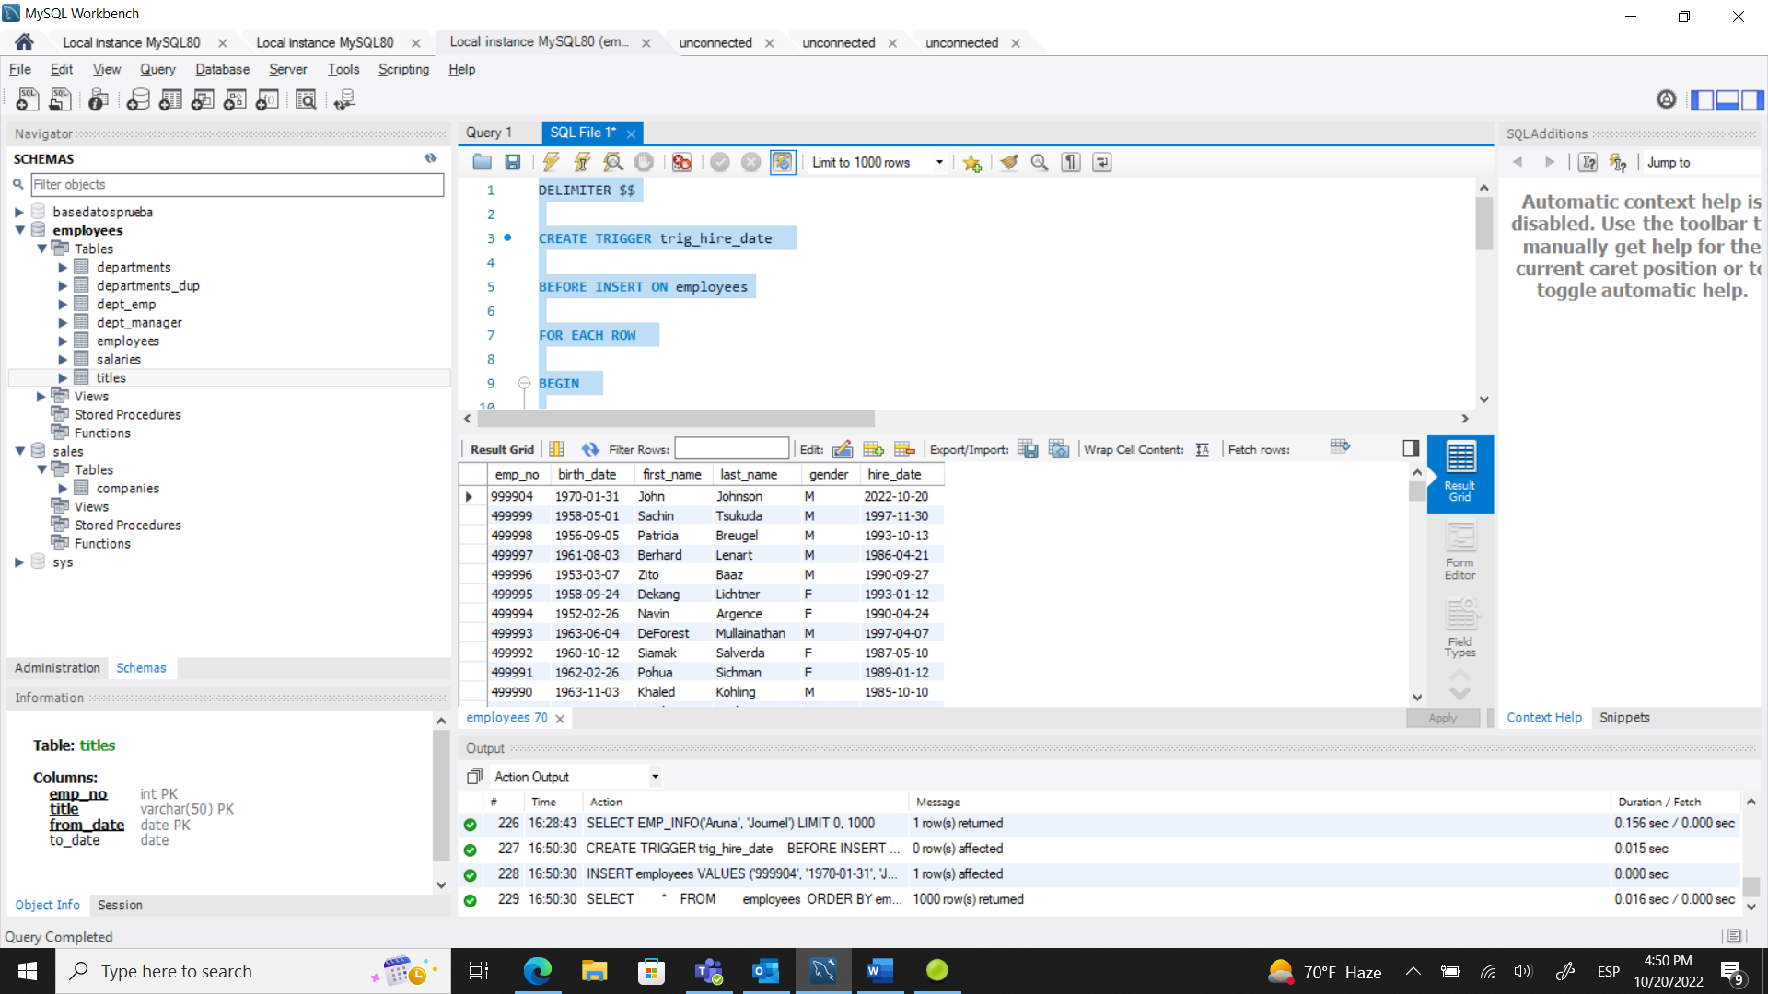

**247. MySQL Indexes - solution 1**

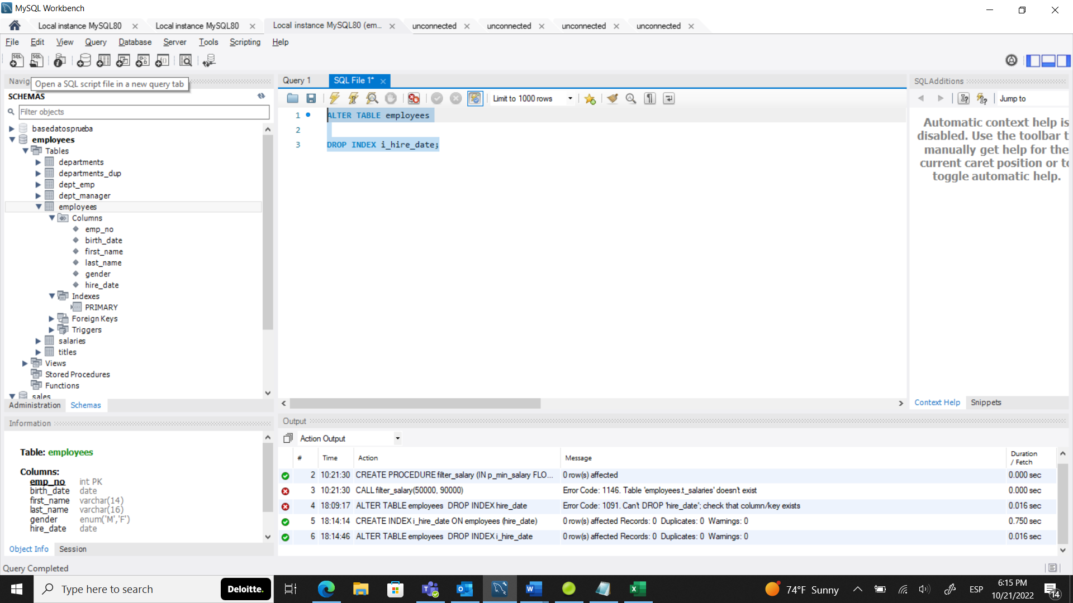

**249. MySQL Indexes - solution 2**

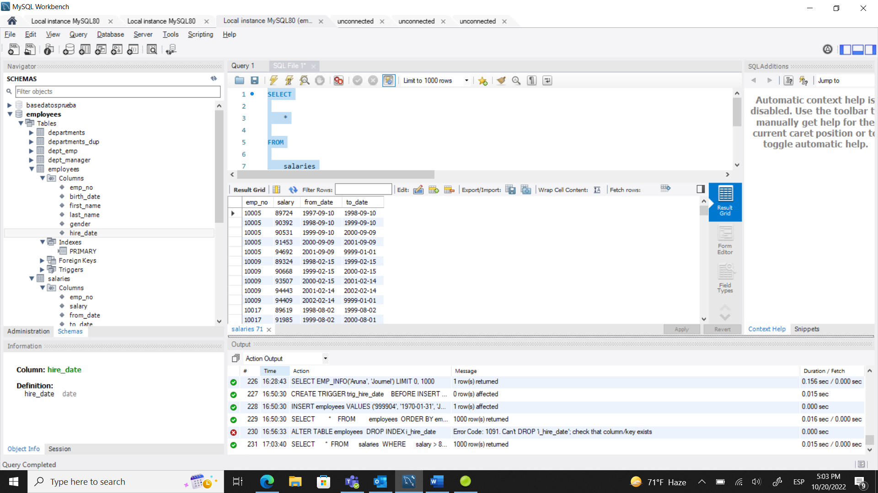

**252.The CASE Statement - solution 1**

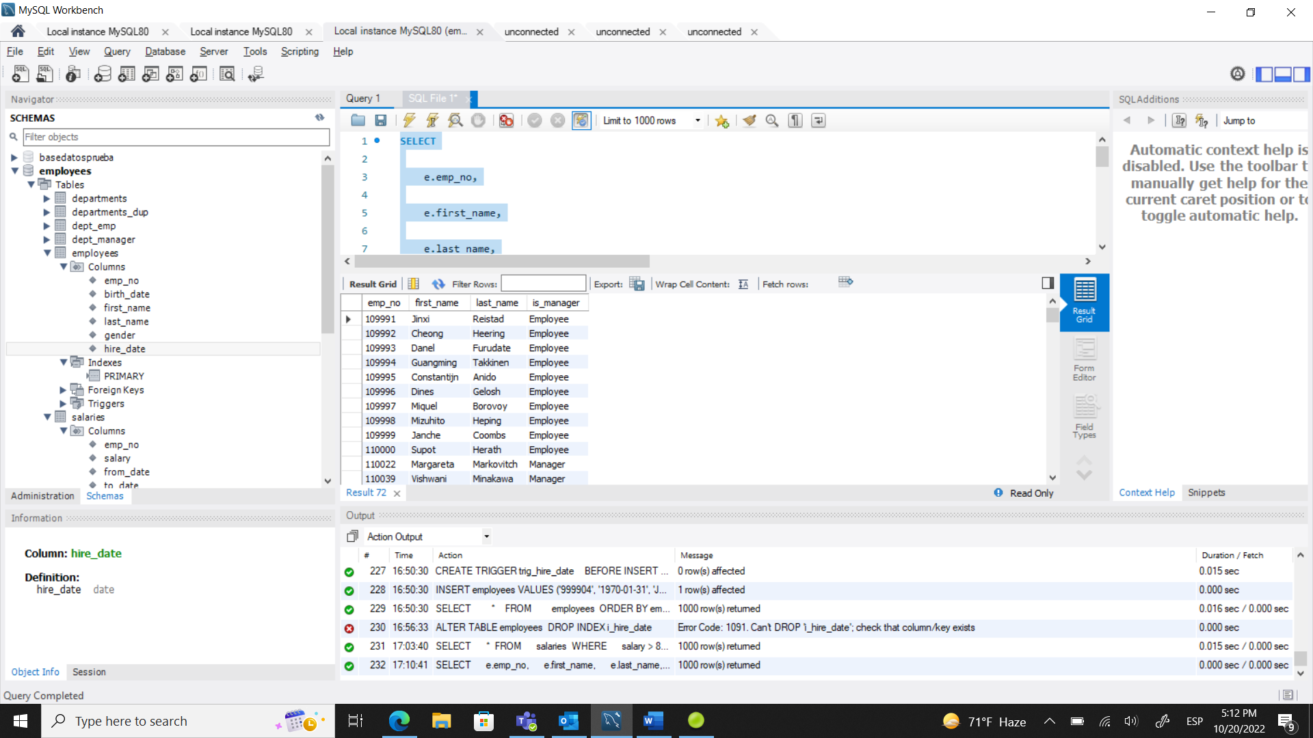

**254.The CASE Statement - solution 2**

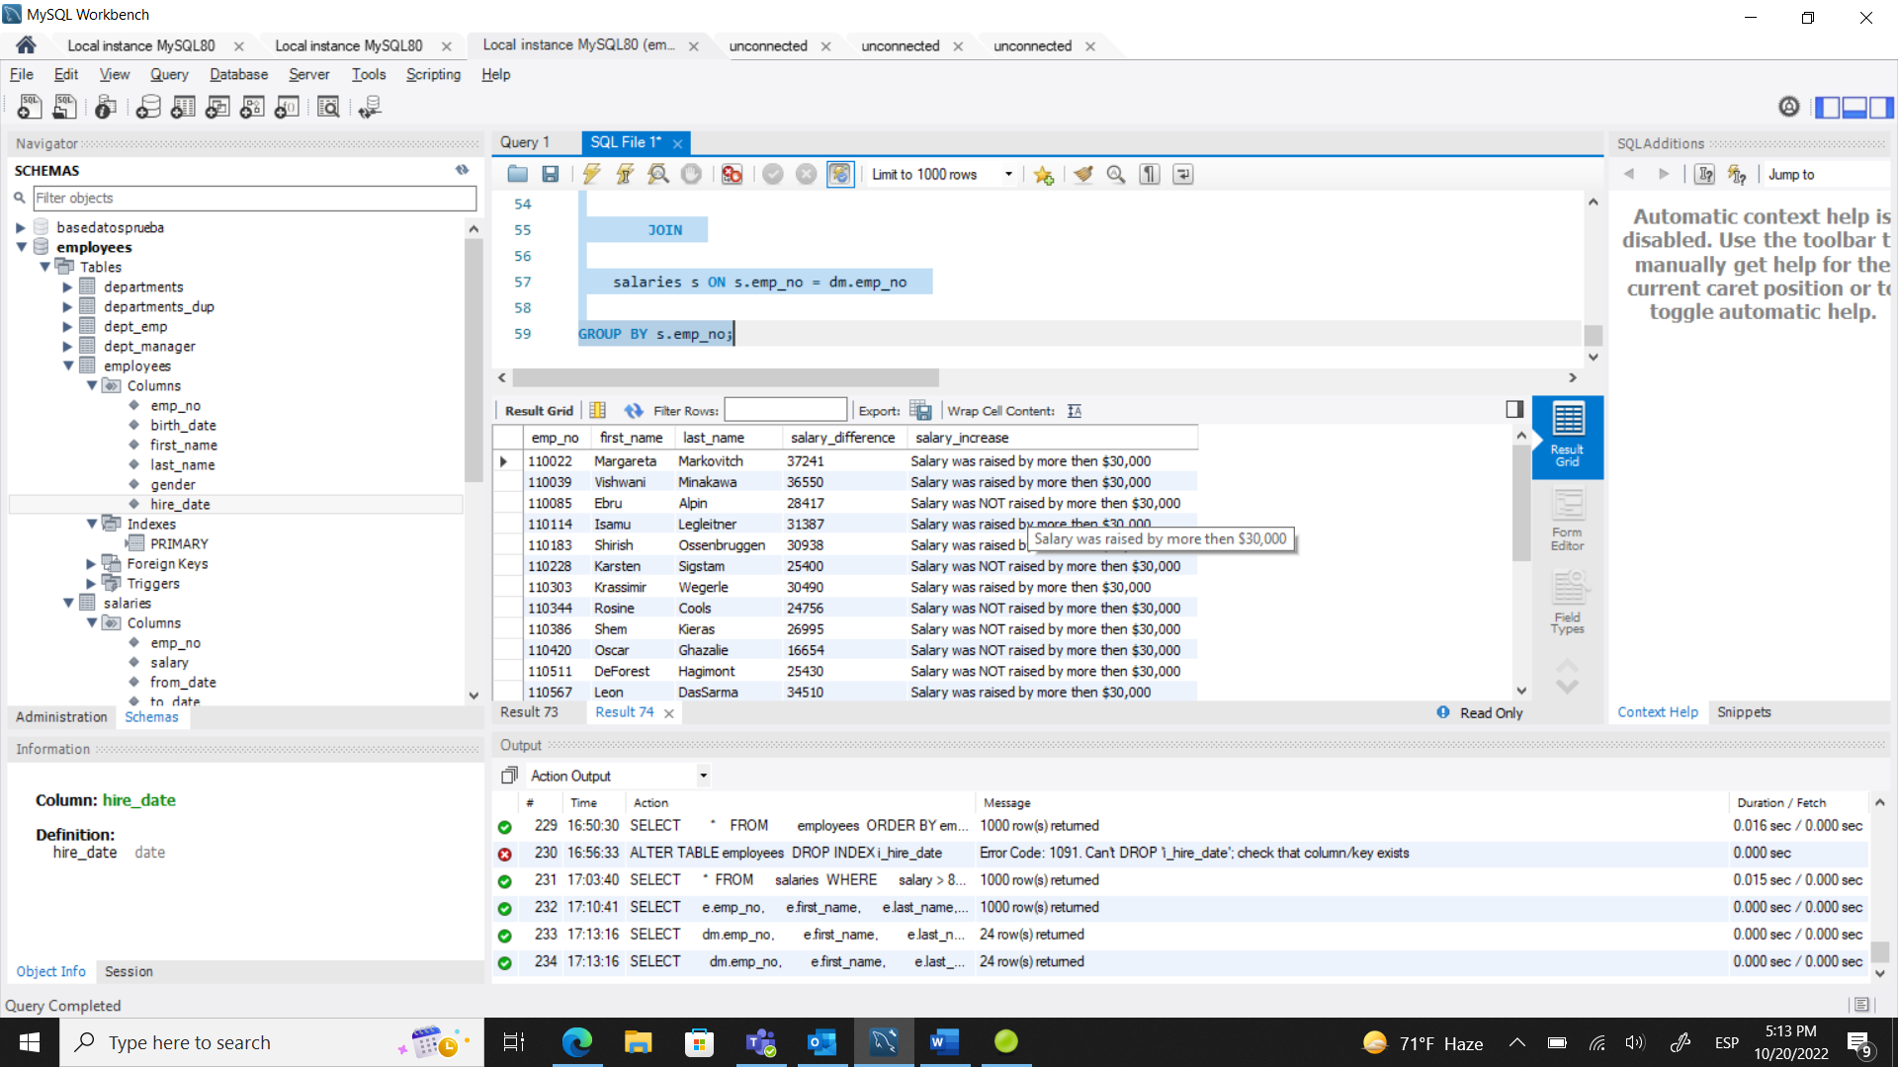

**256. The CASE Statement - solution 3**

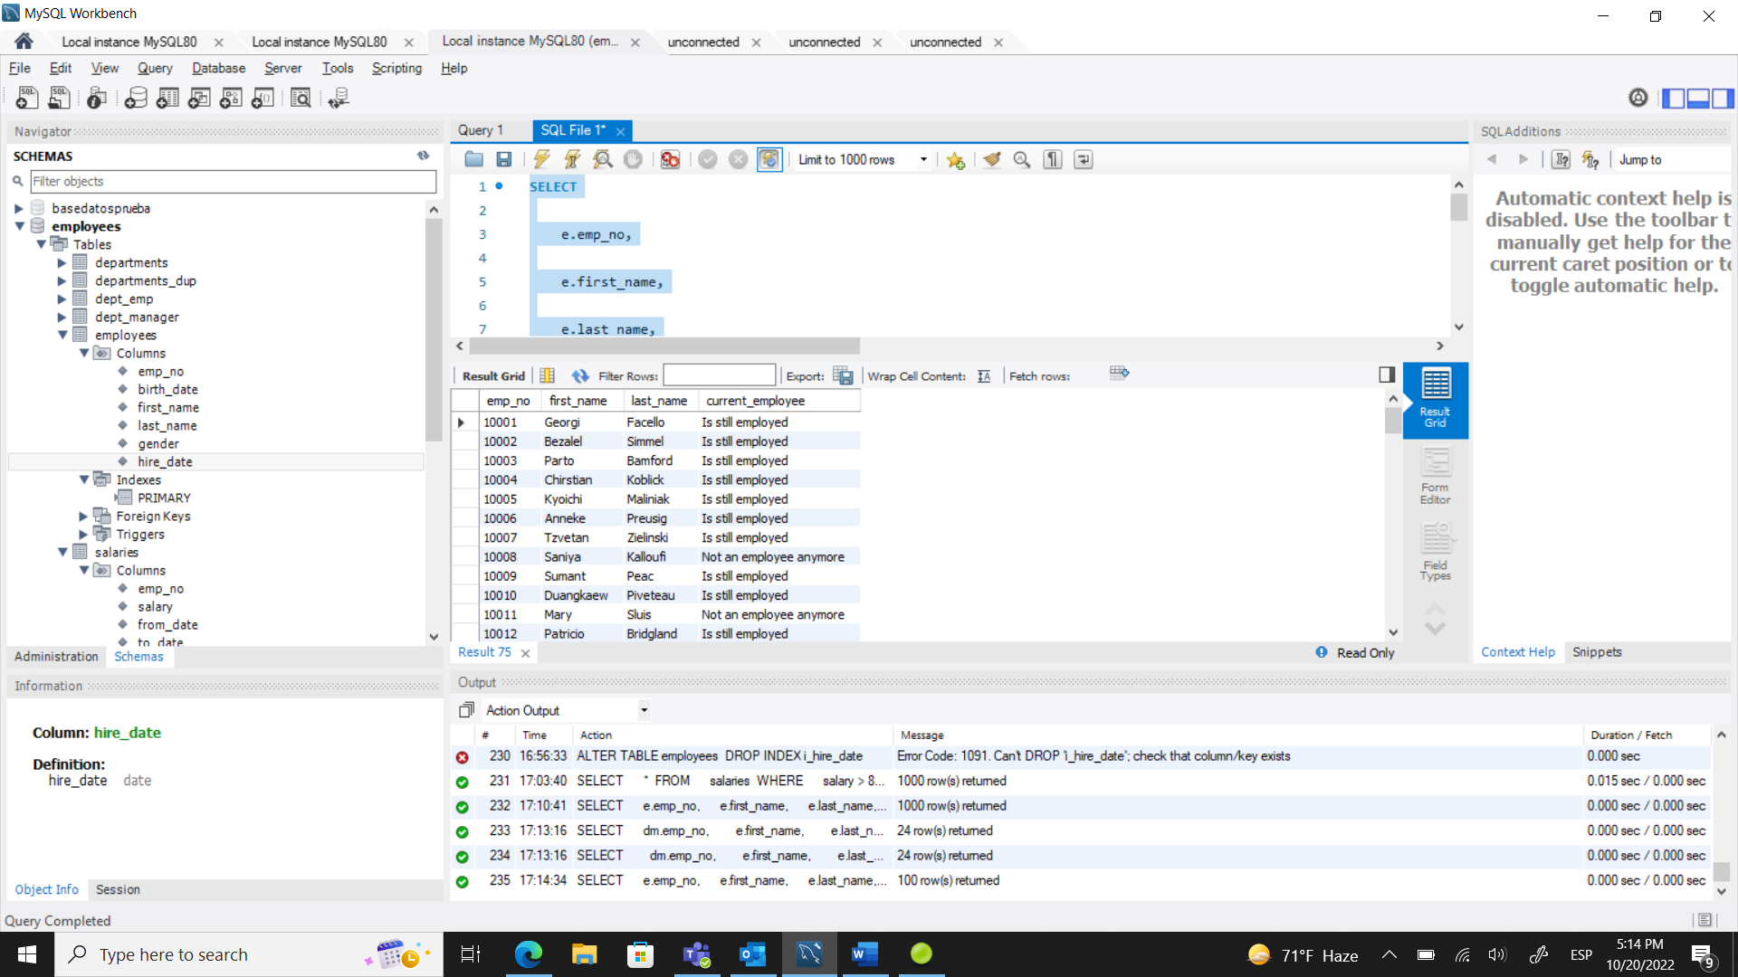

**260. The ROW_NUMBER() Ranking Window Function – Solution**

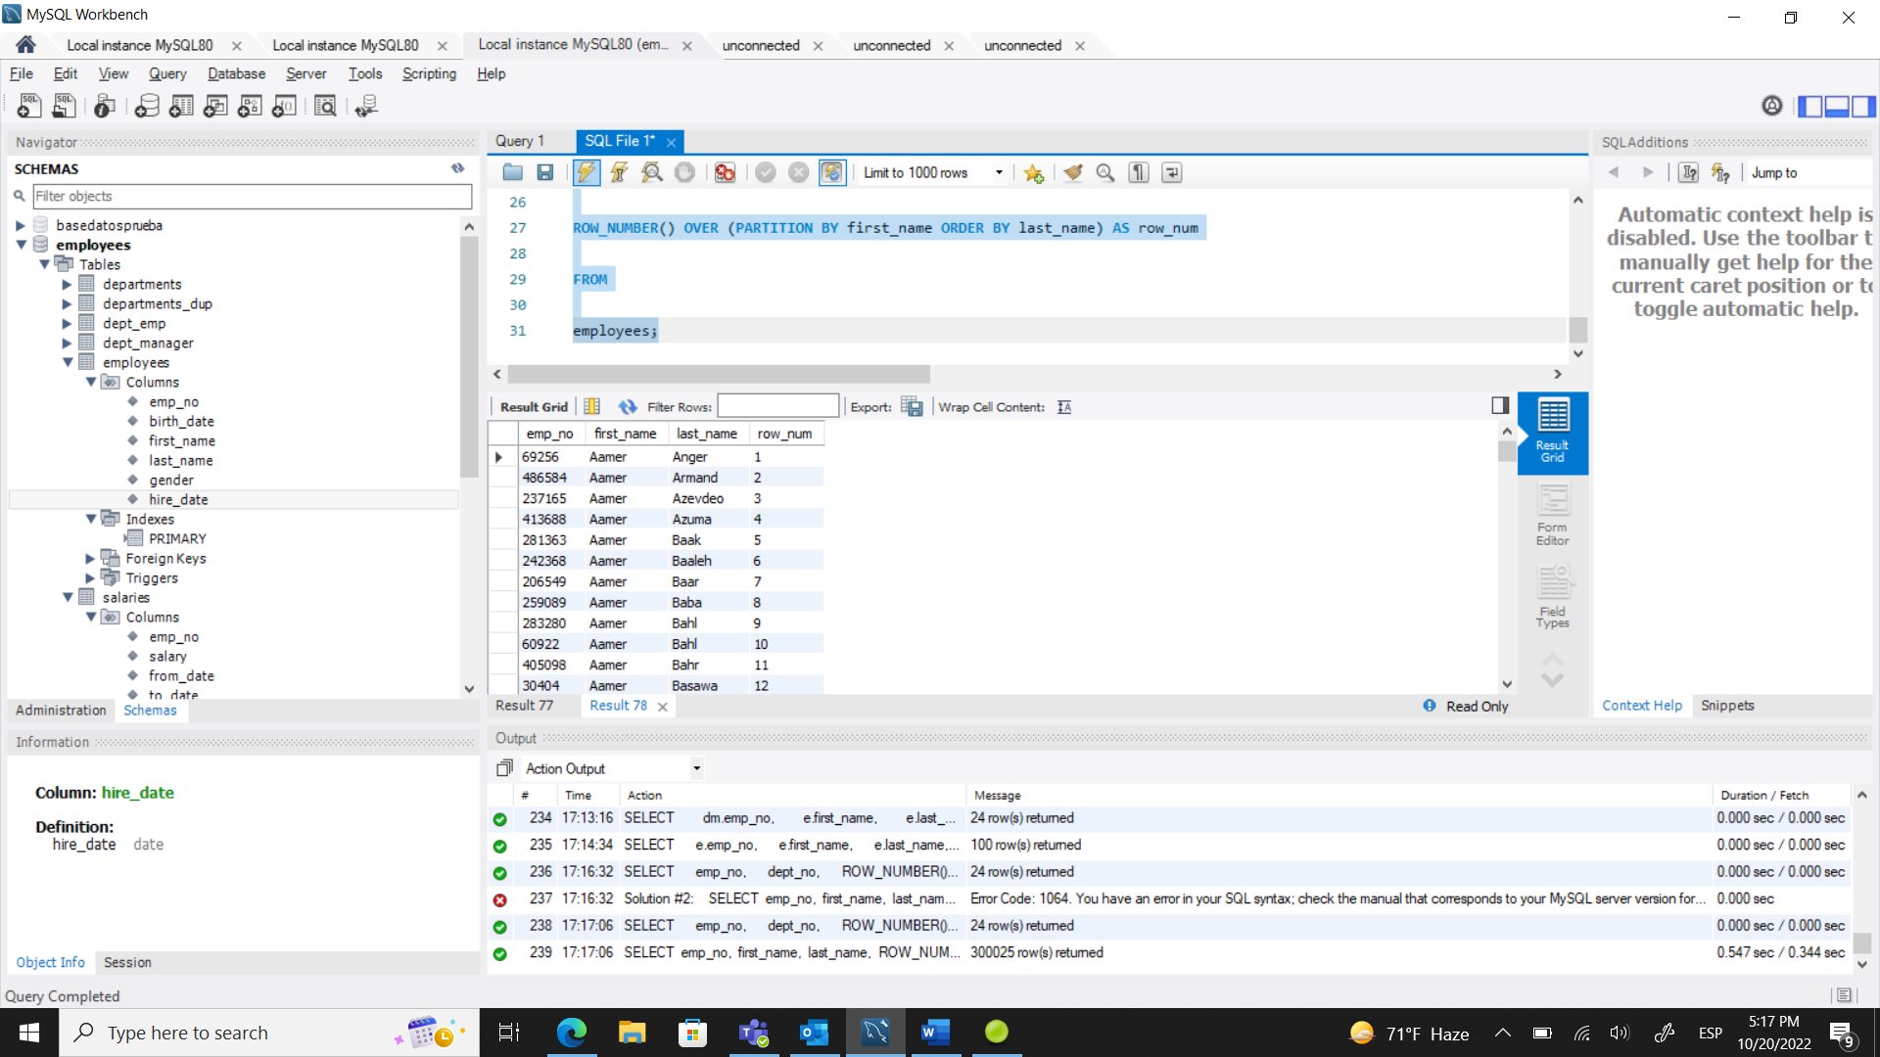

**263. A Note on Using Several Window Functions – Solution**

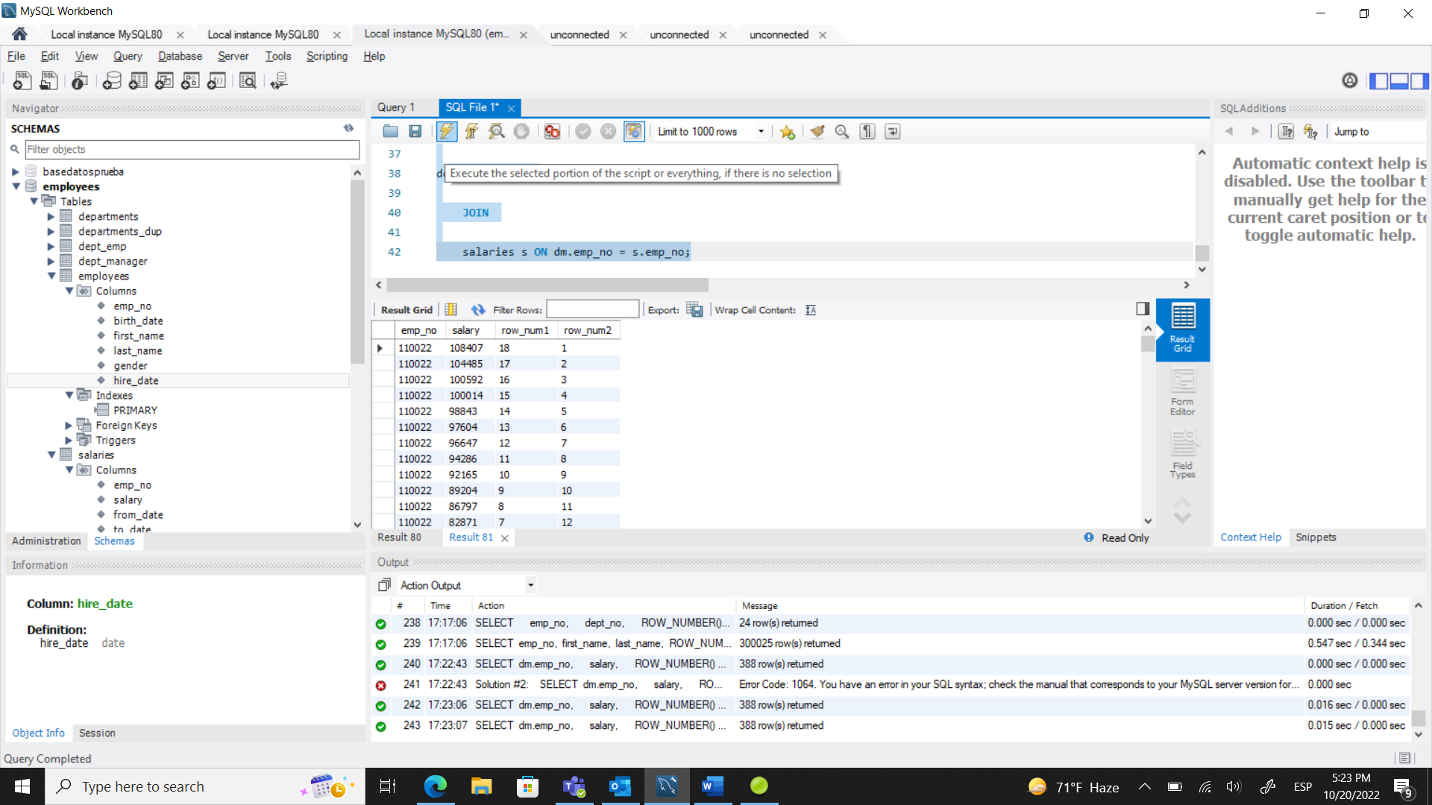

**266. MySQL Window Functions Syntax – Solution**

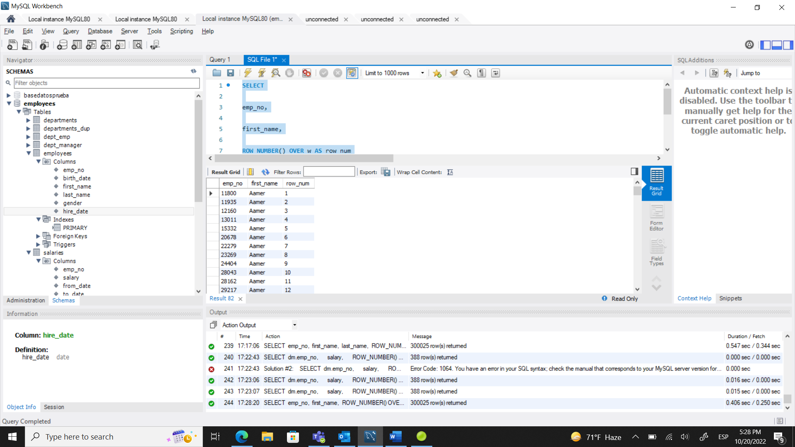

**269. The PARTITION BY Clause VS the GROUP BY Clause – Solution**

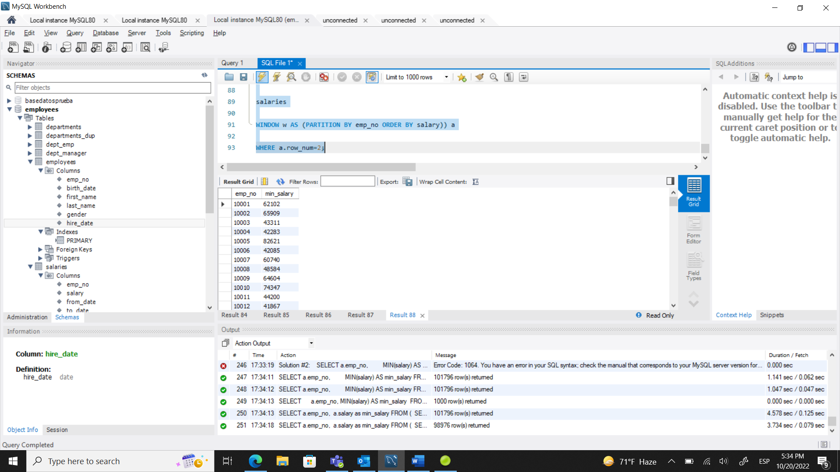

**272. The MySQL RANK() and DENSE_RANK() Window Functions – Solution**

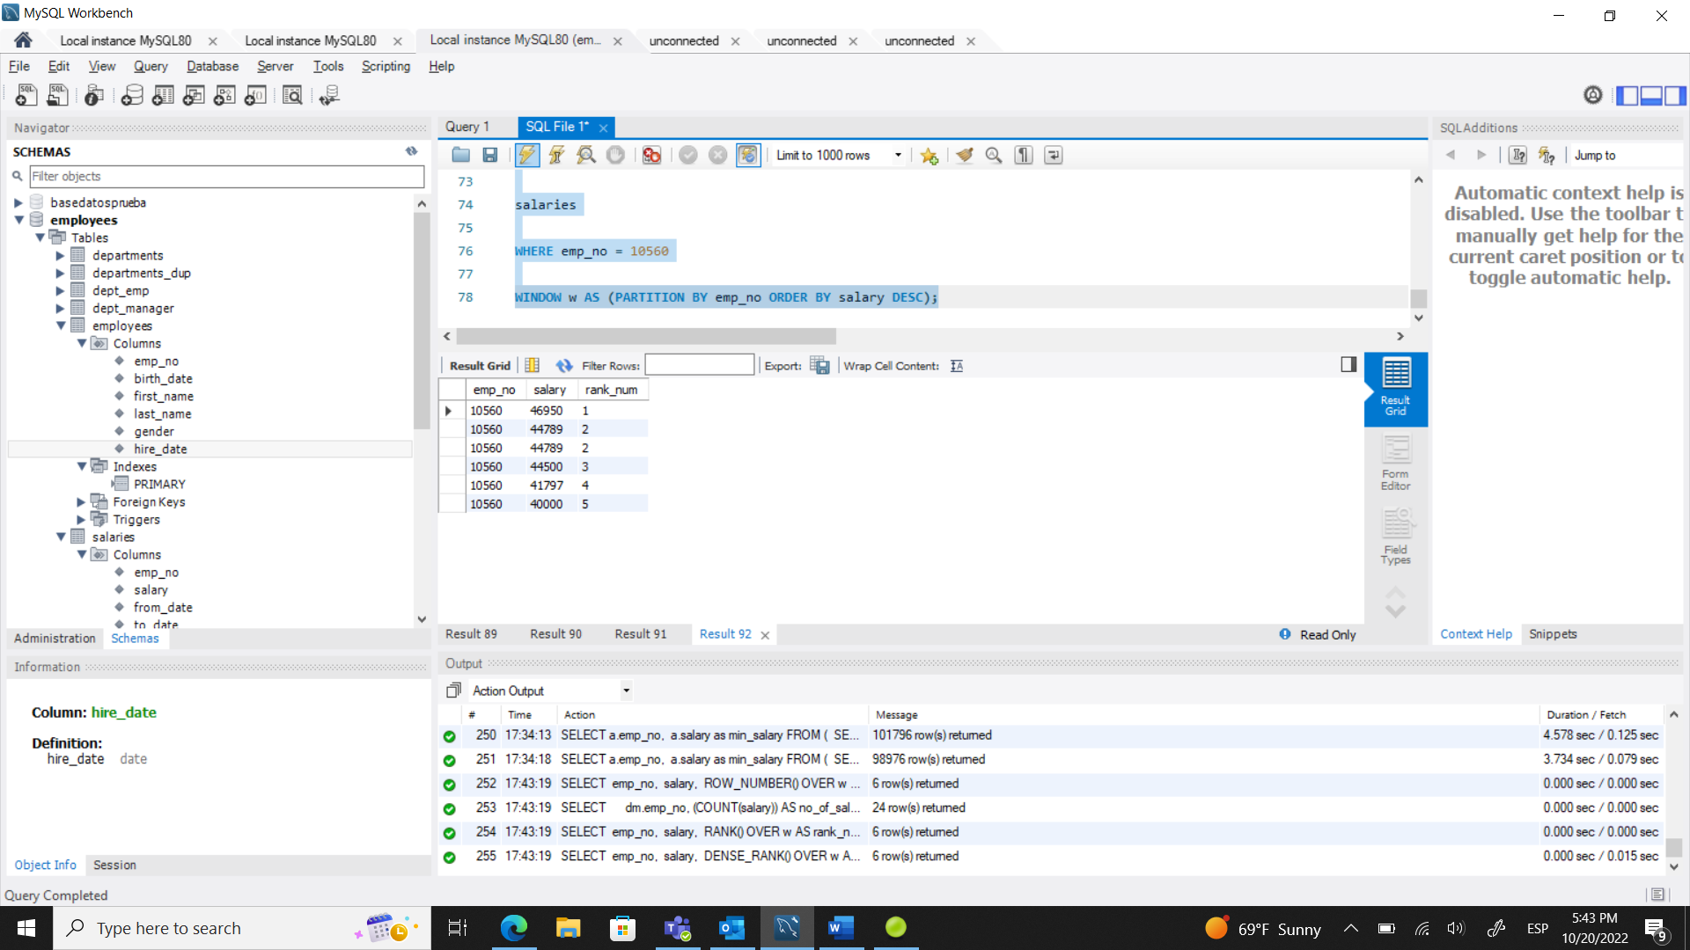

**275. Working with MySQL Ranking Window Functions and Joins Together – Solution**

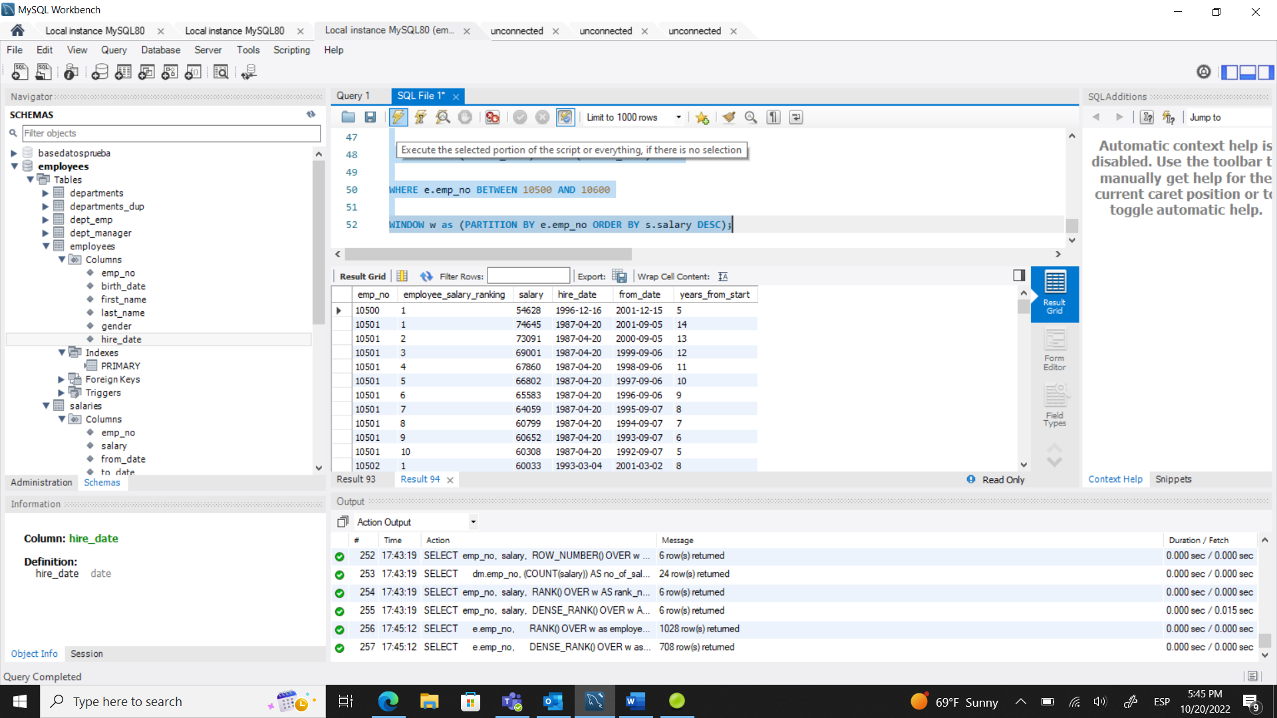

**278. The LAG() and LEAD() Value Window Functions – Solution**

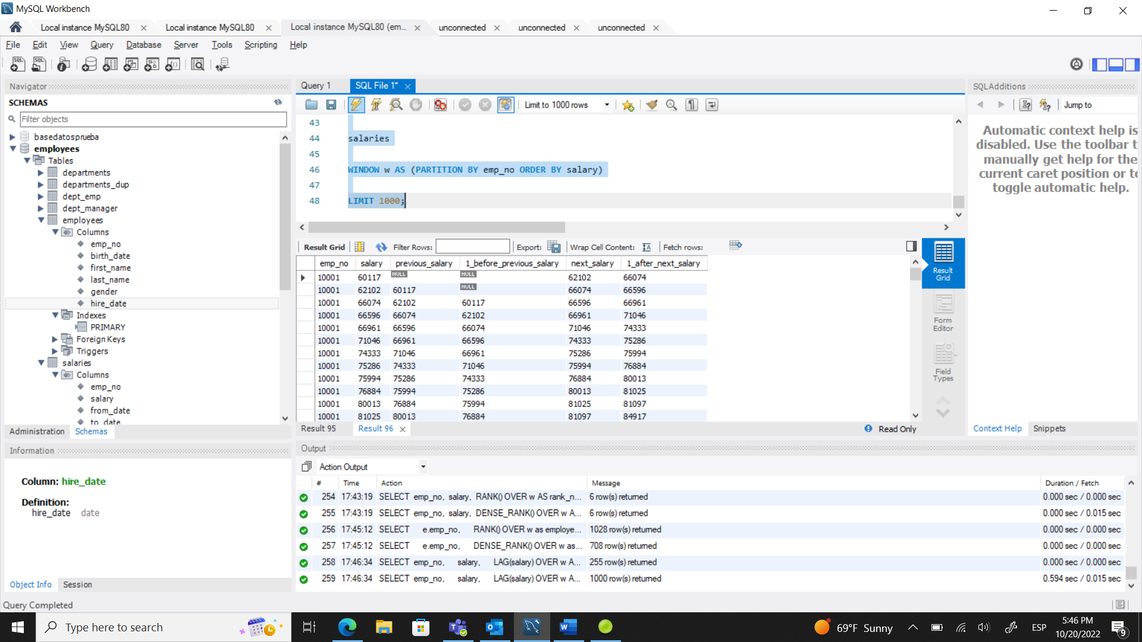

**281. MySQL Aggregate Functions in the Context of Window Functions - Part I-Solution**

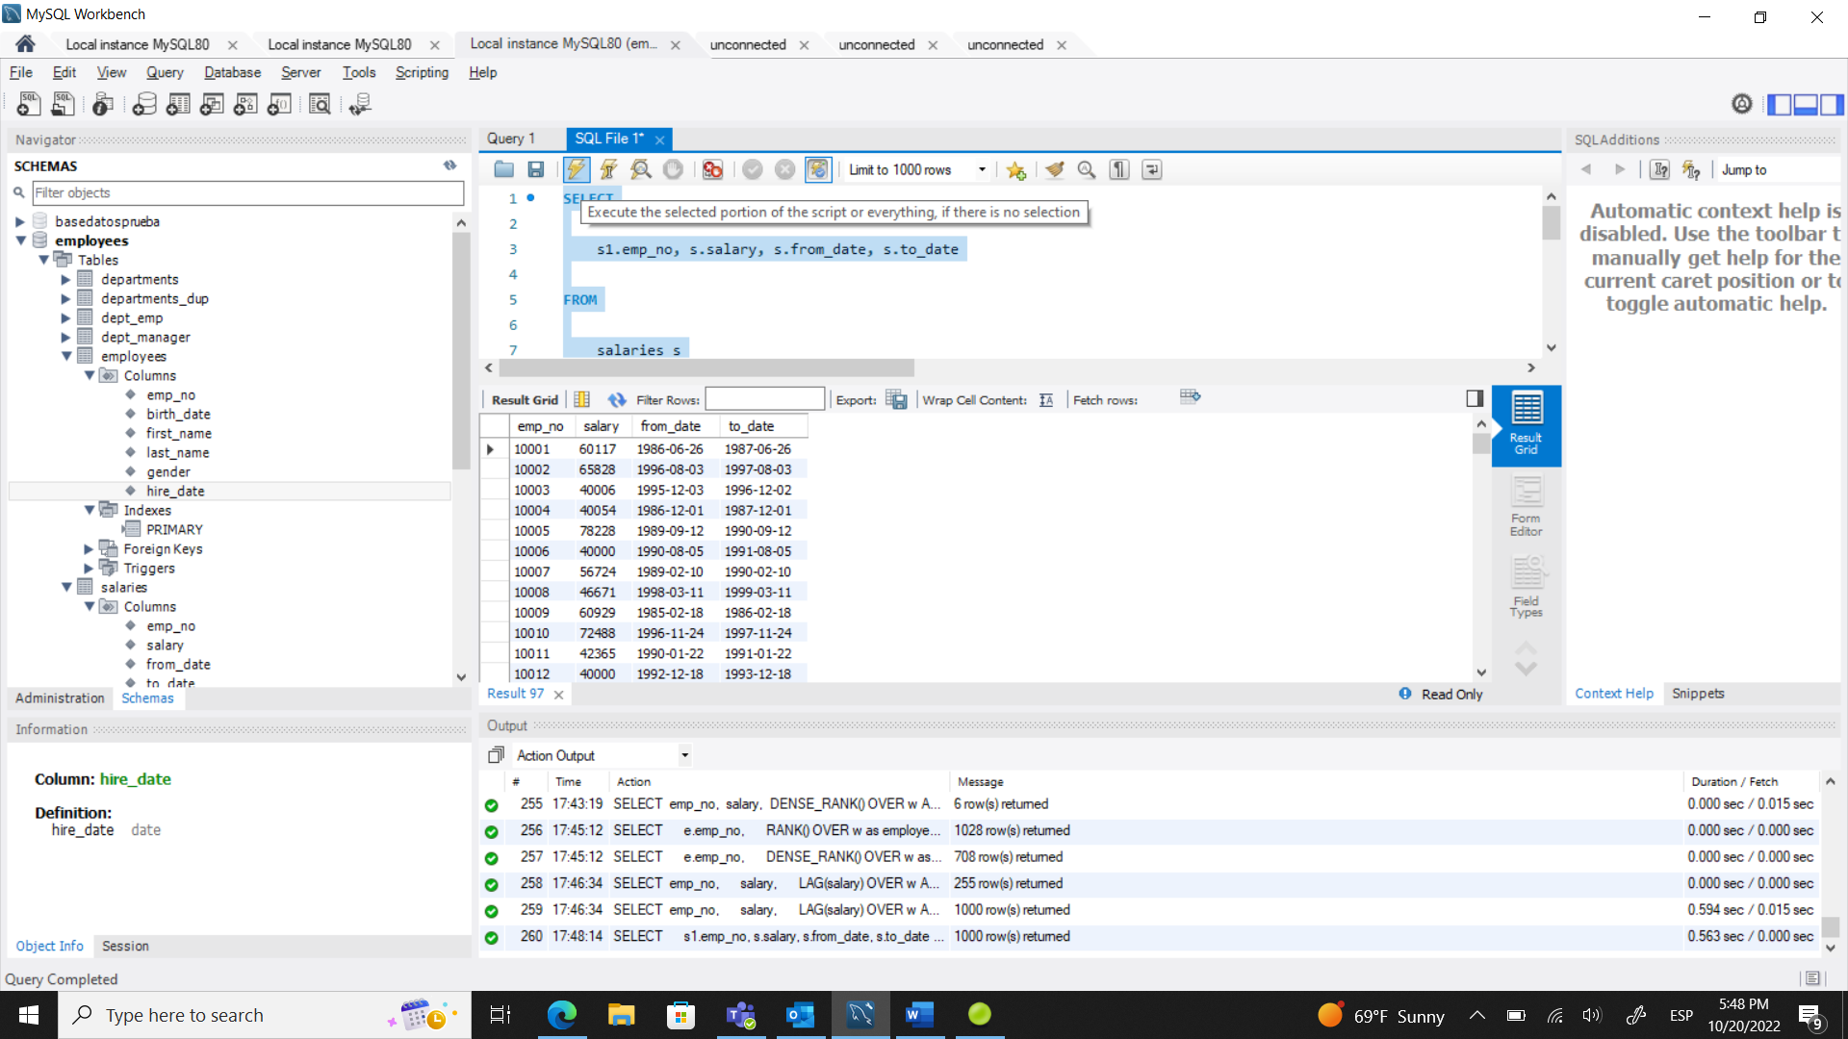

**284. MySQL Aggregate Functions in the Context of Window Functions - Part II-Solution**

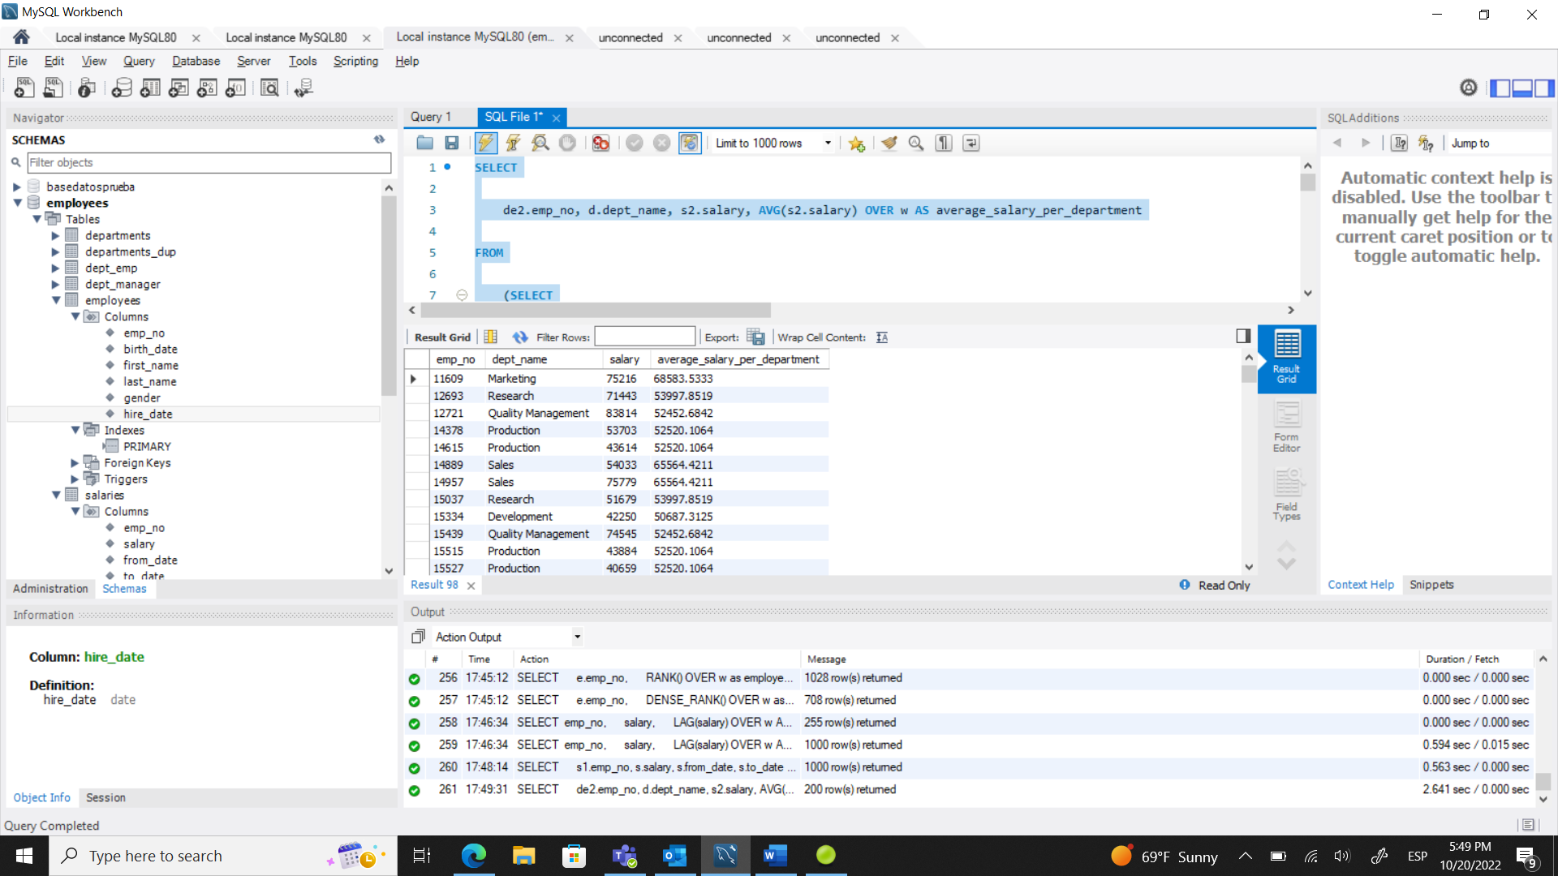

**294.Task 1: SQL Solution – Code**

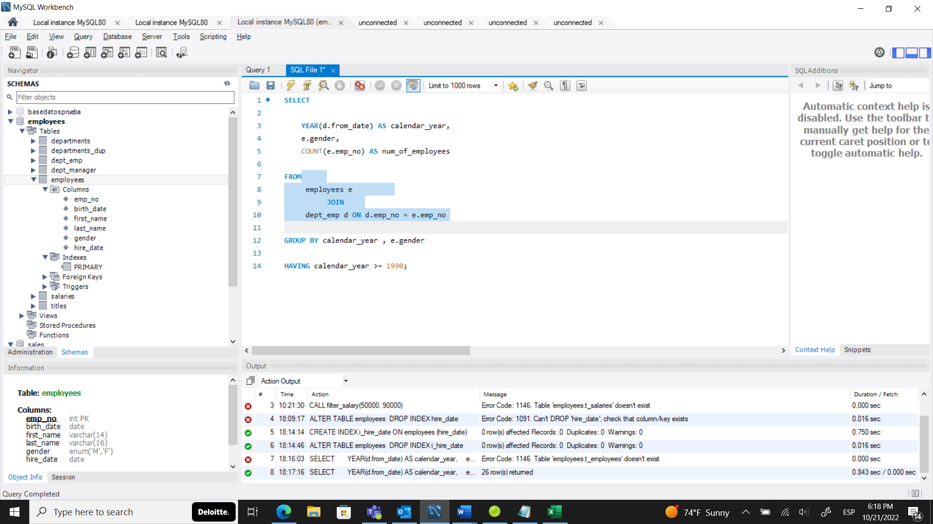

**301.Task 2: SQL Solution – Code**

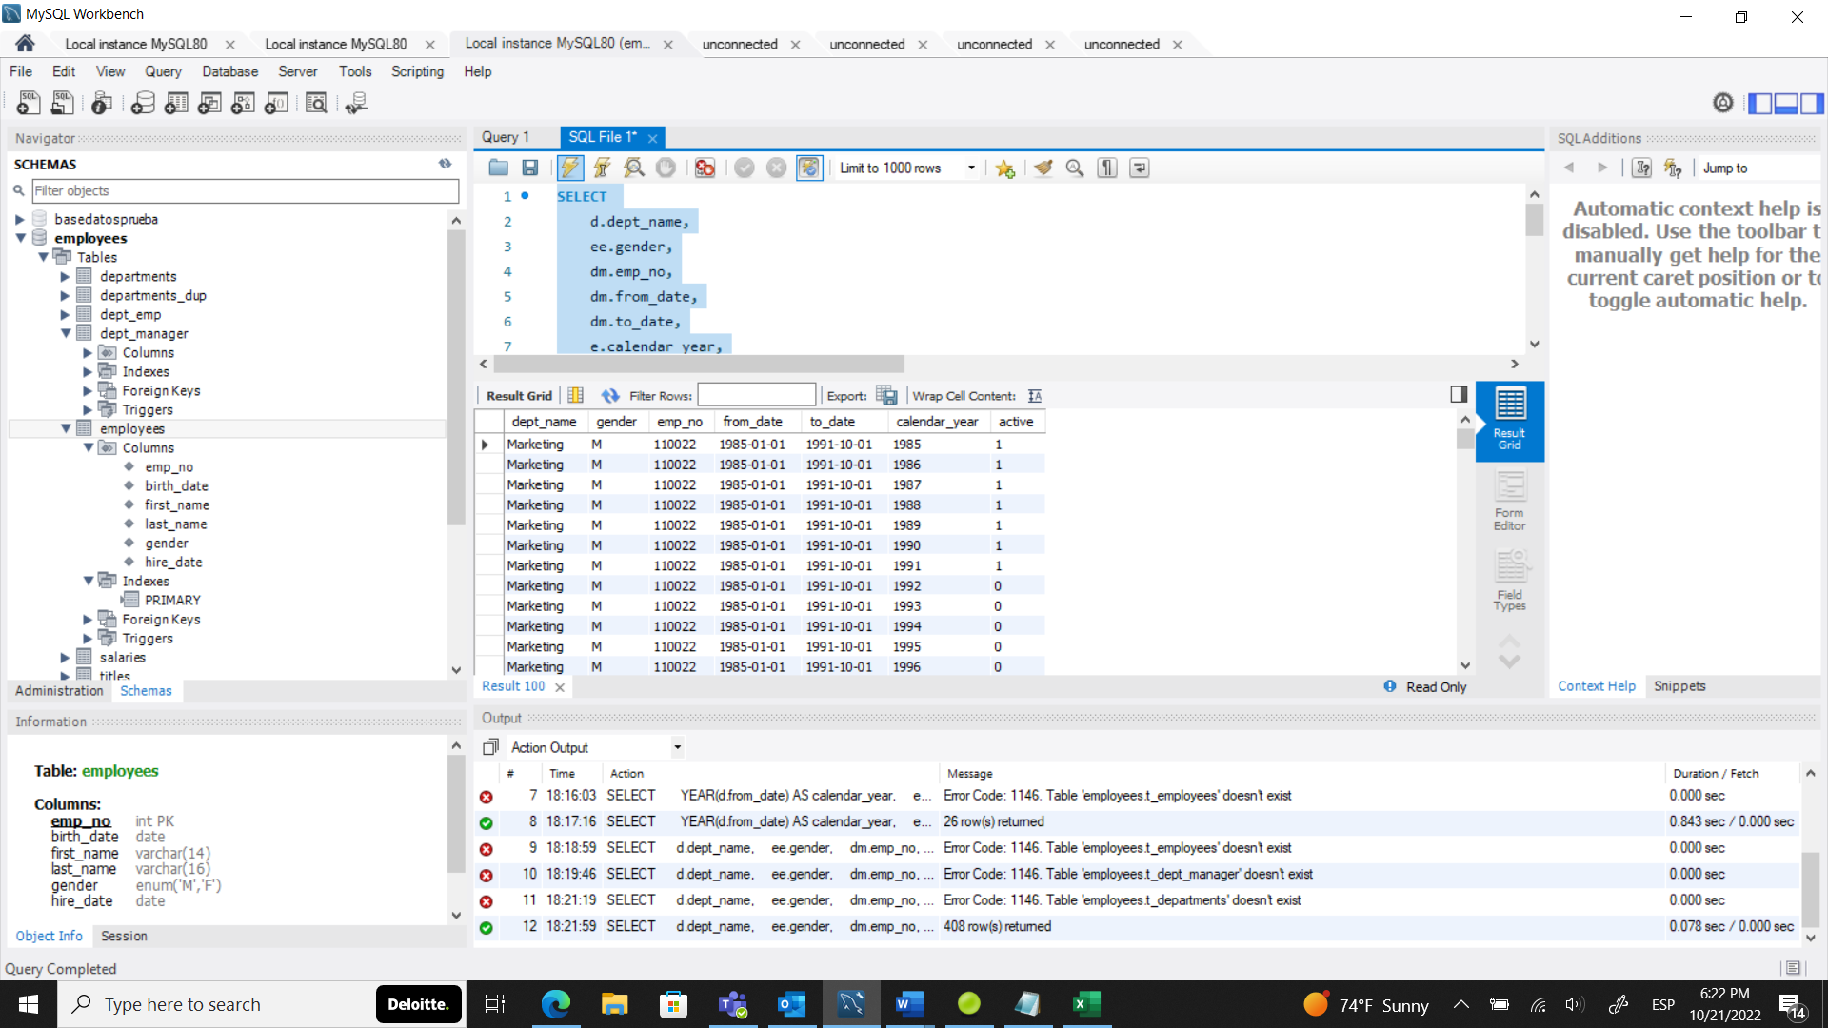

**306. Task 3: SQL Solution – Code**

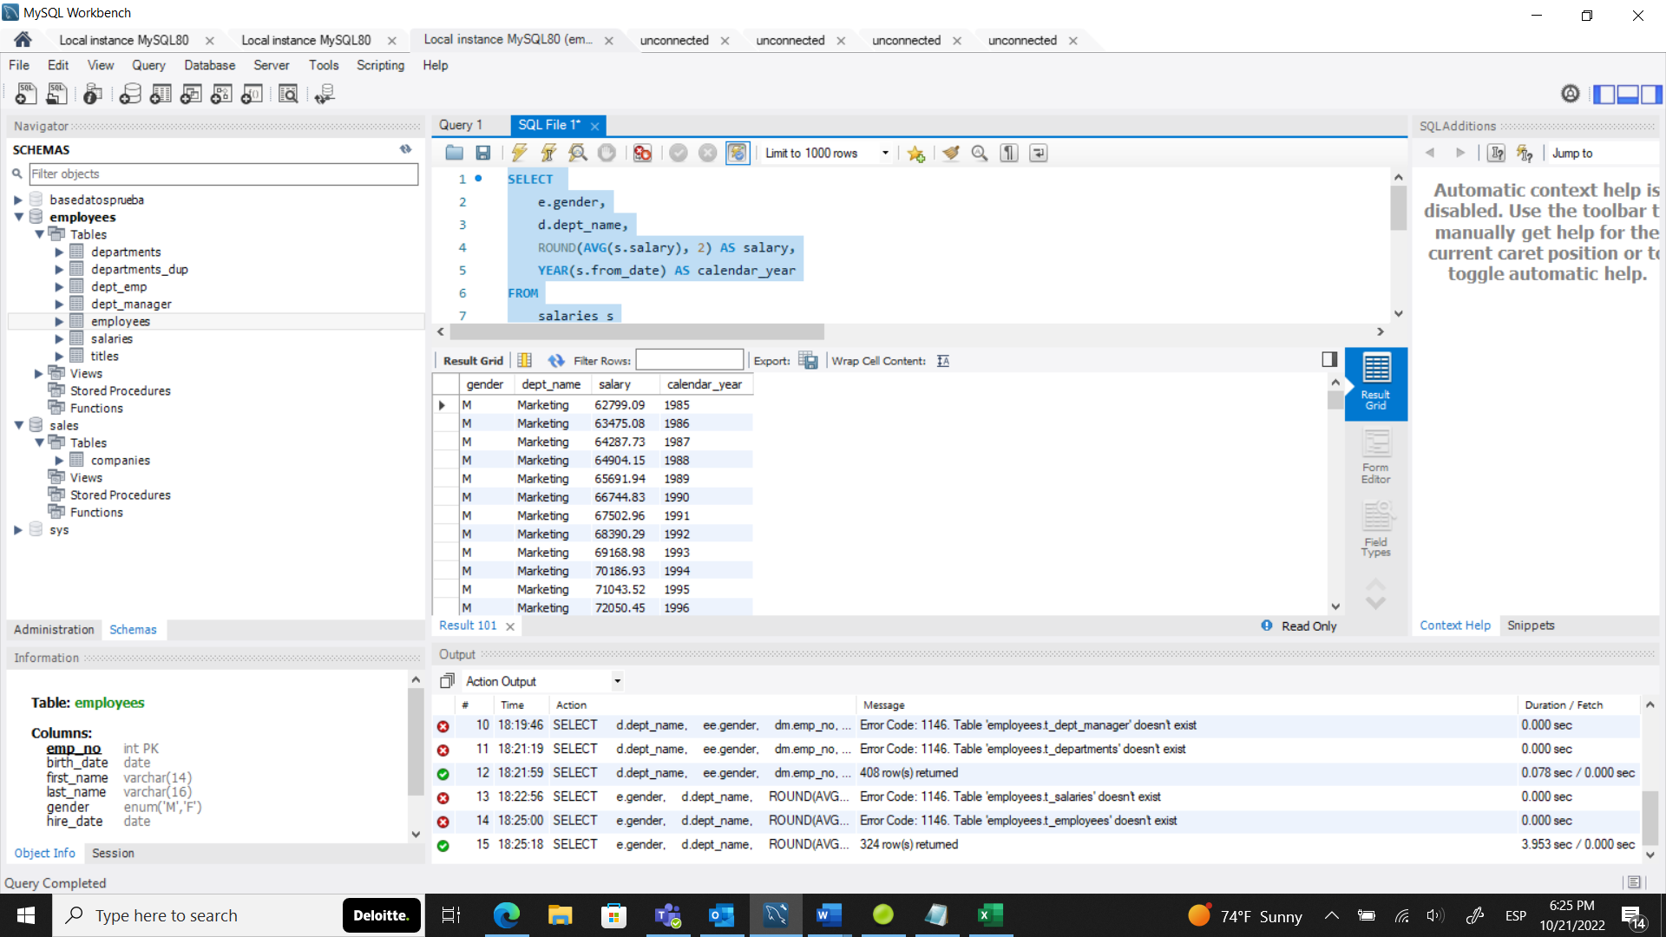

**311.Task 4: Solution in SQL - Code**

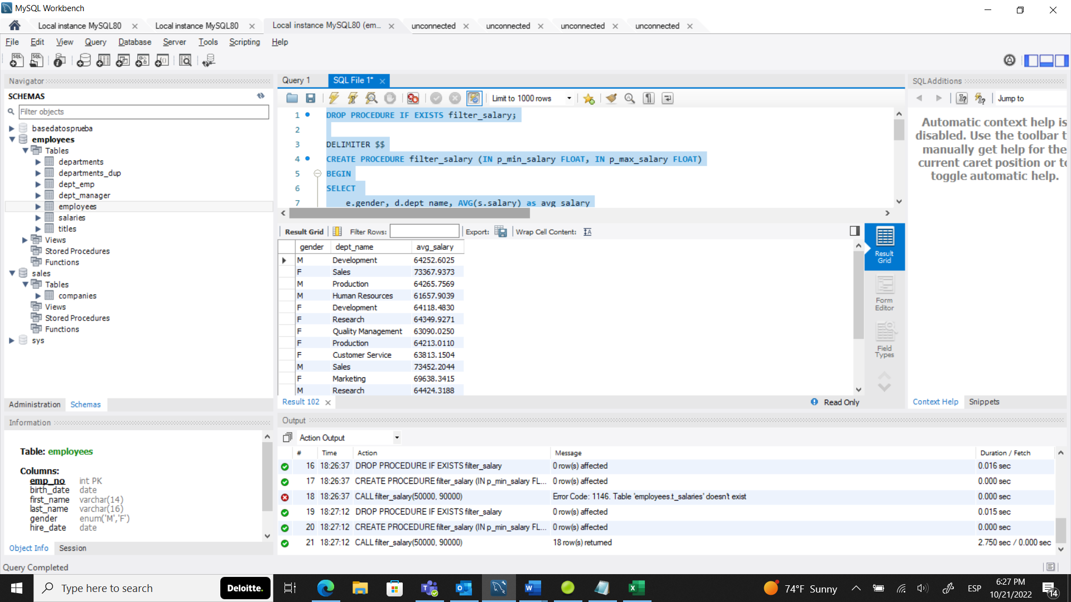

**Seccion 27 final query questions**

**USE employees;**

**# Exercise 1**

**# Find the average salary of male and female employees in each department.**

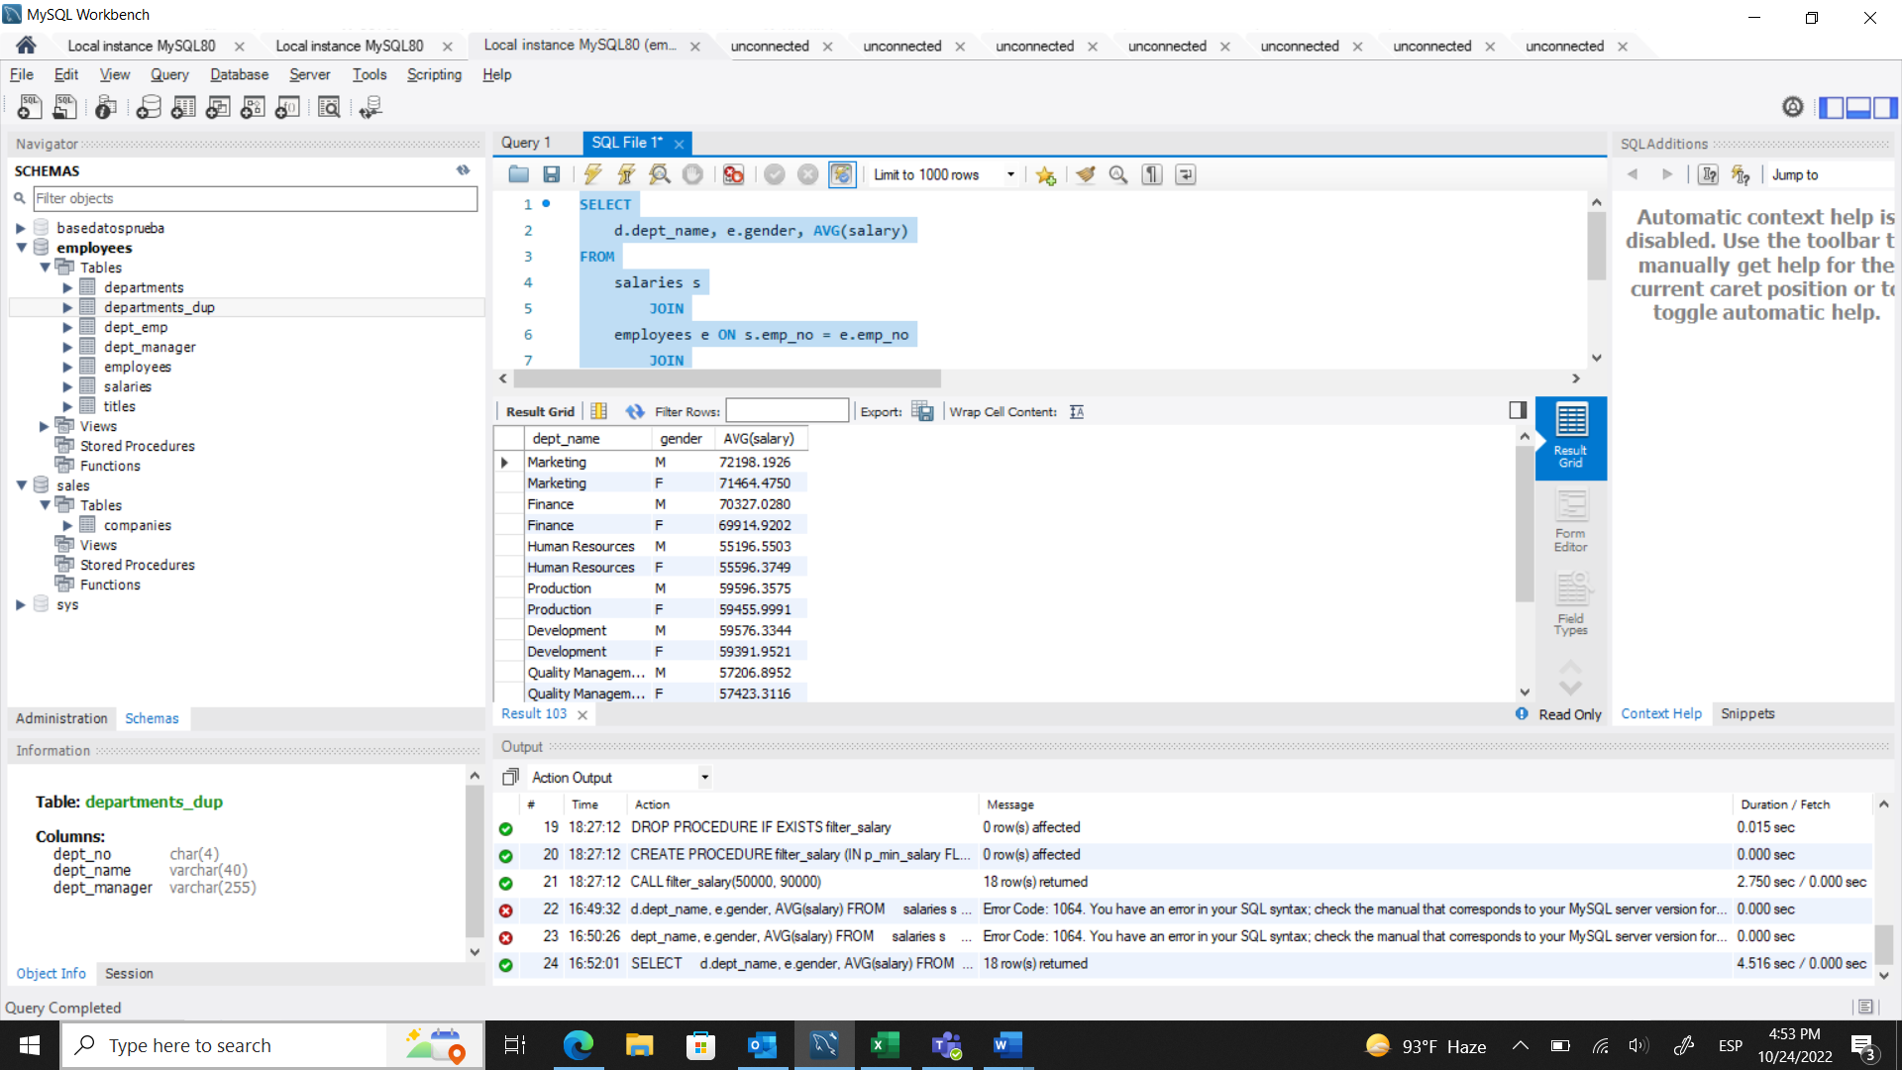

**# Exercise 2**

**# Find the lowest department number encountered the 'dept_emp' table. Then, find the highest department number.**

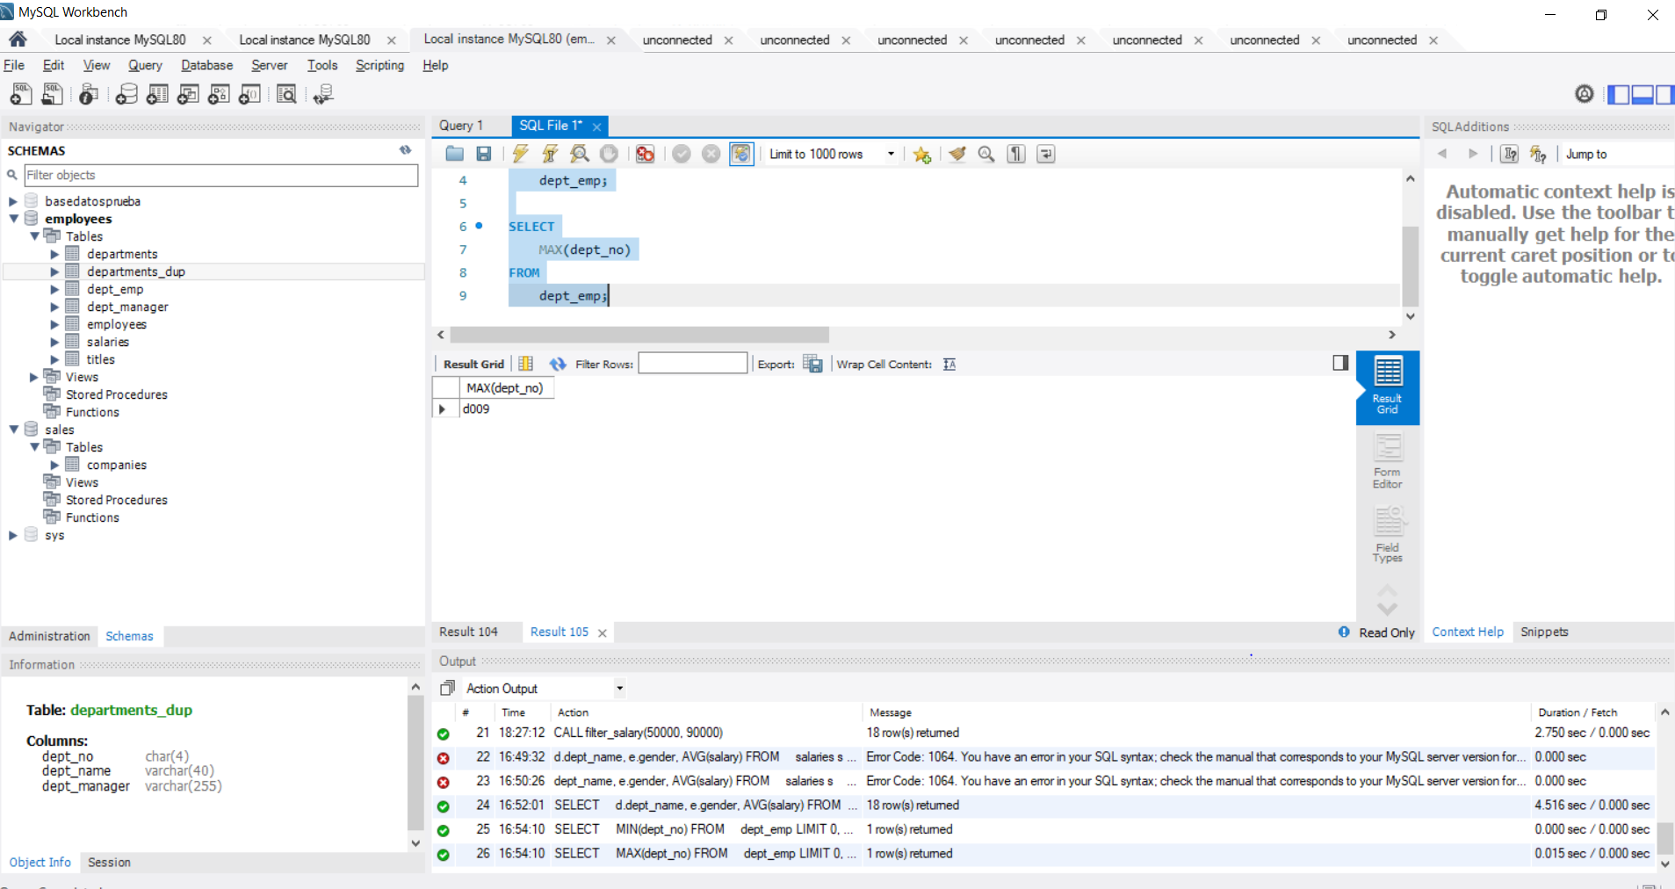

**# Exercise 3**

**# Obtain a table containing the following three fields for all individuals whose employee number is no greater than 10040:**

**# - employee number**

**# - the smallest department number among the departments where an employee has worked in (use a subquery to retrieve this value from the 'dept_emp' table)**

**# - assign '110022' as 'manager' to all individuals whose employee number is less than or equal to 10020, and '110039' to those whose number is between 10021 and 10040 inclusive (use a CASE statement to create the third field).**

**# If you've worked correctly, you should obtain an output containing 40 rows.**

**# Here’s the top part of the output.**

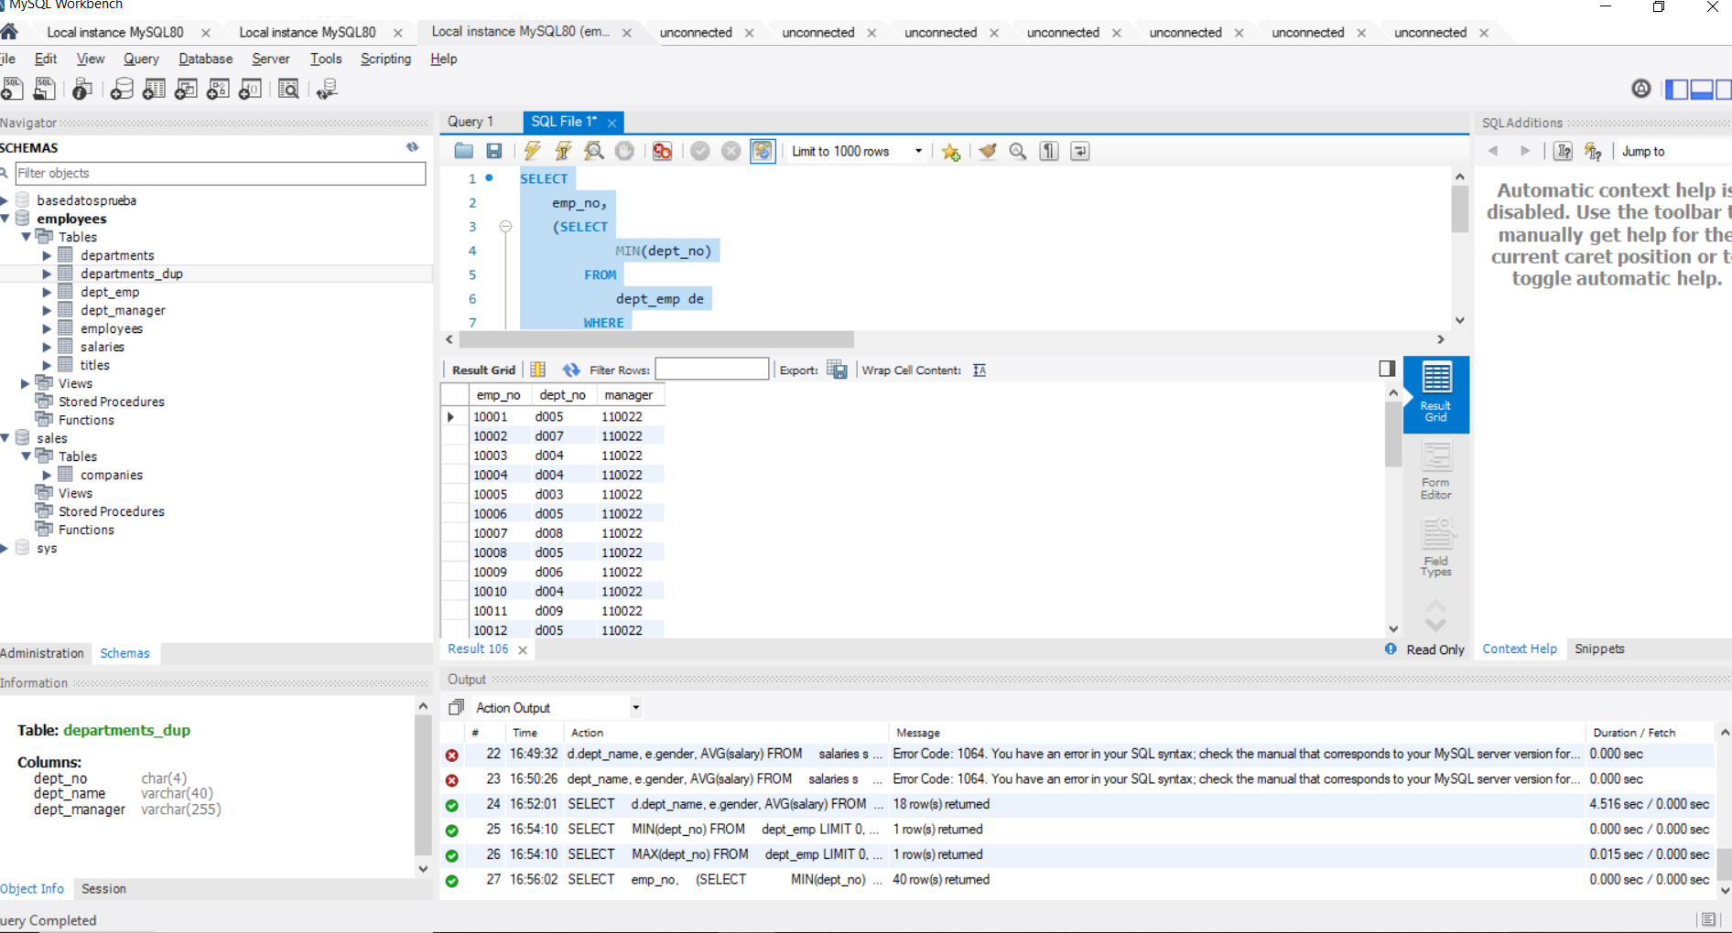

**# Exercise 4**

**# Retrieve a list with all employees that have been hired in the year 2000.**

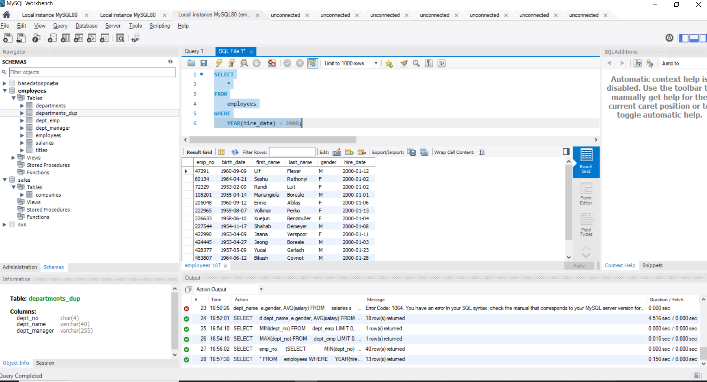

**# Exercise 5**

**# Retrieve a list with all employees from the ‘titles’ table who are engineers.**

**# Repeat the exercise, this time retrieving a list with all employees from the ‘titles’ table who are senior engineers.**

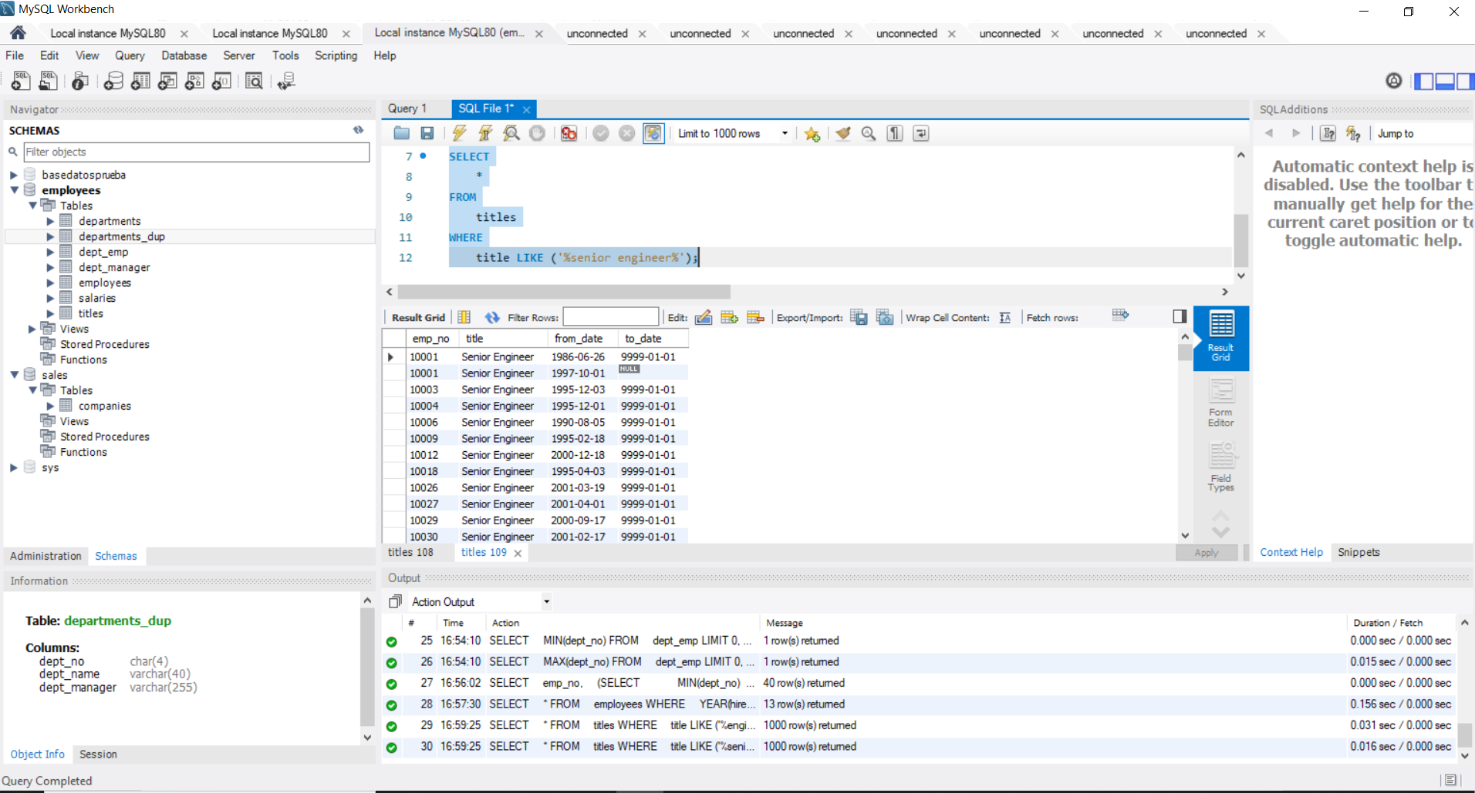

**# After LIKE, you could proceed to indicate what you are looking for with or without using parentheses. Both options work correctly. We think using parentheses is better for legibility reasons and that’s why it is the first option we’ve suggested.**

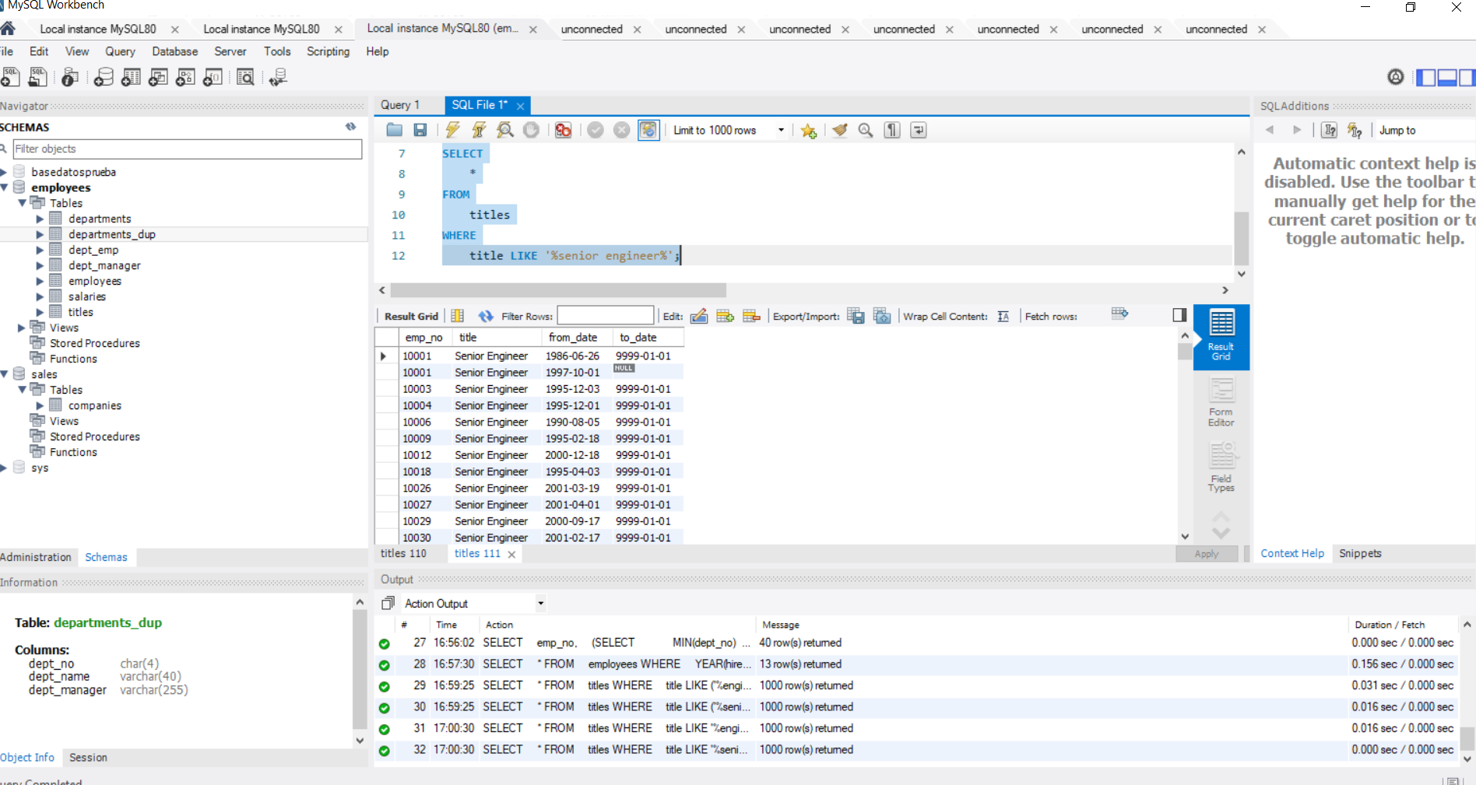

**# Exercise 6**

**# Create a procedure that asks you to insert an employee number to obtain an output containing the same number, as well as the number and name of the last department the employee has worked for.**

**# Finally, call the procedure for employee number 10010.**

**# If you've worked correctly, you should see that employee number 10010 has worked for department number 6 - "Quality Management".**

**DROP procedure IF EXISTS last_dept;**

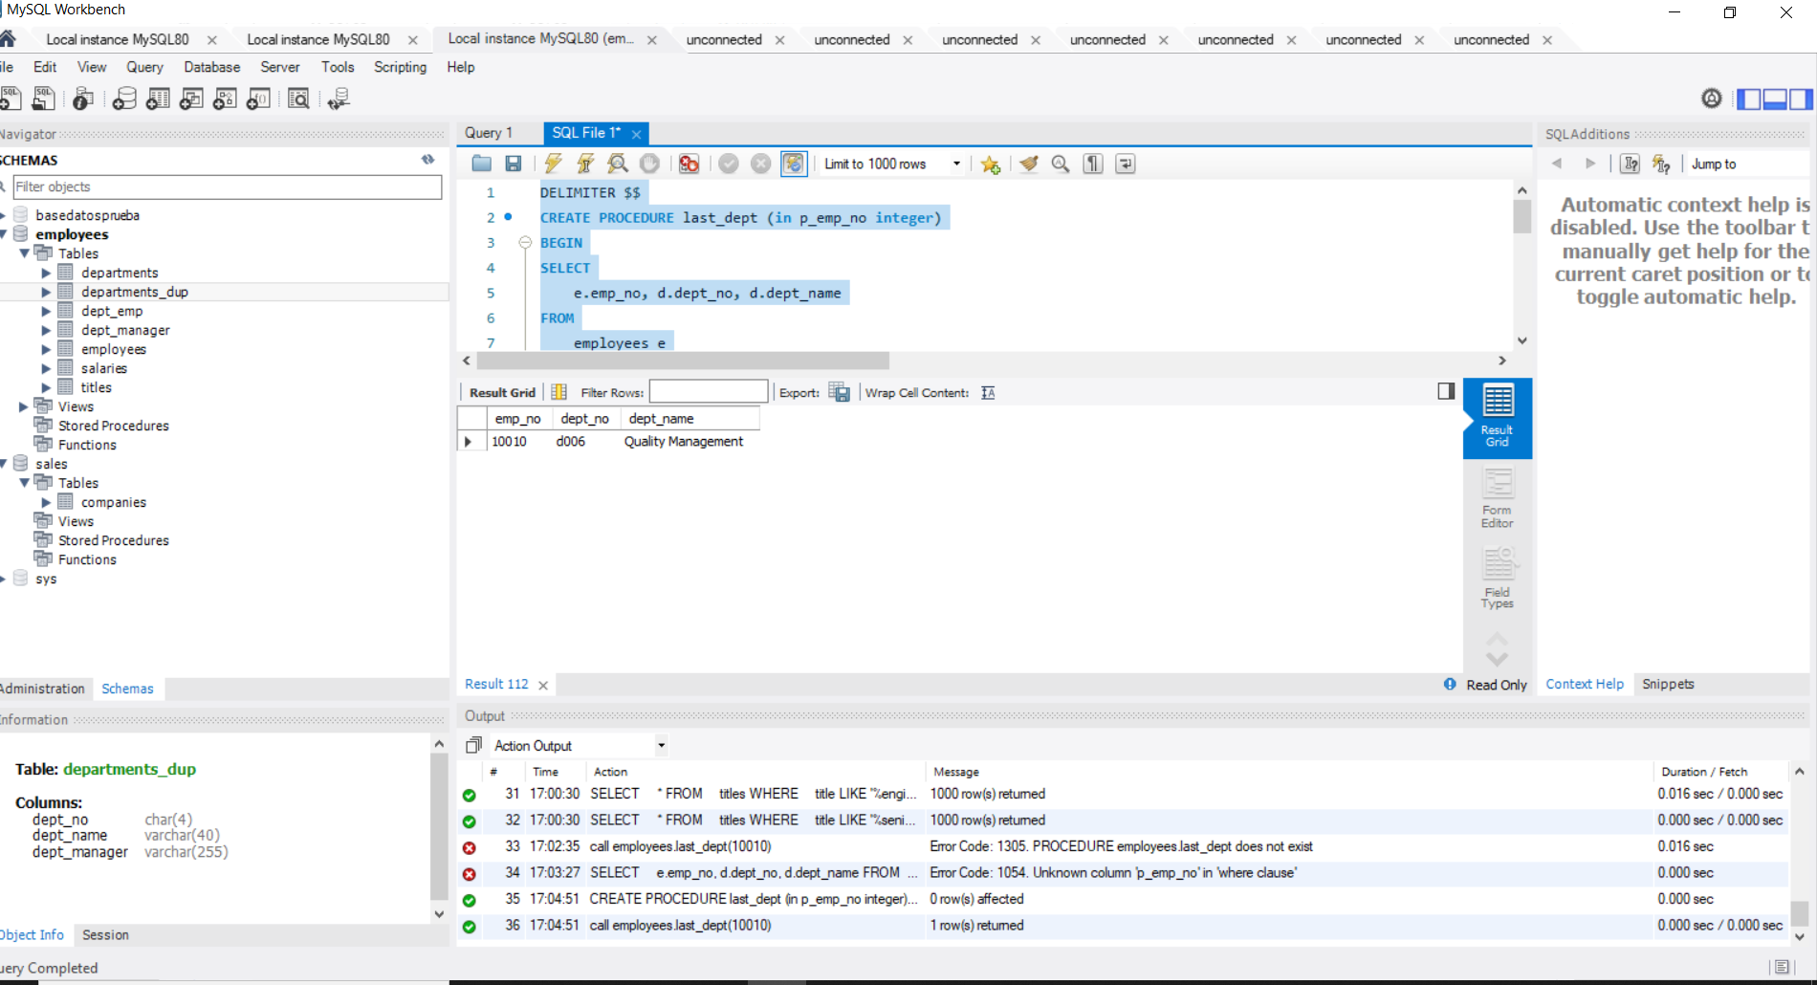

**# Exercise 7**

**# How many contracts have been registered in the ‘salaries’ table with duration of more than one year and of value higher than or equal to $100,000?**

**# Hint: You may wish to compare the difference between the start and end date of the salaries contracts.**

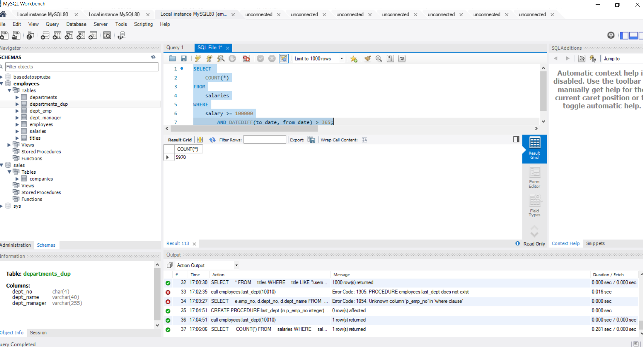

**# Exercise 8**

**# Create a trigger that checks if the hire date of an employee is higher than the current date. If true, set this date to be the current date. Format the output appropriately (YY-MM-DD).**

**# Extra challenge: You may try to declare a new variable called 'today' which stores today's data, and then use it in your trigger!**

**# After creating the trigger, execute the following code to see if it's working properly.**

**ORDER BY emp_no DESC;**

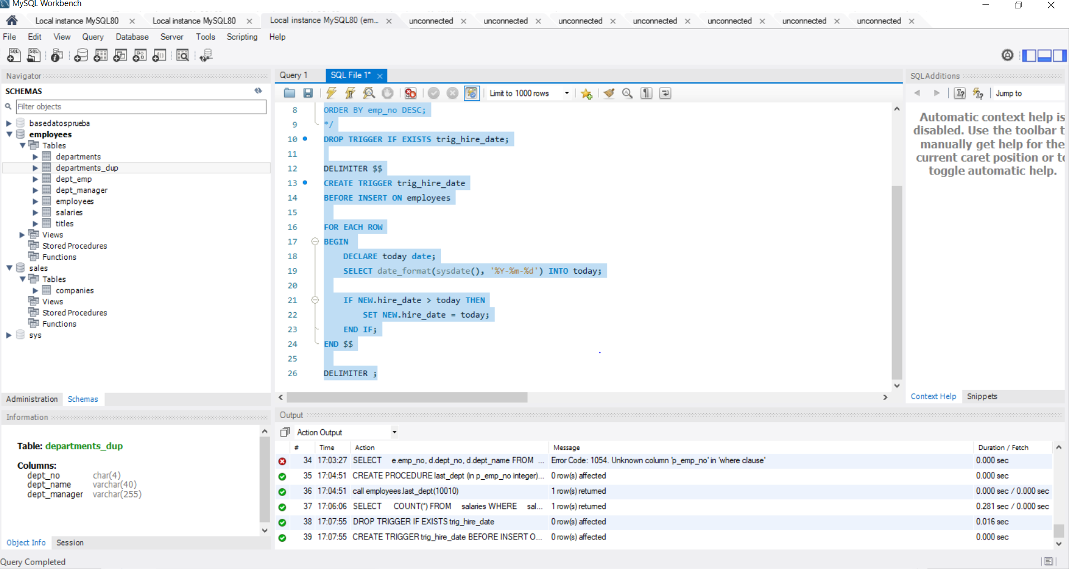

**# Exercise 9**

**# Define a function that retrieves the largest contract salary value of an employee. Apply it to employee number 11356.**

**# Also, what is the lowest salary value per contract of the same employee? You may want to create a new function that will deliver this number to you. Apply it to employee number 11356 again.**

**# Feel free to apply the function to other employee numbers as well.**

**DROP FUNCTION IF EXISTS f_highest_salary;**

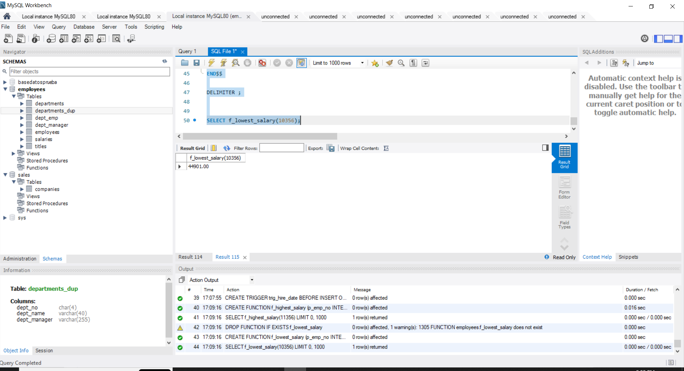

**# Exercise 10**

**# Based on the previous example, you can now try to create a function that accepts also a second parameter which would be a character sequence.**

**# Evaluate if its value is 'min' or 'max' and based on that retrieve either the lowest or the highest salary (using the same logic and code**

**# from Exercise 9). If this value is a string value different from ‘min’ or ‘max’, then the output of the function should return**

**# the difference between the highest and the lowest salary.**

**DROP FUNCTION IF EXISTS f_salary;**

